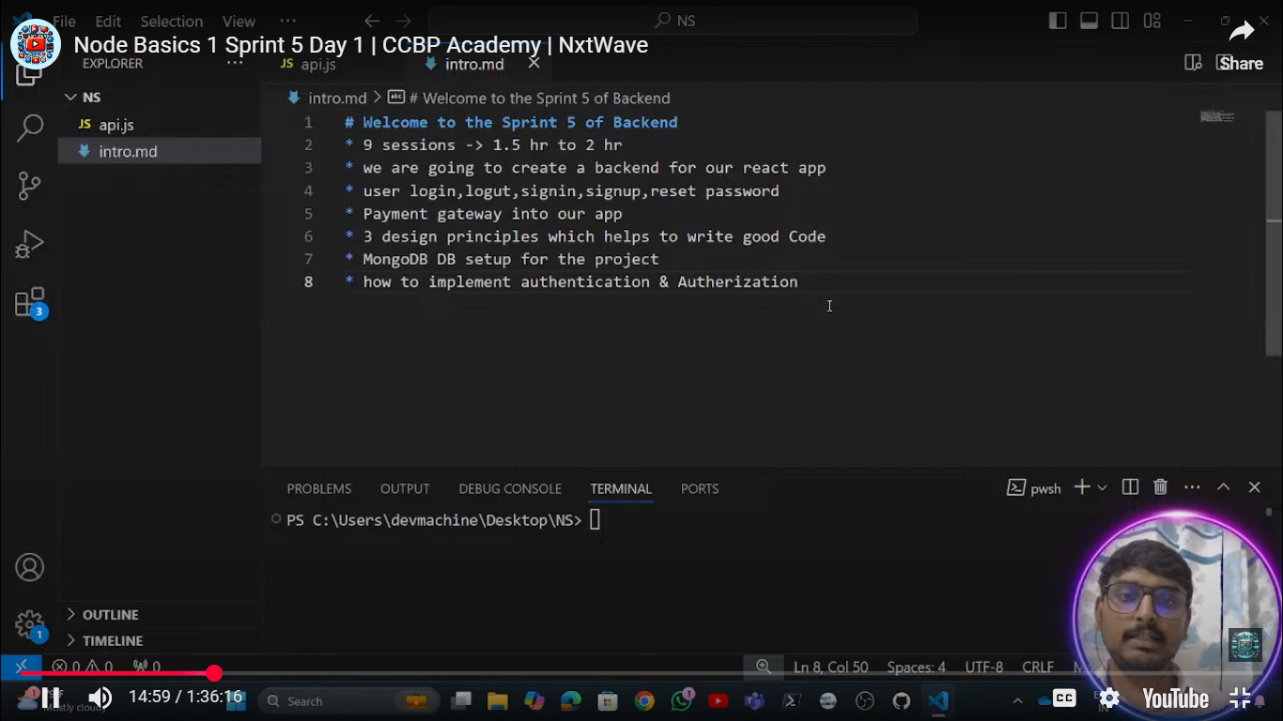

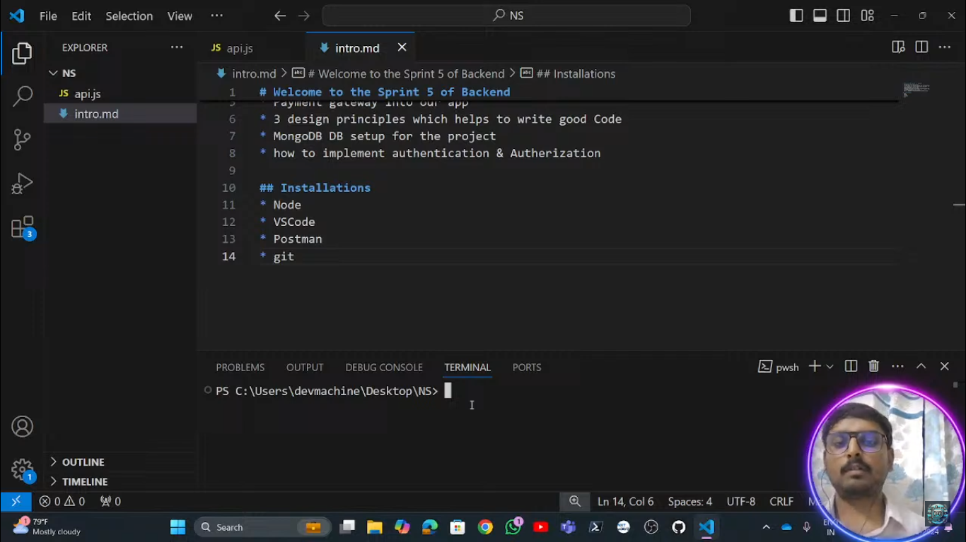

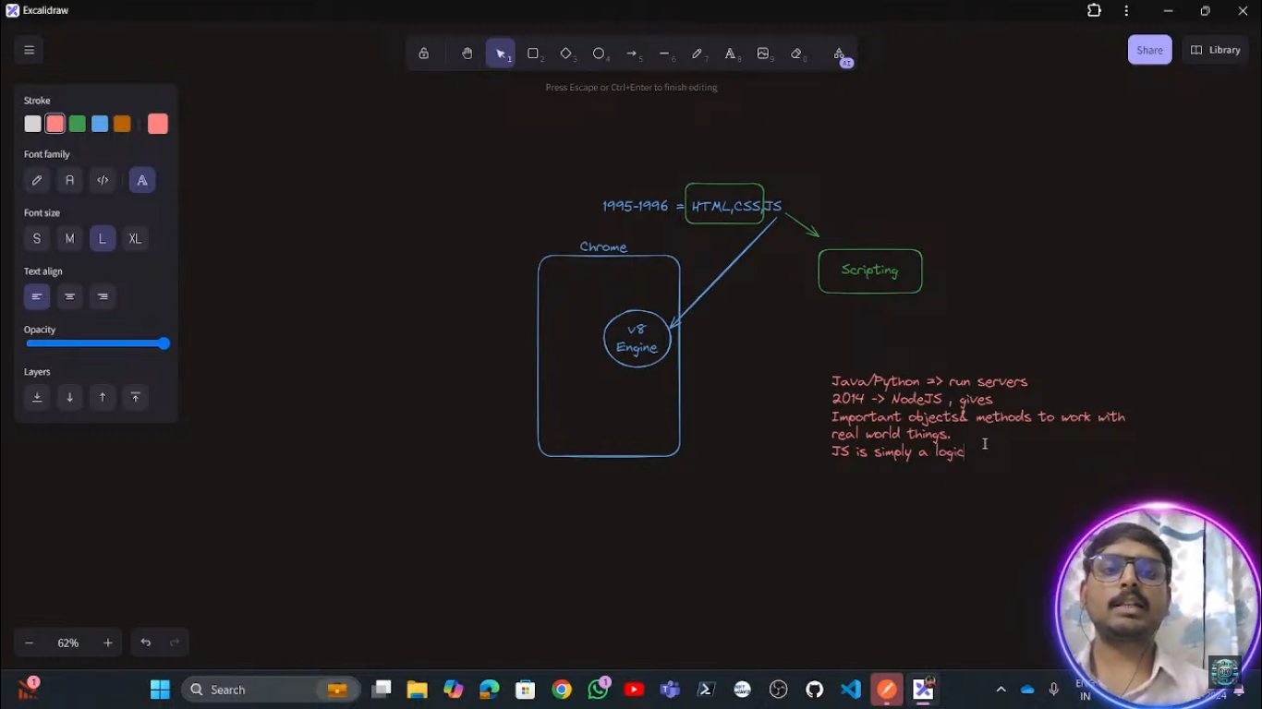

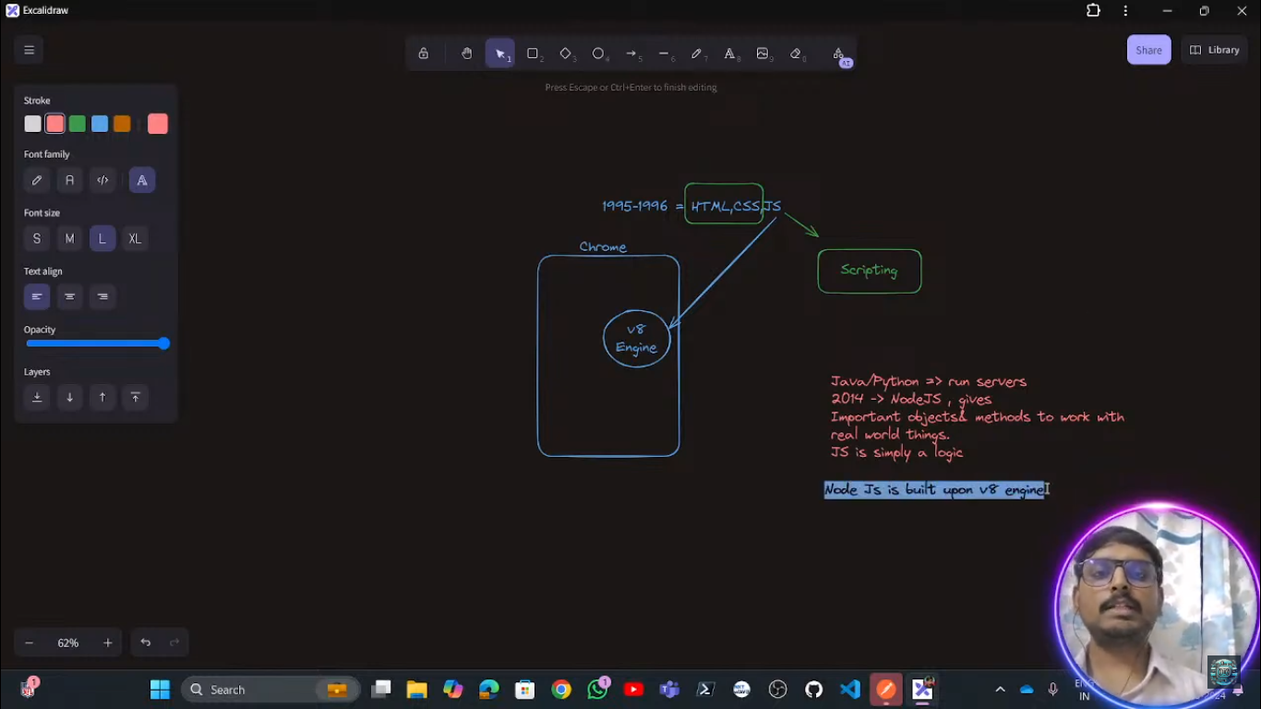

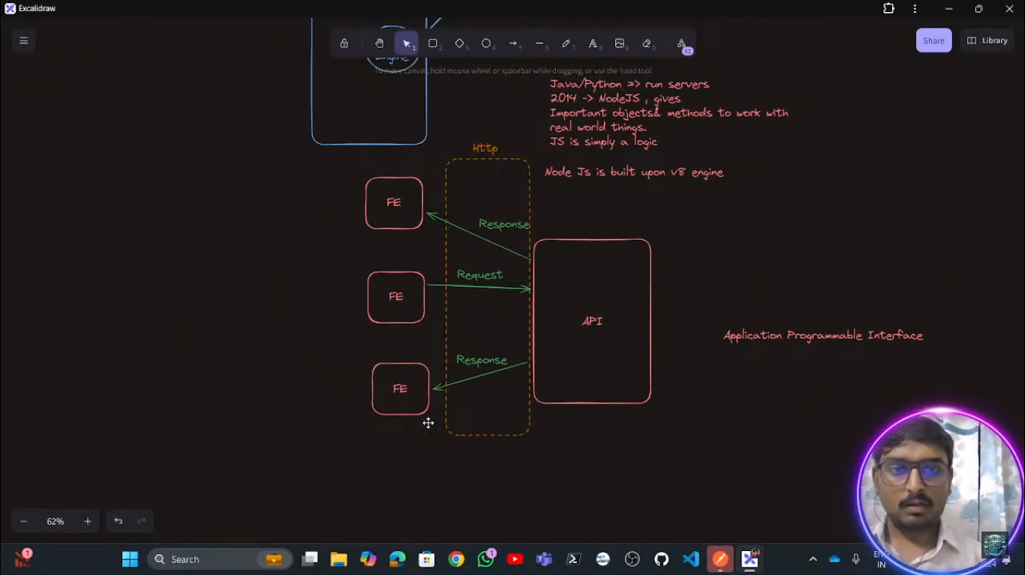

Here the Http is the intermediater between the front-end to backend to communicate between each-other and that http is the a module of the nodeJs .

And a express-Js a framework of nodeJs which is used to create a http sever

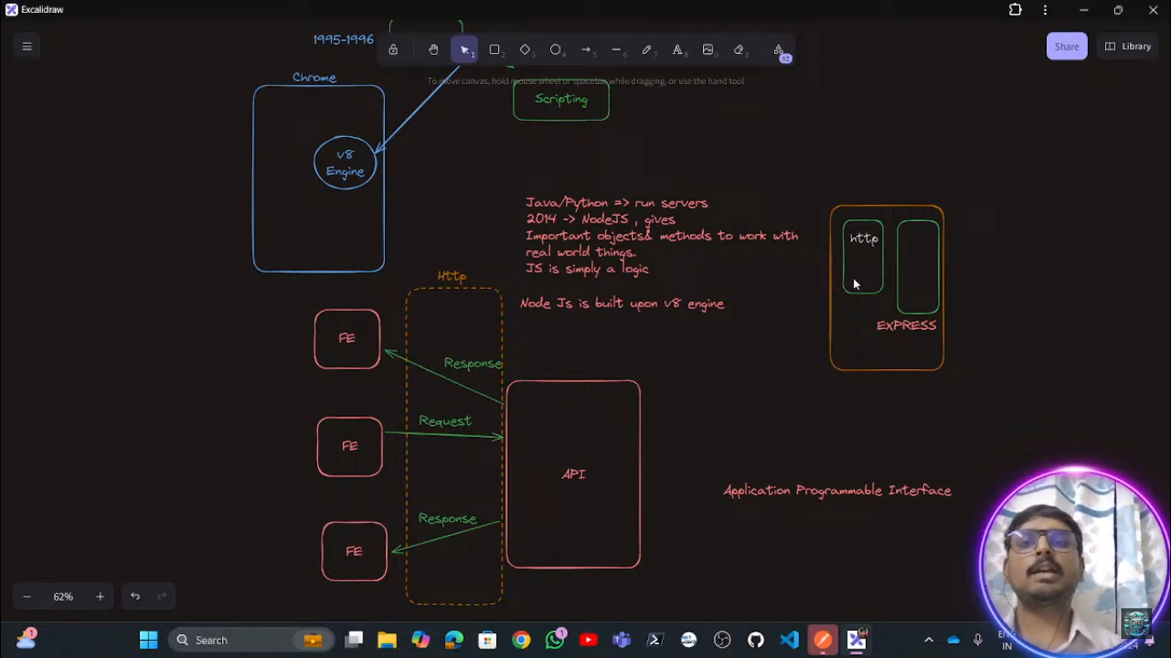

In order to create any node package we need to use the command as

Npm init –y

## ****Breaking Down the Command****

* **npm** → The **Node Package Manager**, which is used to manage dependencies (libraries, frameworks, tools) in a Node.js project.
* **init** → Initializes a new Node.js project by creating a package.json file.
* **-y** → Skips the interactive questions and **automatically accepts default values** for the package.json file.

**Difference Between npm init and npm init -y**

| **Command** | **Description** |
| --- | --- |
| npm init | Starts an **interactive prompt** where you manually enter values (project name, version, description, etc.). |
| npm init -y | Skips the interactive prompt and **automatically generates a package.json file** with default values. |

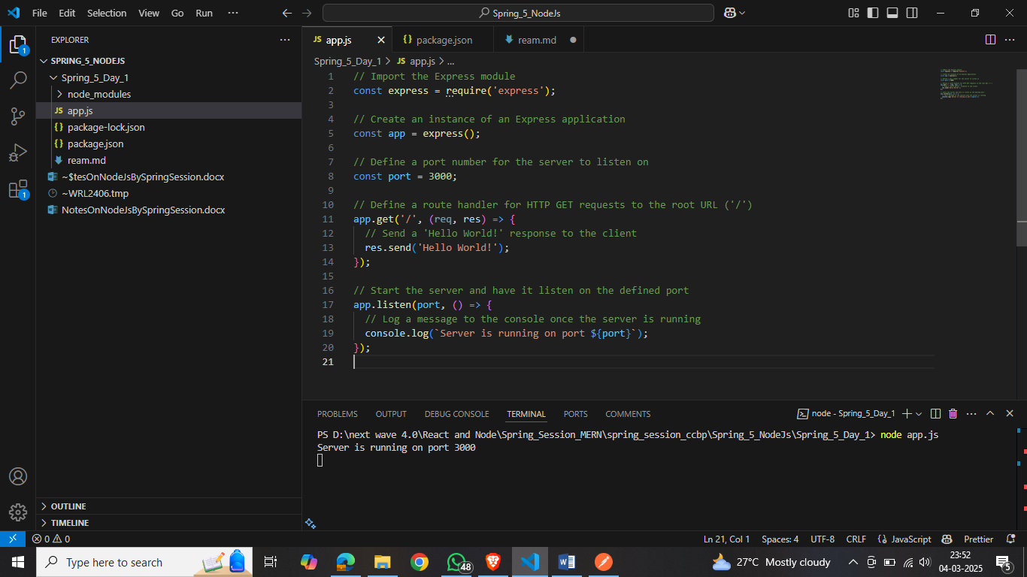

**Explanation:**

* **Import the Express module:** This line imports the Express module, which is a minimal and flexible Node.js web application framework that provides a robust set of features for web and mobile applications.
* **Create an instance of an Express application:** Here, we create an instance of an Express application by calling the express() function. This app object will be used to define routes and middleware for our application.
* **Define a port number for the server to listen on:** We specify the port number (3000) on which the server will listen for incoming requests.
* **Define a route handler for HTTP GET requests to the root URL ('/'):** This line sets up a route handler that listens for GET requests to the root URL ('/'). When such a request is received, the provided callback function is executed.
* **Send a 'Hello World!' response to the client:** Within the callback function, we use the res.send() method to send the string 'Hello World!' as a response to the client.
* **Start the server and have it listen on the defined port:** The app.listen() method starts the server and makes it listen for incoming connections on the specified port.
* **Log a message to the console once the server is running:** Once the server is up and running, the callback function passed to app.listen() is executed, logging a message to the console to indicate that the server is operational.

This code sets up a basic Express.js server that responds with 'Hello World!' when a GET request is made to the root URL. For more information and examples, you can refer to the official Express.js documentation.

<https://developer.mozilla.org/en-US/docs/Learn_web_development/Extensions/Server-side/Express_Nodejs/Introduction>

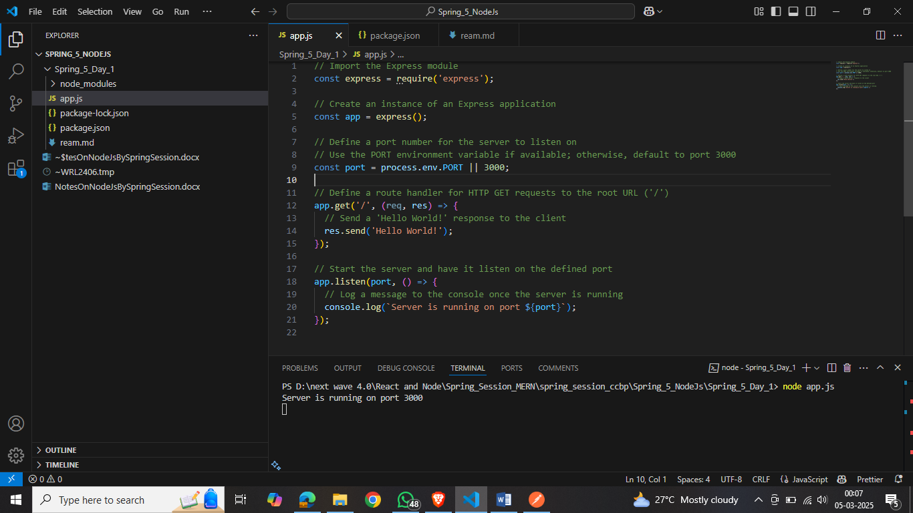

In this example:

* process.env.PORT retrieves the port number set by the environment.
* If process.env.PORT is undefined, the server defaults to port 3000.

**Benefits of Using process.env.PORT:**

* **Flexibility:** Allows the application to adapt to various environments without code modifications.
* **Compatibility:** Ensures the application listens on the port specified by hosting providers, which may assign ports dynamically.
* **Avoiding Conflicts:** Reduces the risk of port conflicts when multiple applications run on the same server.

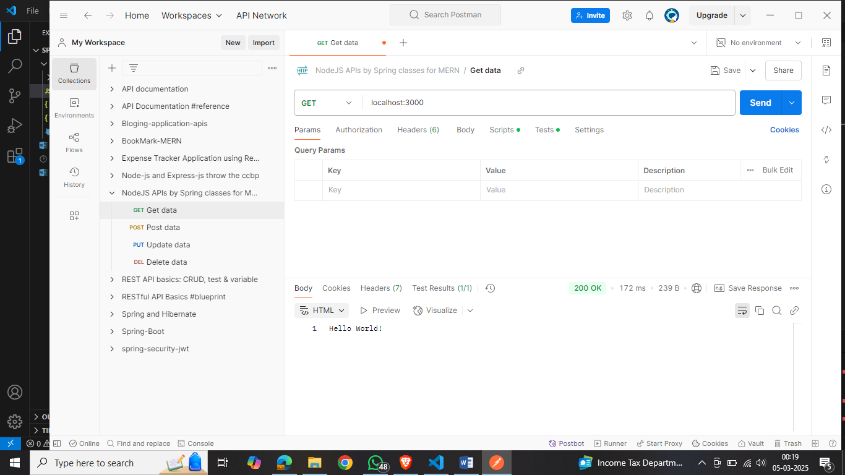

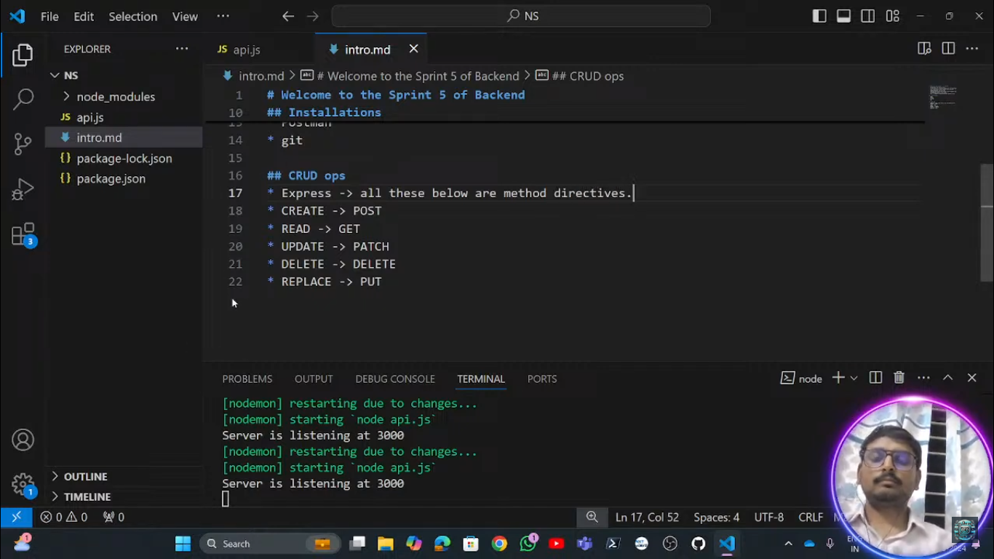

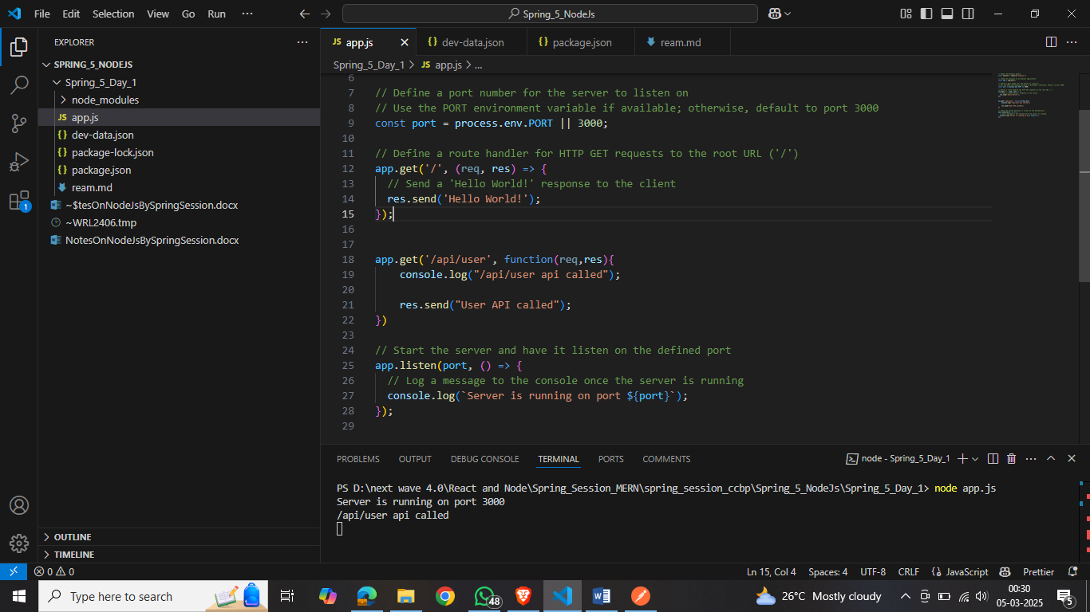

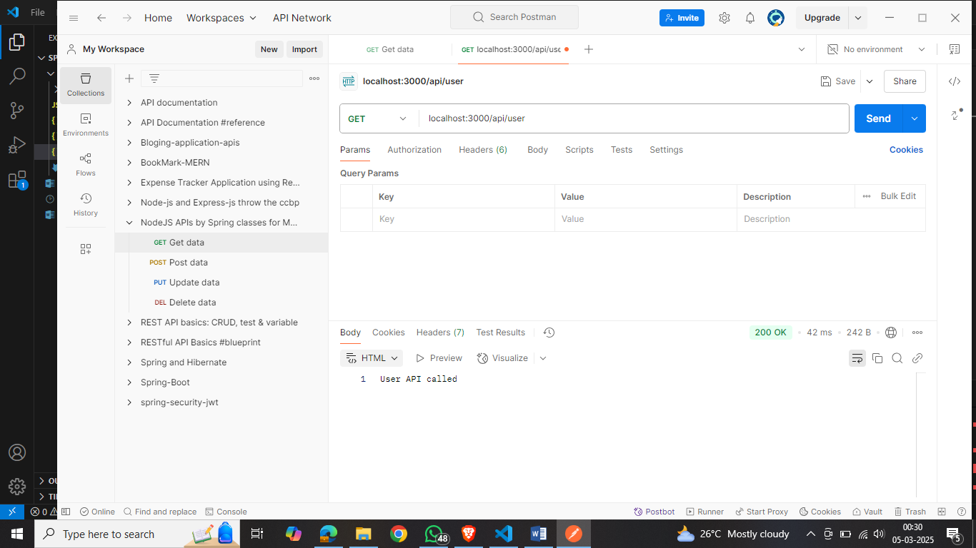

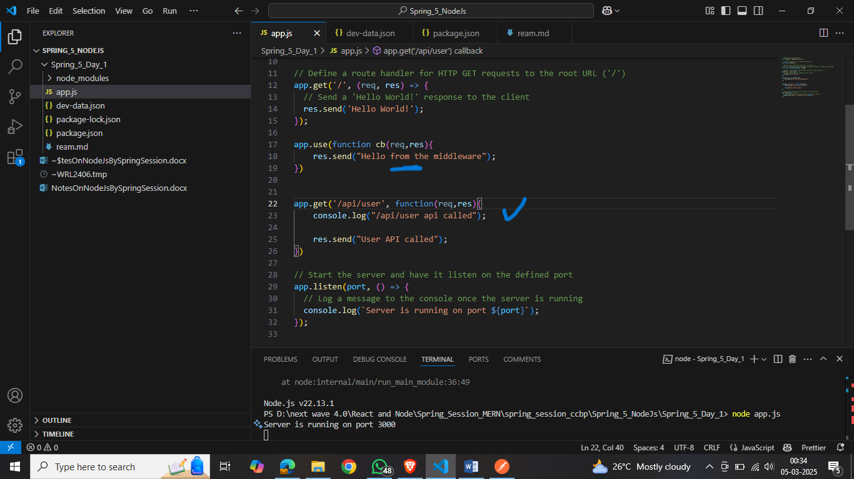

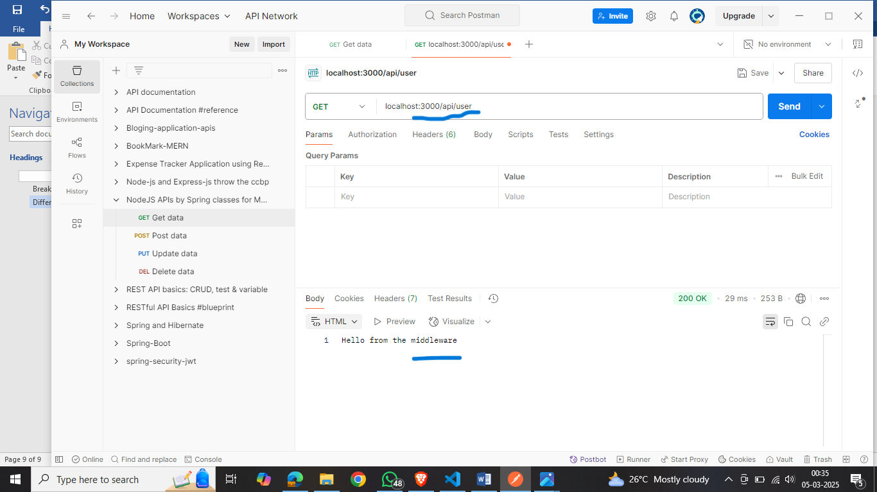

Here we are not getting the currect respose because

In Express.js, middleware functions are executed in the order they are defined. citeturn0search2 This sequential execution means that if a middleware function sends a response without calling next(), subsequent middleware and route handlers won't be executed.

In your code, the middleware function defined by app.use(function cb(req, res) { res.send("Hello from the middleware"); }) is placed before the /api/user route handler. When a request matches this middleware, it sends a response and doesn't call next(), preventing the /api/user route handler from being reached.

**Solution:**

To ensure that the /api/user route handler is executed, you should place the middleware function after all route handlers or modify it to call next() so that the request can proceed to the next matching route. Here's how you can adjust your code:

**Option 1: Move the Middleware After Route Handlers**

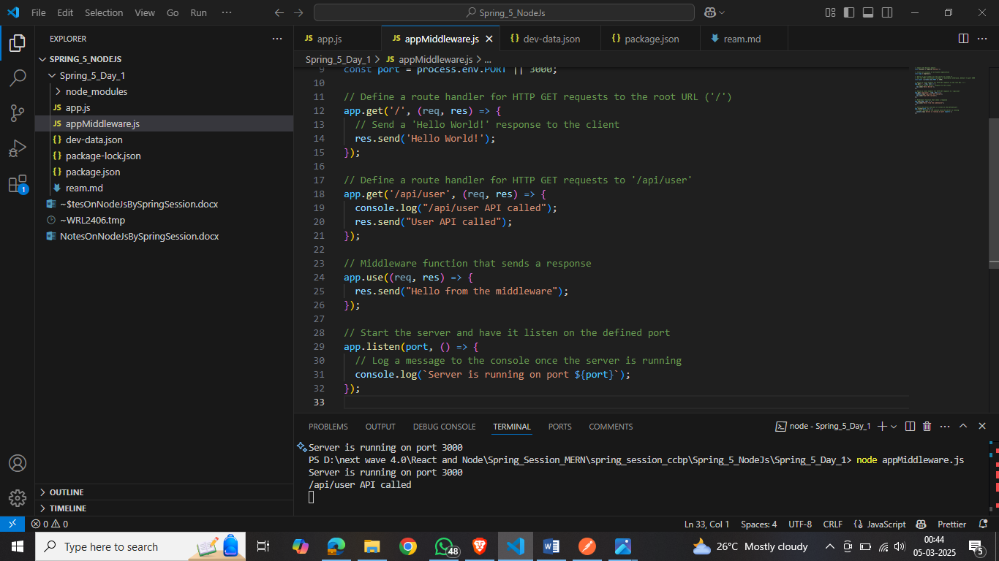

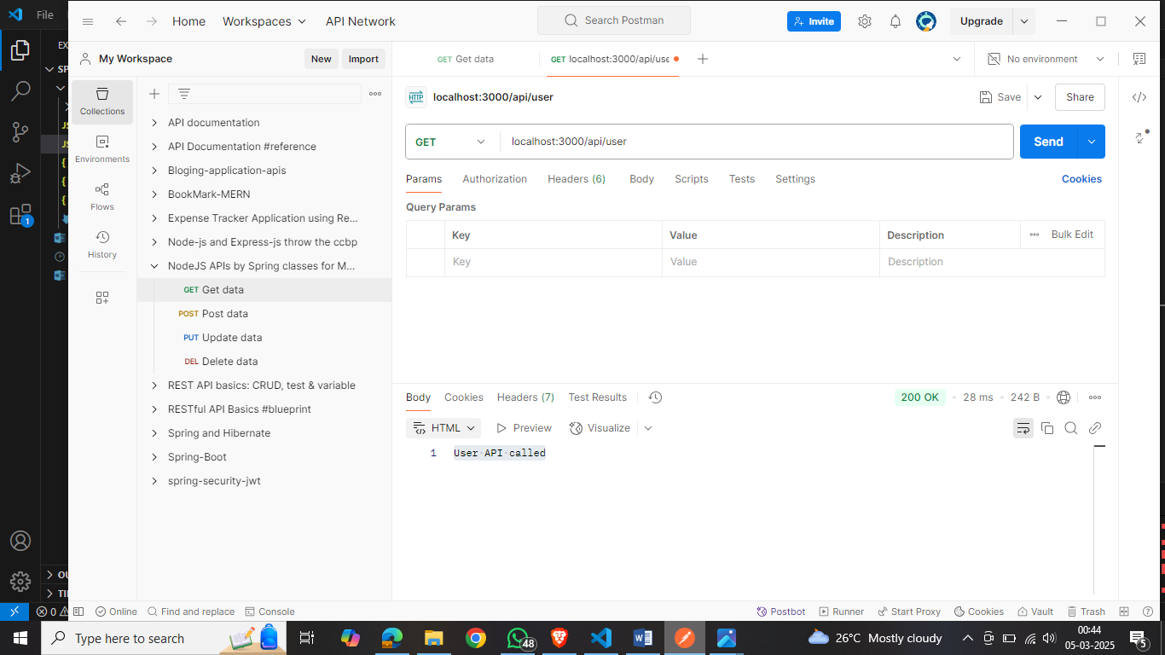

**Option 2: Modify the Middleware to Call next()**

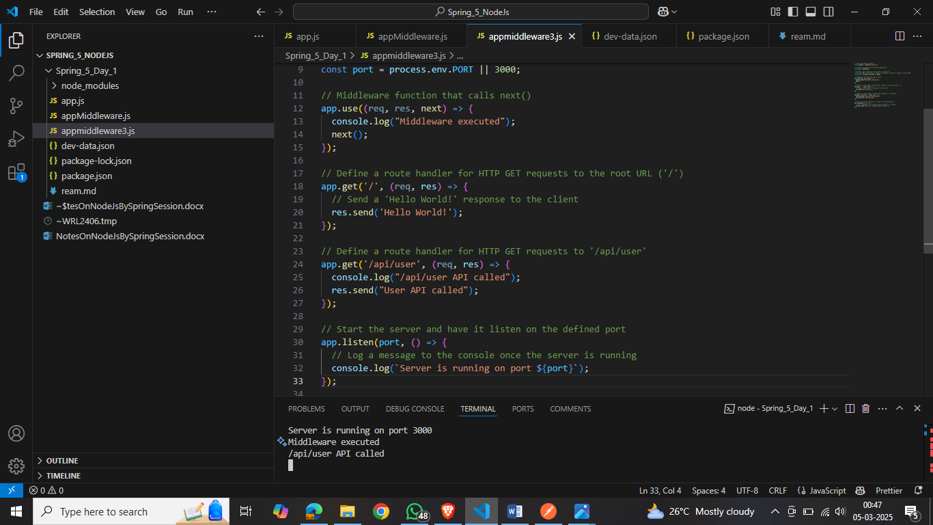



By either moving the middleware function after the route handlers or ensuring it calls next(), you allow the /api/user route handler to be reached and executed as intended.

---------------------------------Dy02------------------

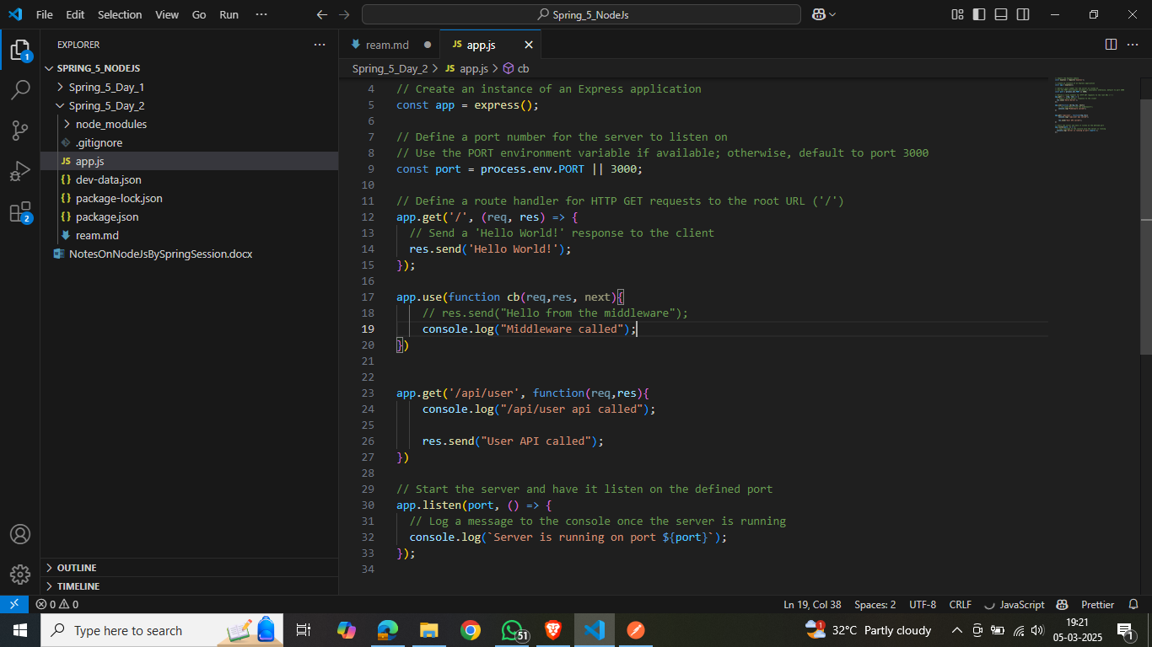

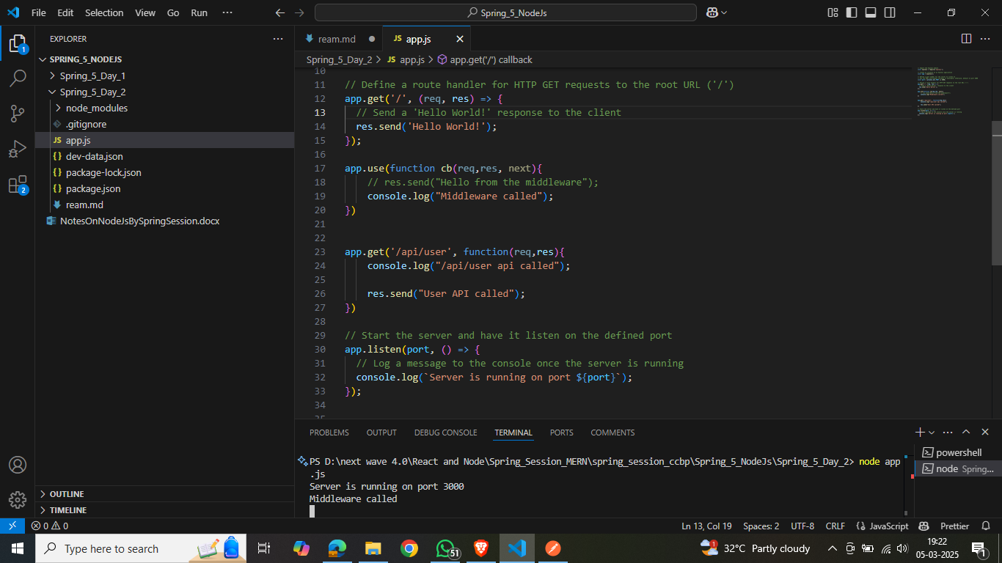

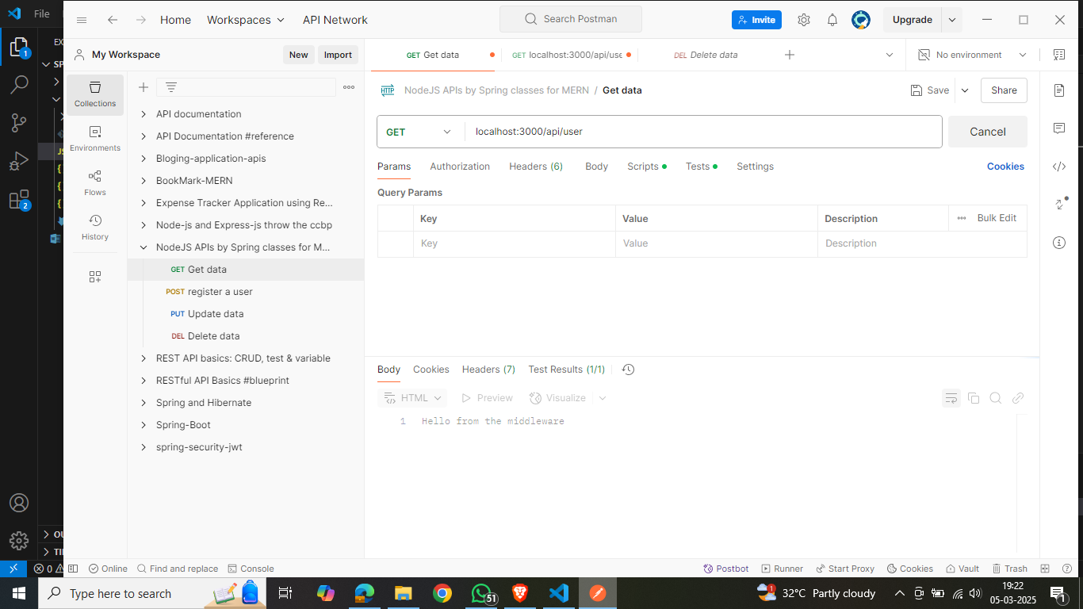

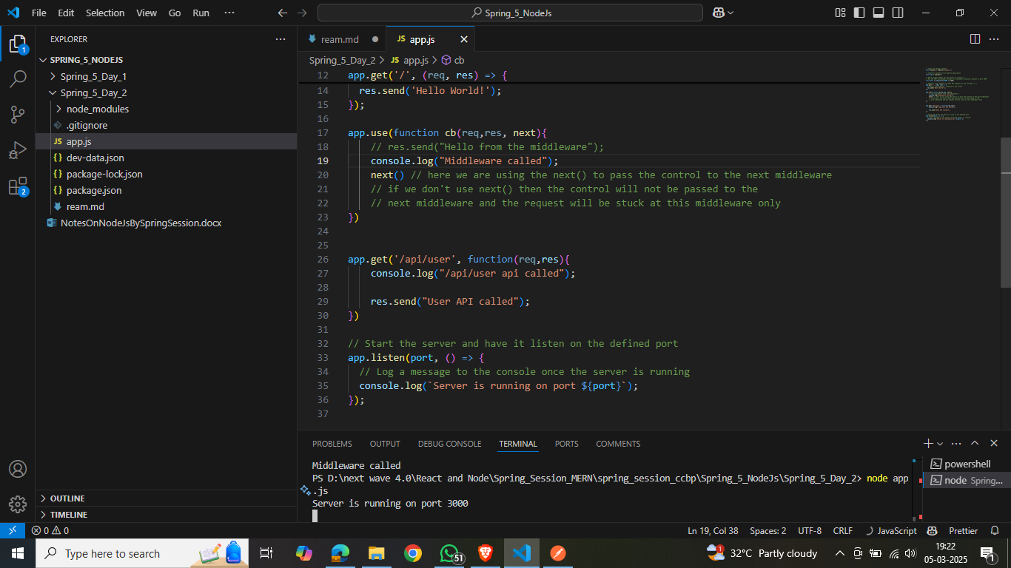

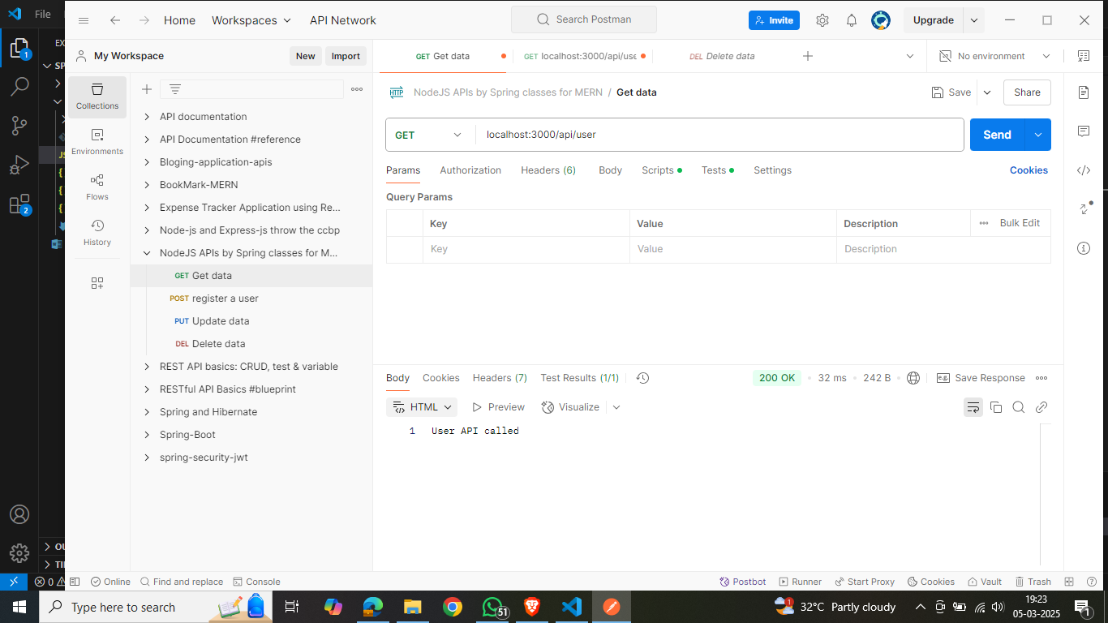

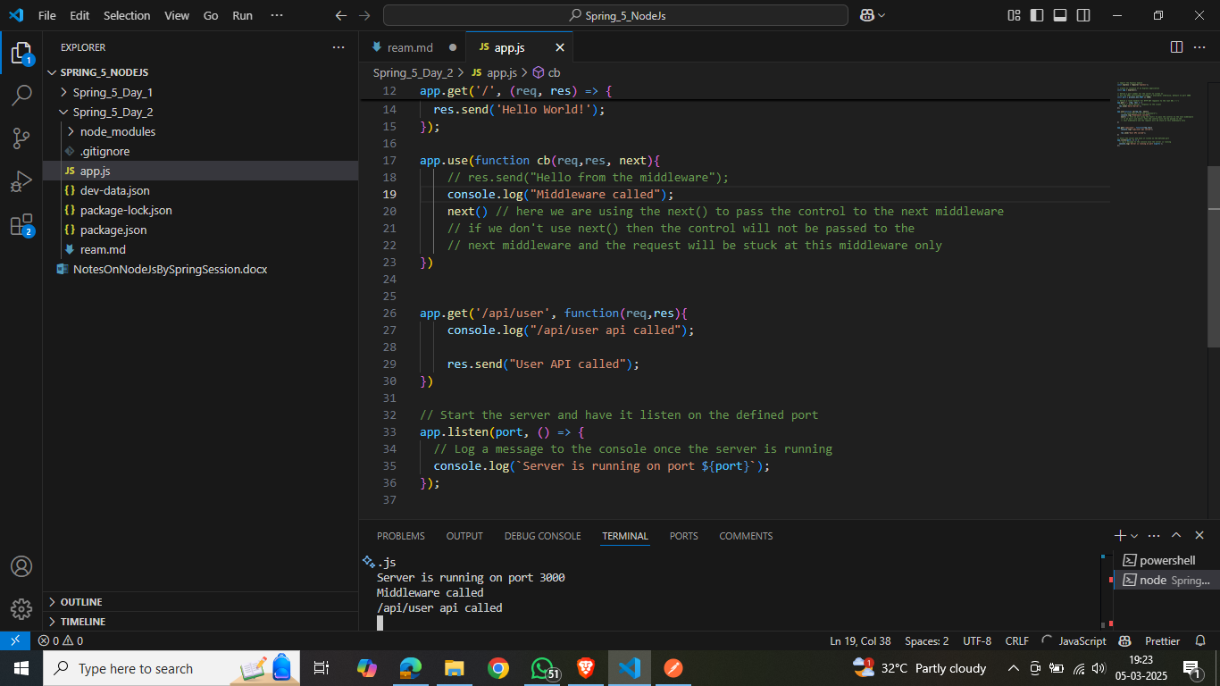

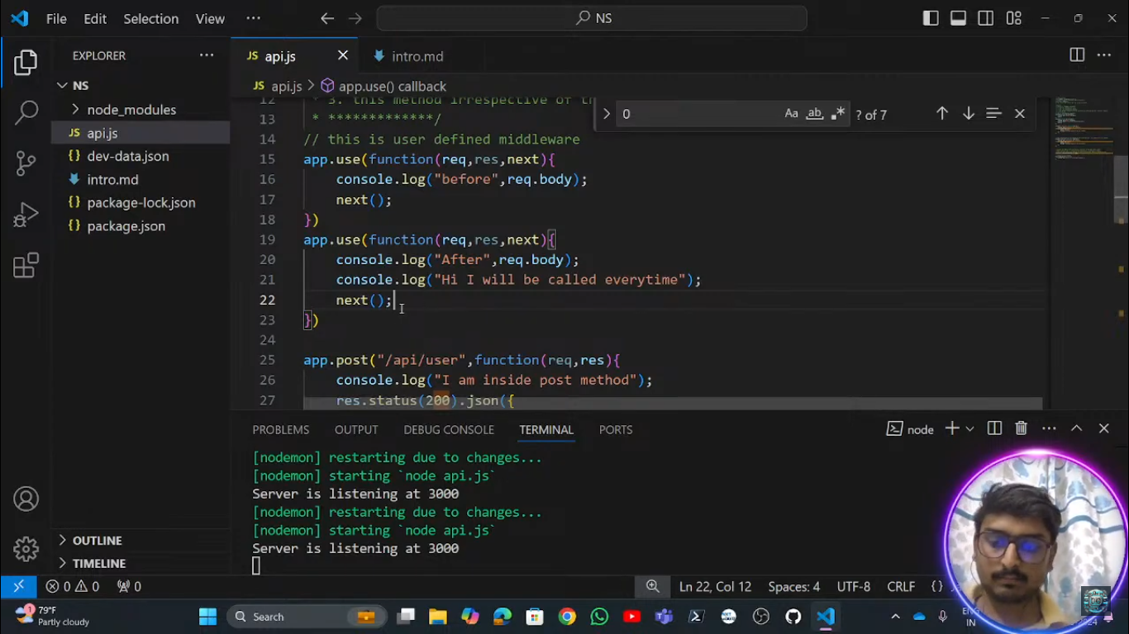

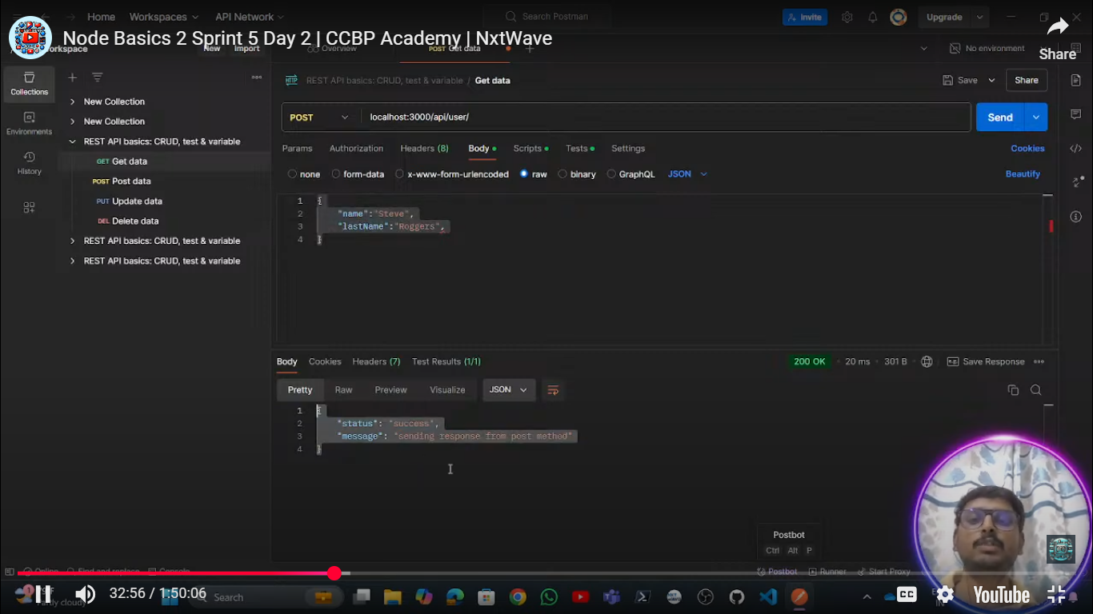’

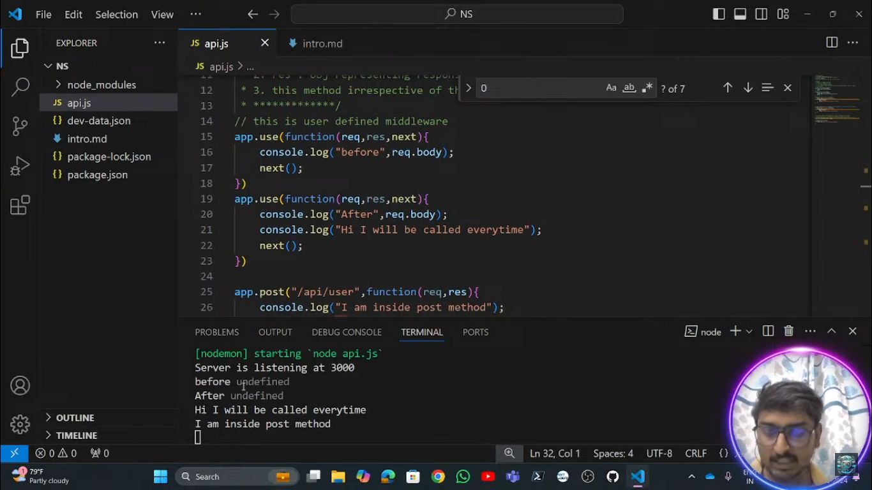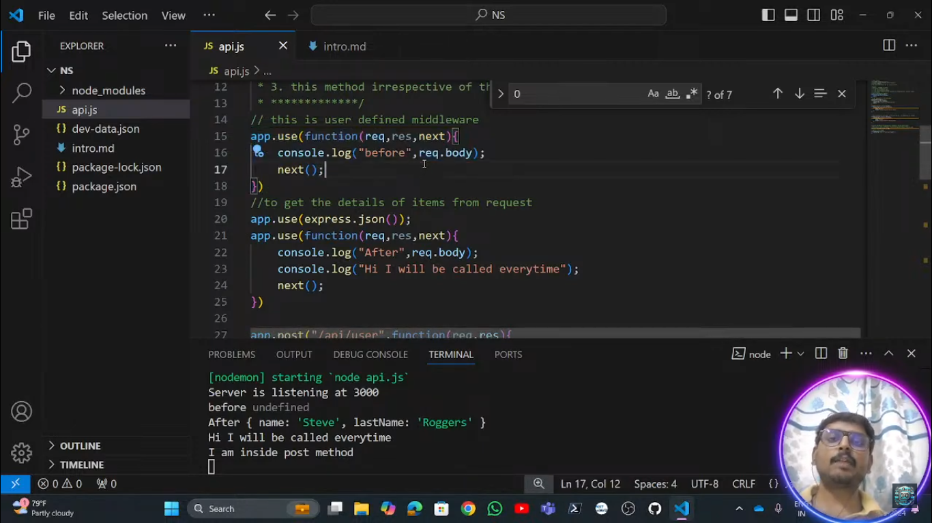

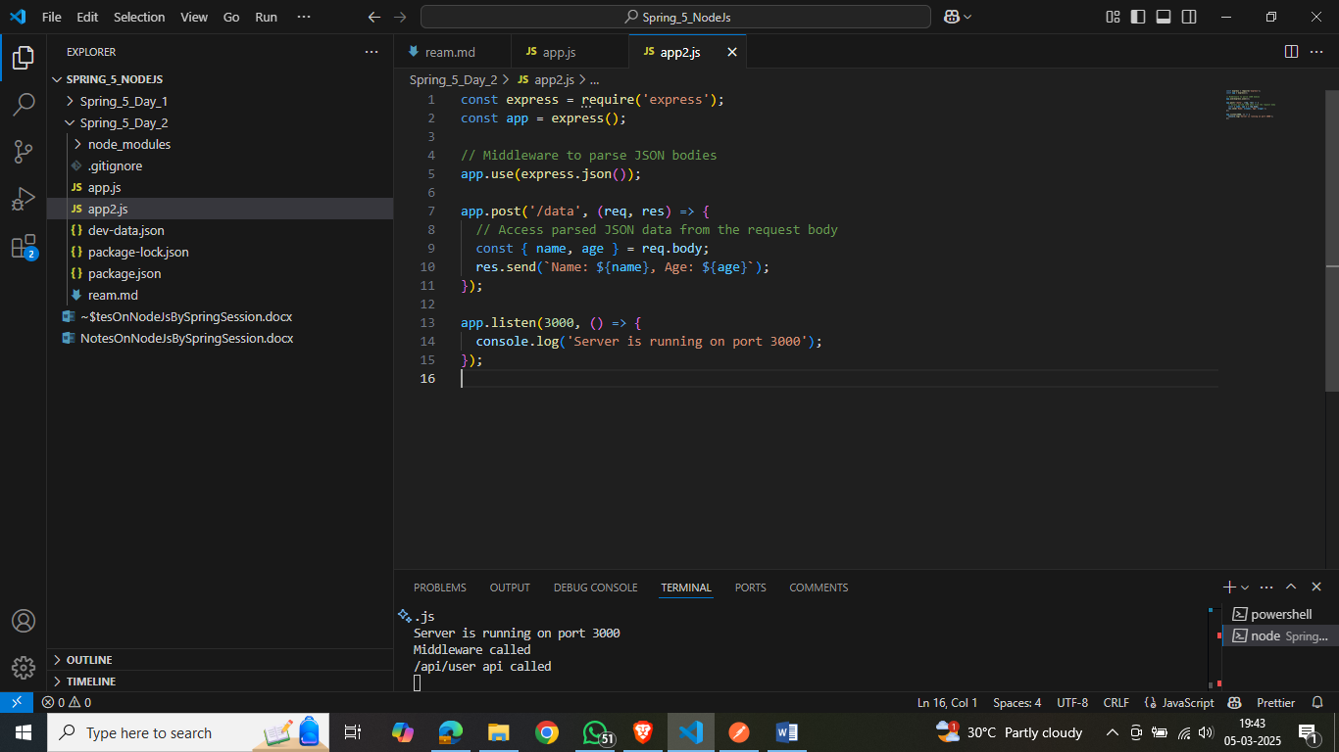

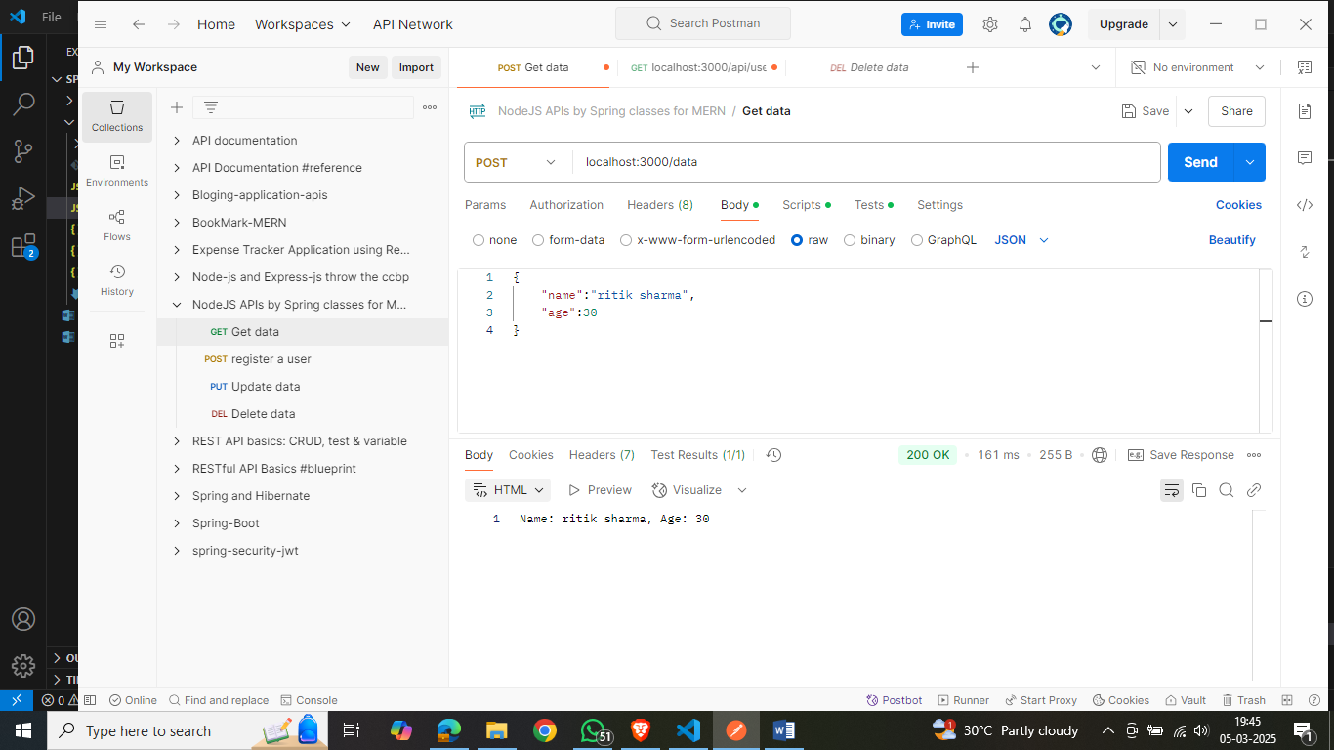

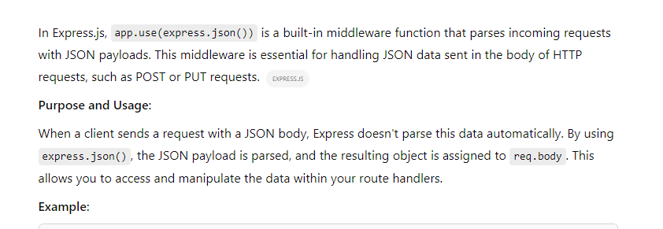

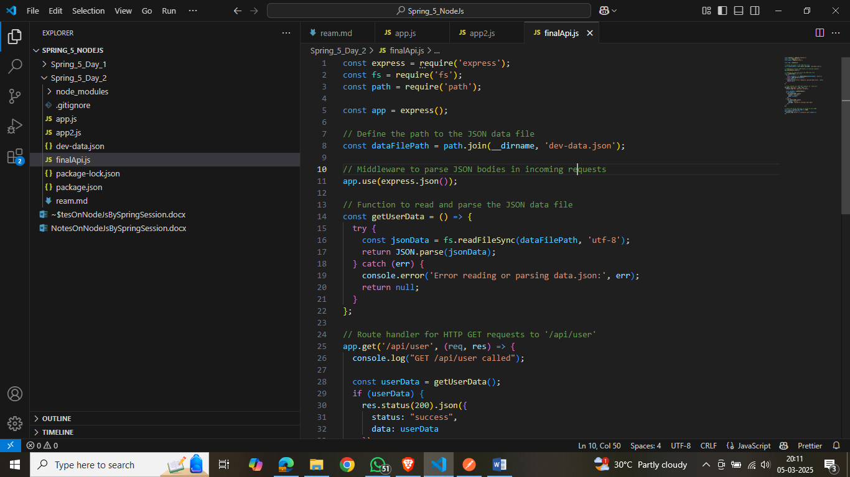

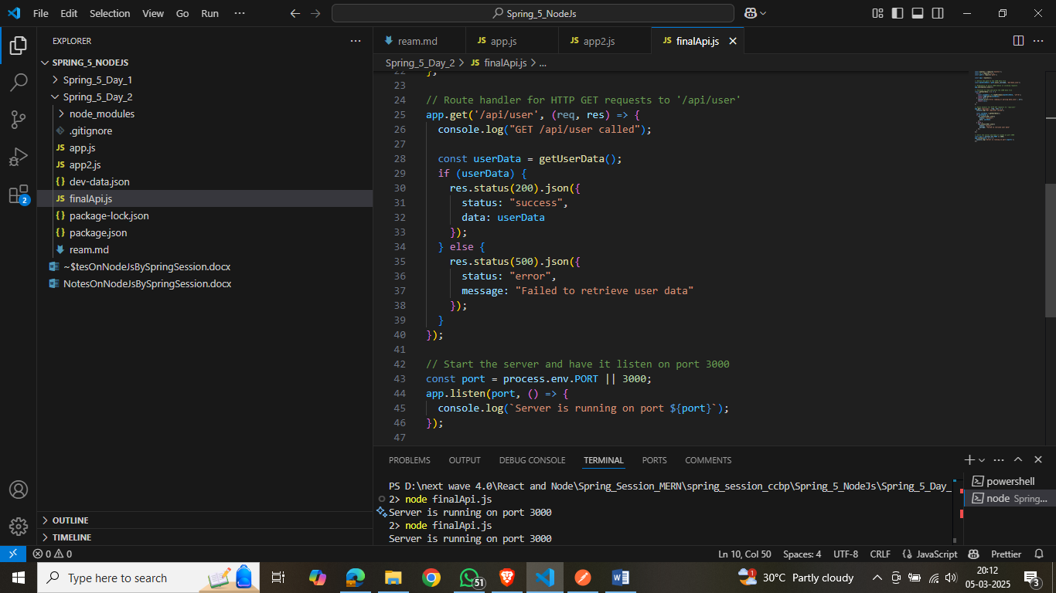

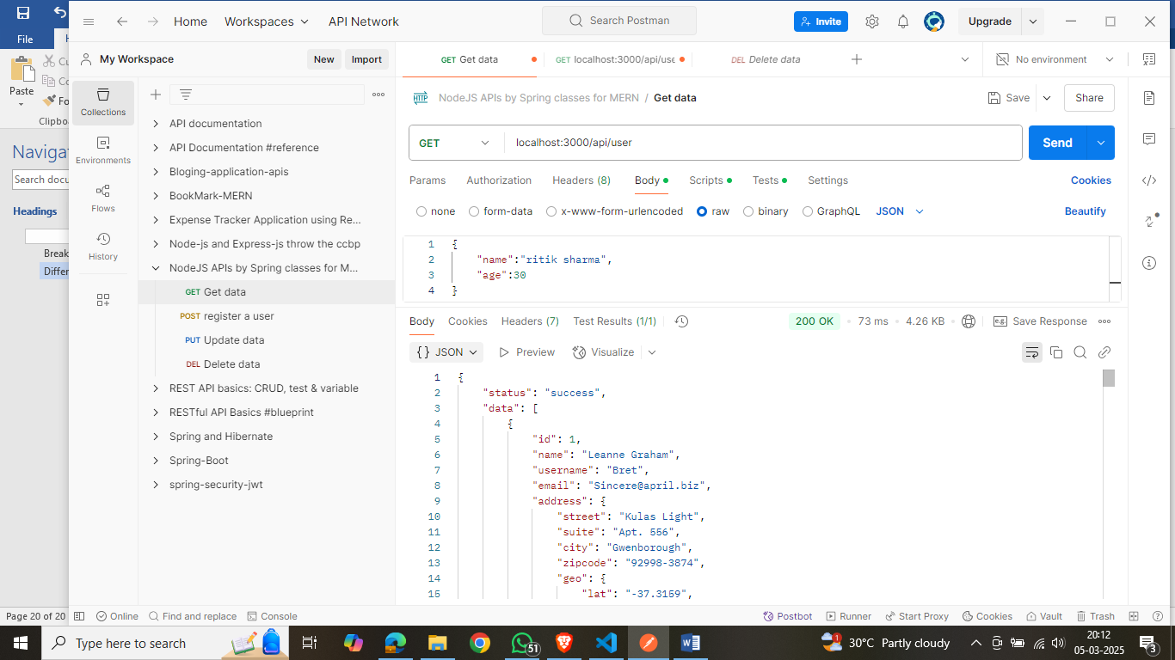

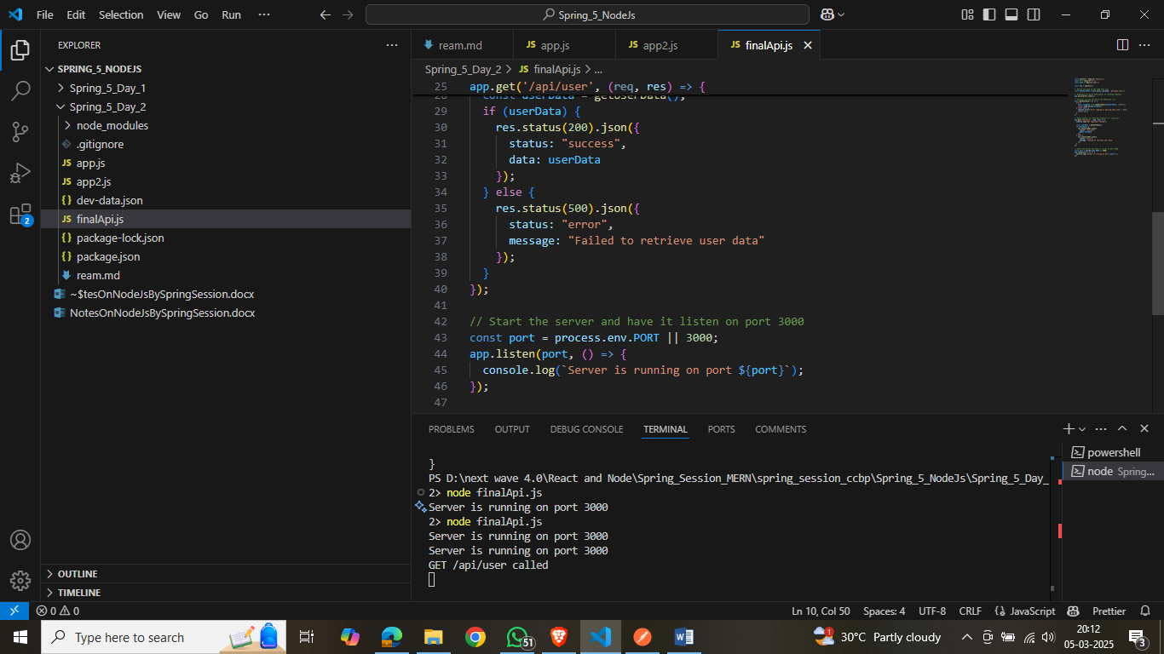

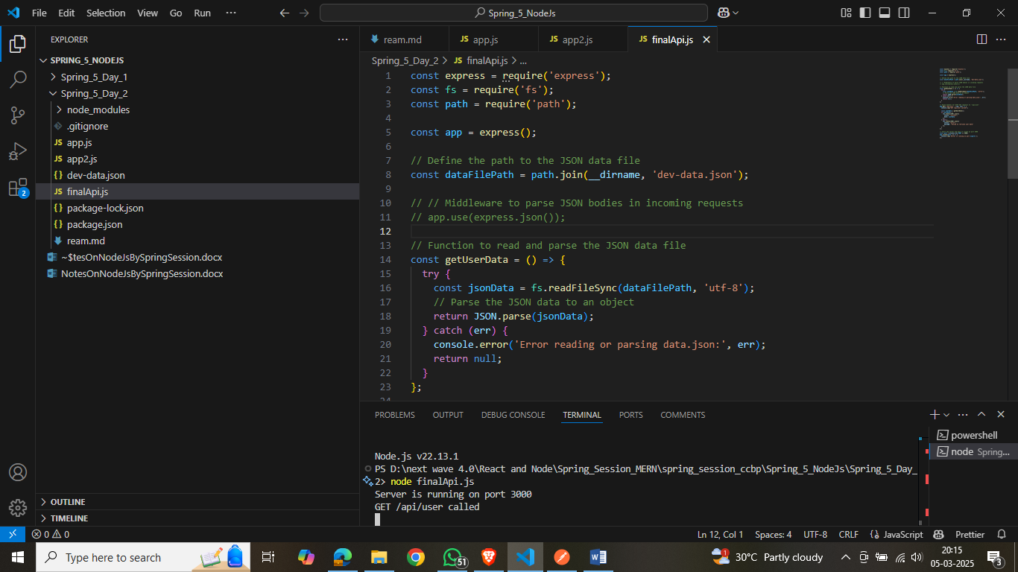

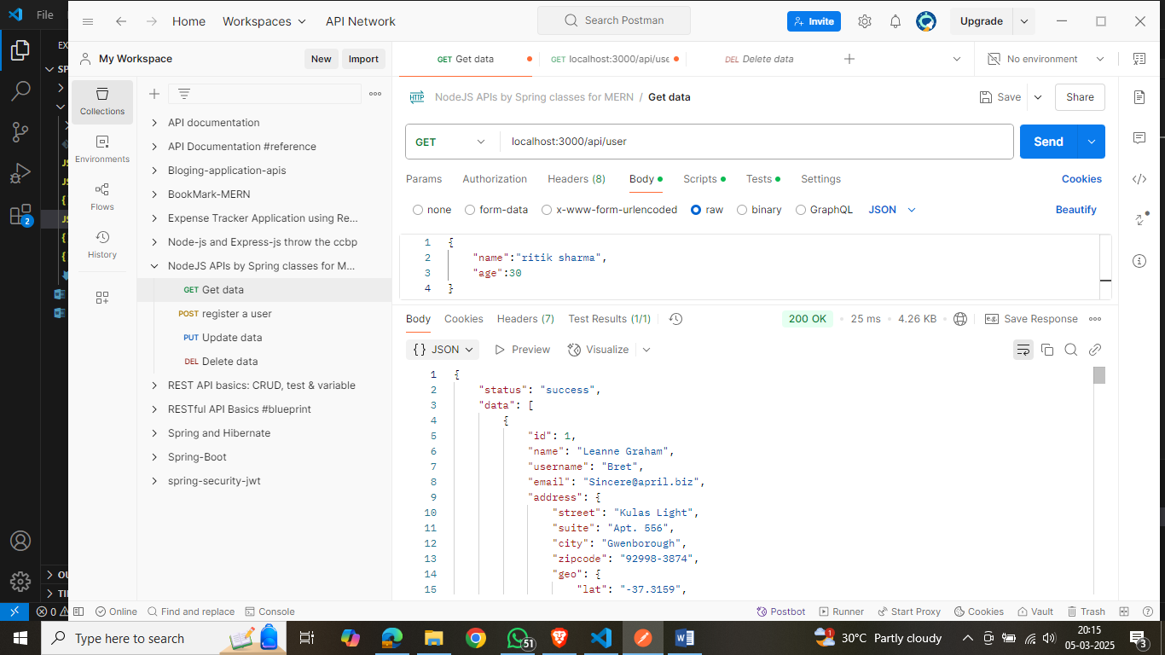

Here without use of app.use(express.json());

We are able to see the data in json format beasue we have to use this when we are getting the data from the request and convert it into json but here we are sending the json not getting from reuest we are responding here.

Day-3:

Creating a .env file:

**what is use of .env file**

**What is the Use of a .env File?**

A .env file (short for "environment file") is used to **store environment variables** in a secure and organized way. It helps keep sensitive information **hidden** from the codebase and makes configurations **more flexible** across different environments (development, testing, production).

**Why Use a .env File?**

✅ **Security** – Keeps **sensitive data** (API keys, database credentials) out of the codebase.  
✅ **Flexibility** – Easily switch configurations for **different environments**.  
✅ **Maintainability** – Centralized location for **configurable settings**.  
✅ **Prevents Accidental Commits** – Usually added to .gitignore to avoid exposing secrets in version control.

**How to Use a .env File in Node.js?**

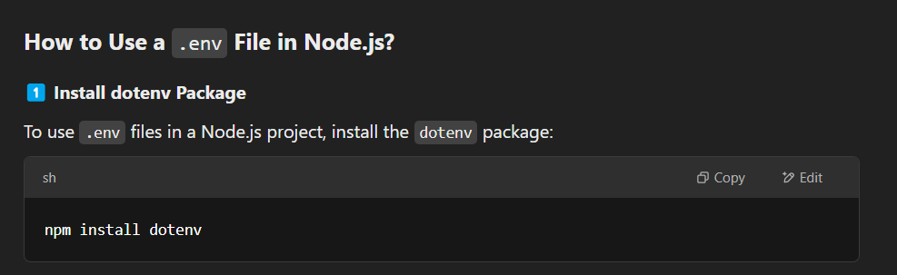

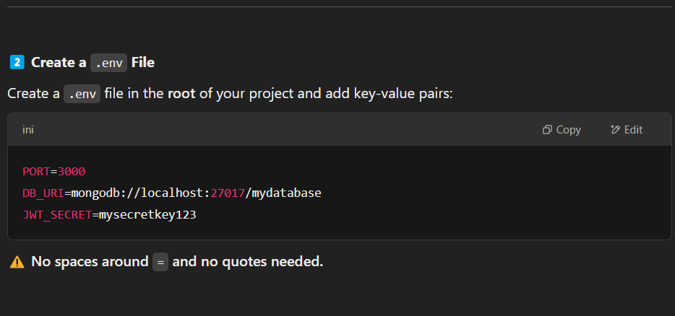

**3️. Load .env Variables in app.js**

In your **main server file (app.js or server.js)**, import dotenv and configure it:

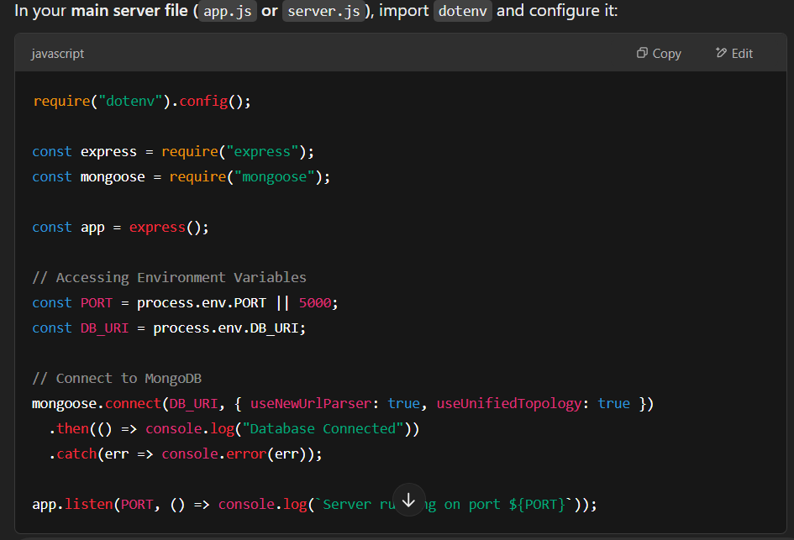

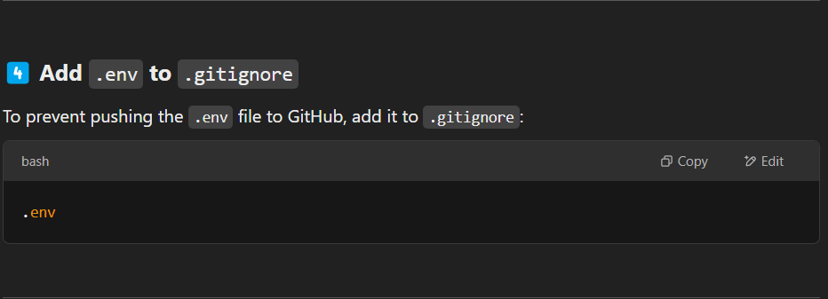

**Use Cases of .env File**

🔹 Storing **API Keys** (e.g., Google, OpenAI, Stripe)  
🔹 Managing **Database Credentials** (MongoDB, MySQL, PostgreSQL)  
🔹 Setting **JWT Secrets** for authentication  
🔹 Configuring **Server Port**  
🔹 Setting **Third-Party Service Credentials**

**Best Practices**

✅ **Never commit .env files** to repositories (use .gitignore).  
✅ Use **environment variable placeholders** in your code.  
✅ In production, use **server environment variables** instead of .env files directly.

**Conclusion**

The .env file is **essential** for handling configurations securely and keeping sensitive data **outside the source code**. It improves security, flexibility, and maintainability in Node.js applications. 🚀

what is meaning of require("dotenv").config();

**Meaning of require("dotenv").config(); in Node.js**

The statement:

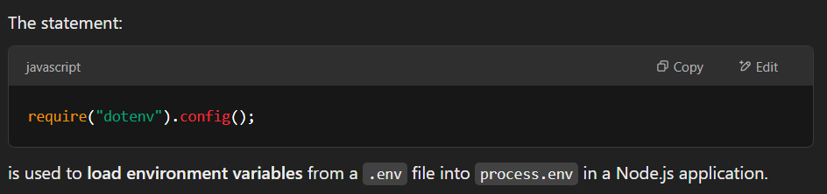

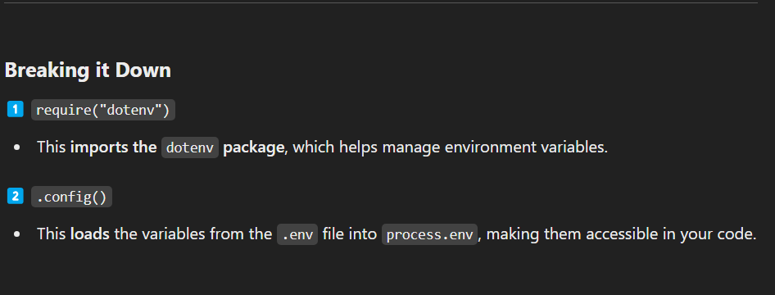

**Why Use dotenv.config()?**

✅ **Loads configuration automatically** from .env.  
✅ **Keeps sensitive data secure** (no hardcoded secrets).  
✅ **Makes deployments flexible** by allowing different configurations for different environments.

**Conclusion**

require("dotenv").config(); is a **must-use** in Node.js applications for securely managing environment variables. It helps keep secrets **out of your codebase** and makes your app **configurable and secure**. 🚀

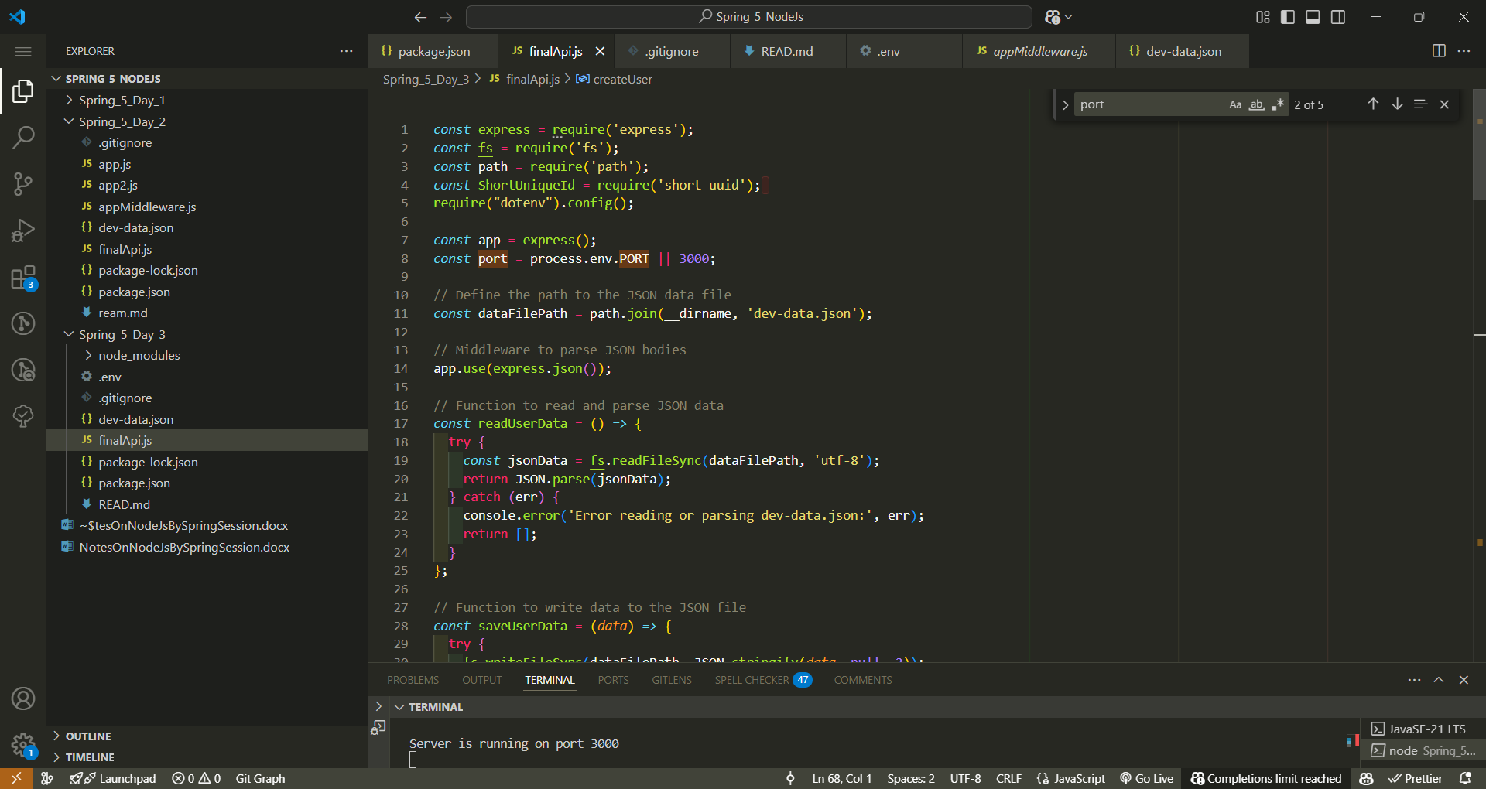

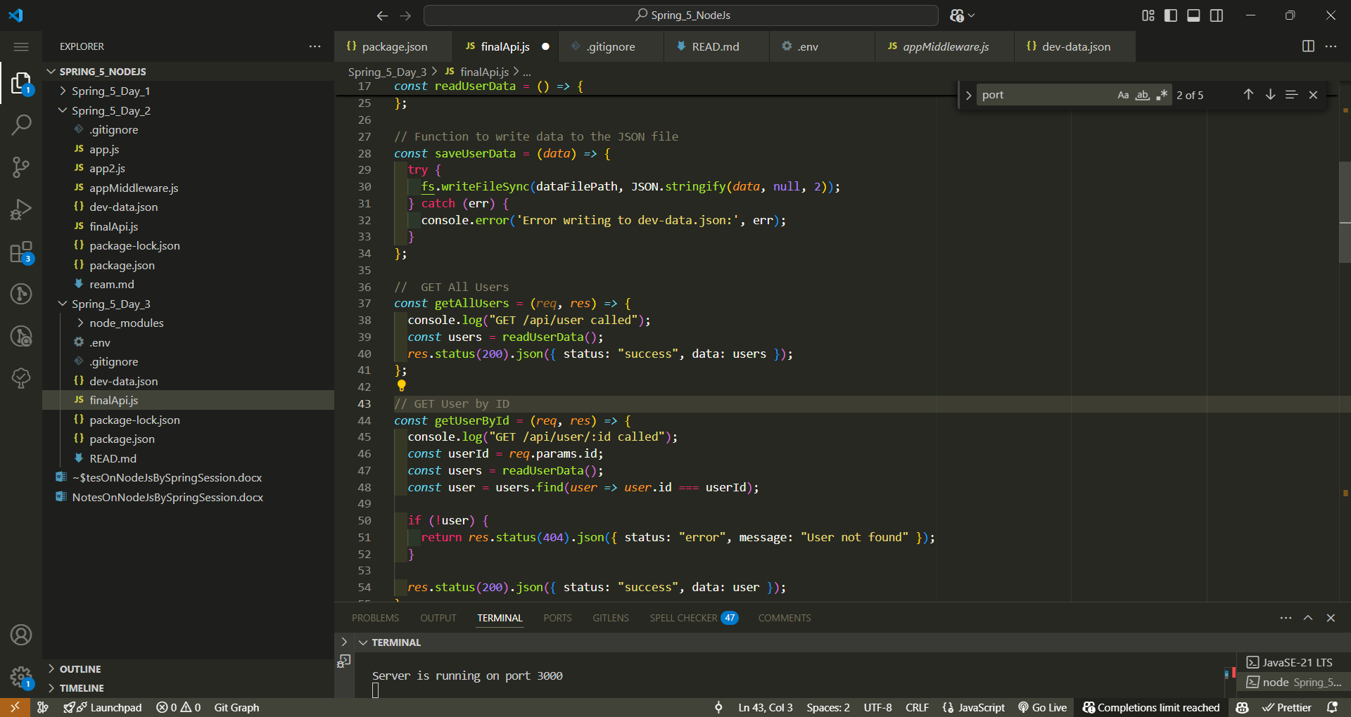

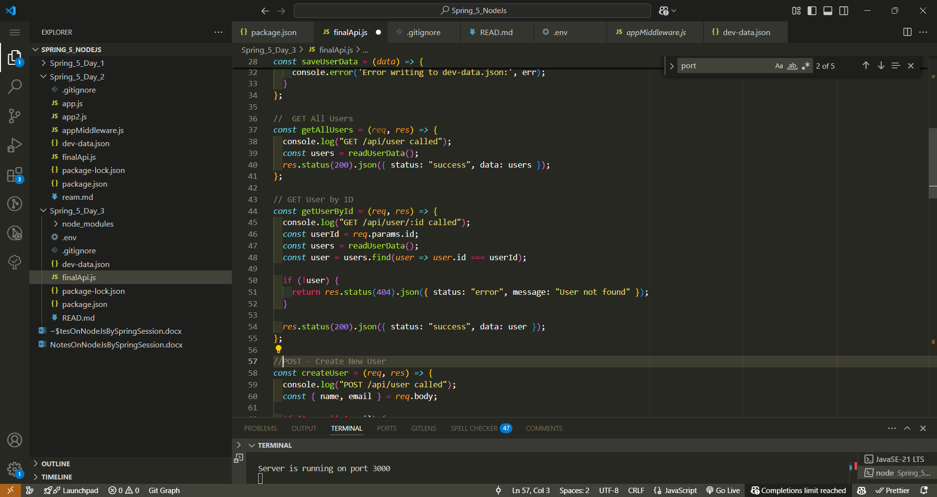

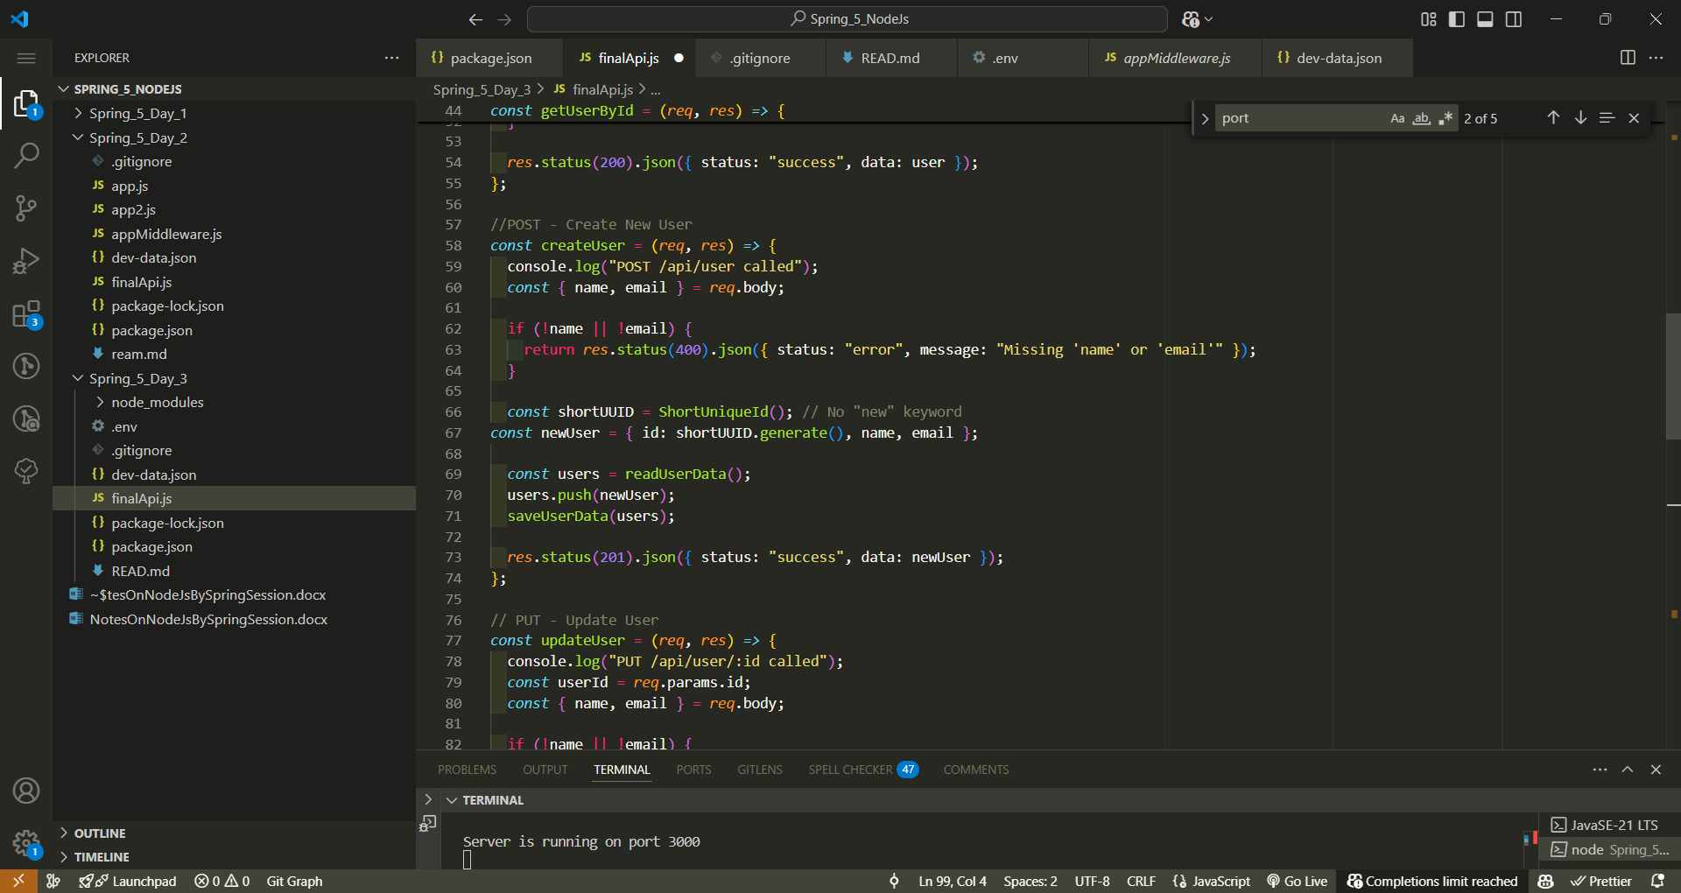

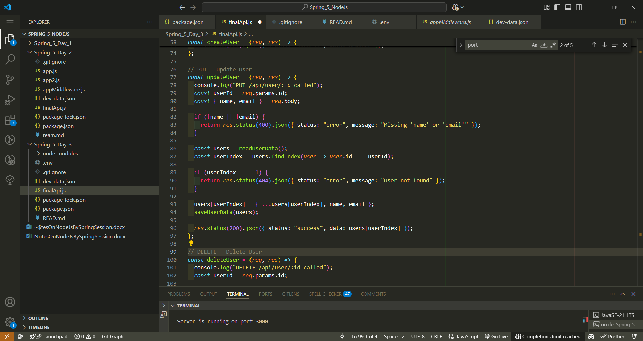

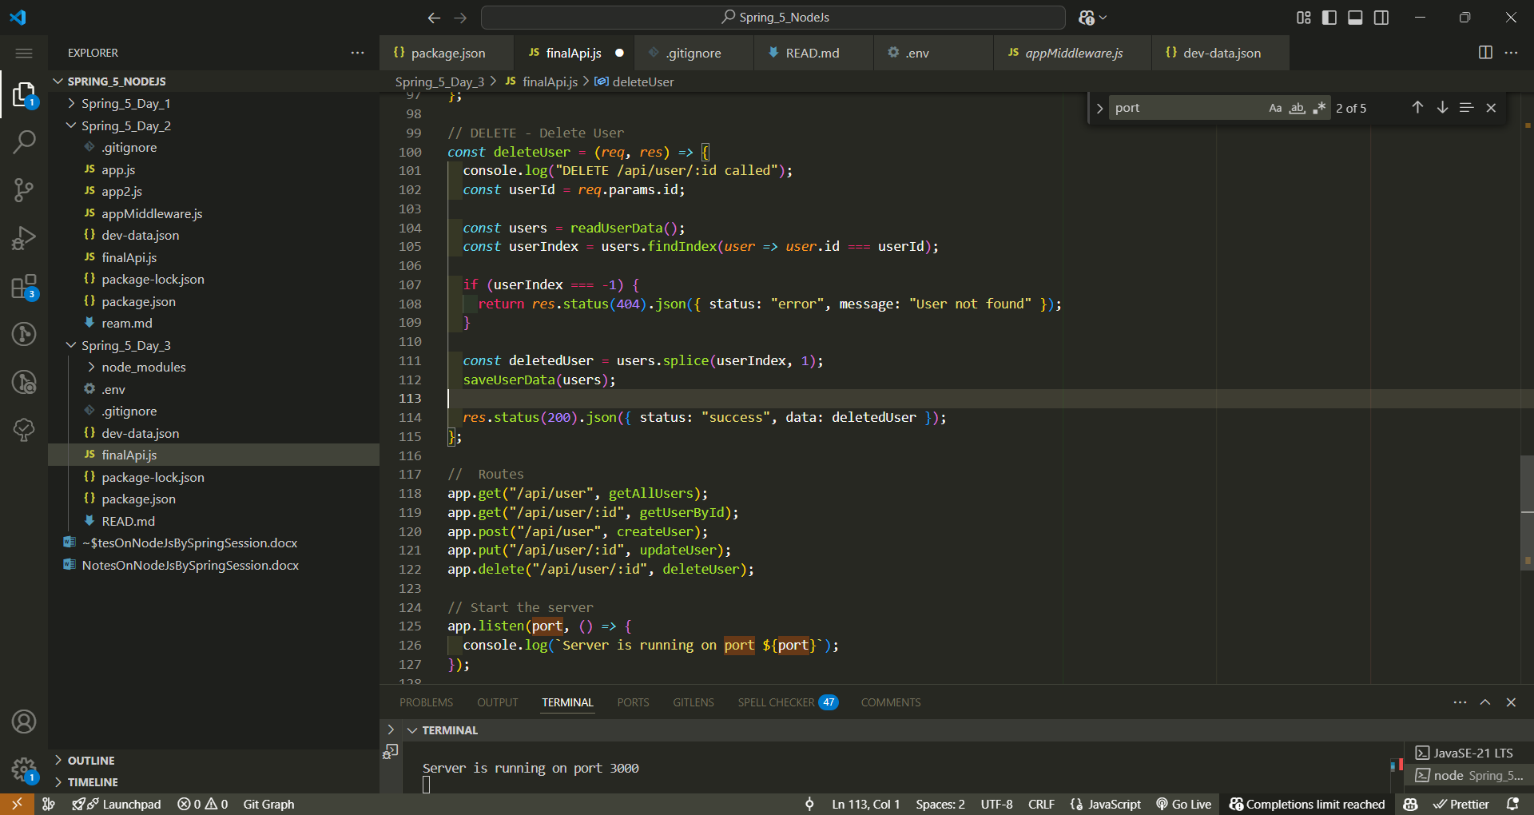

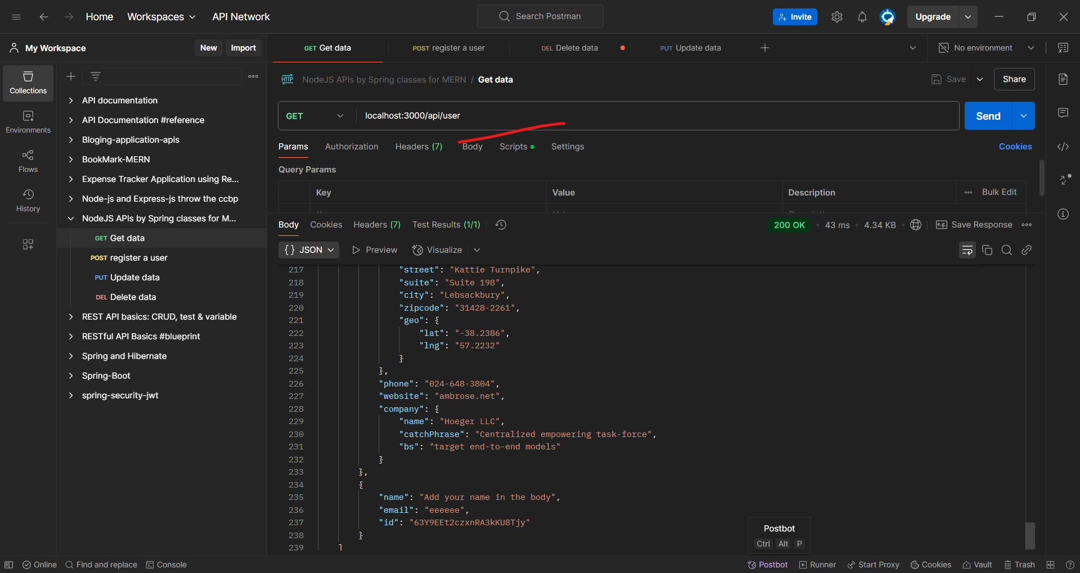

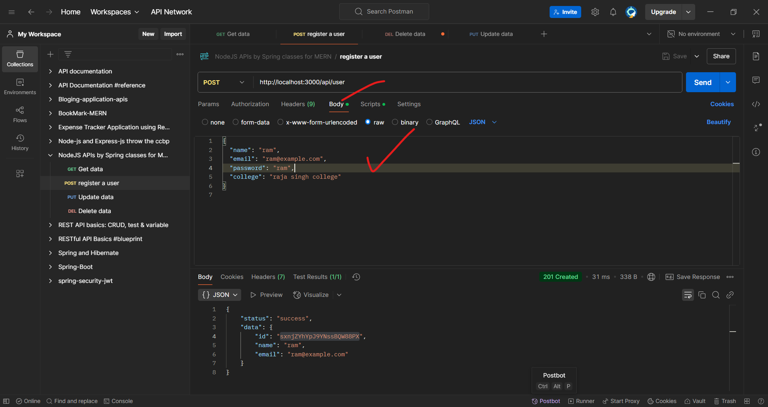

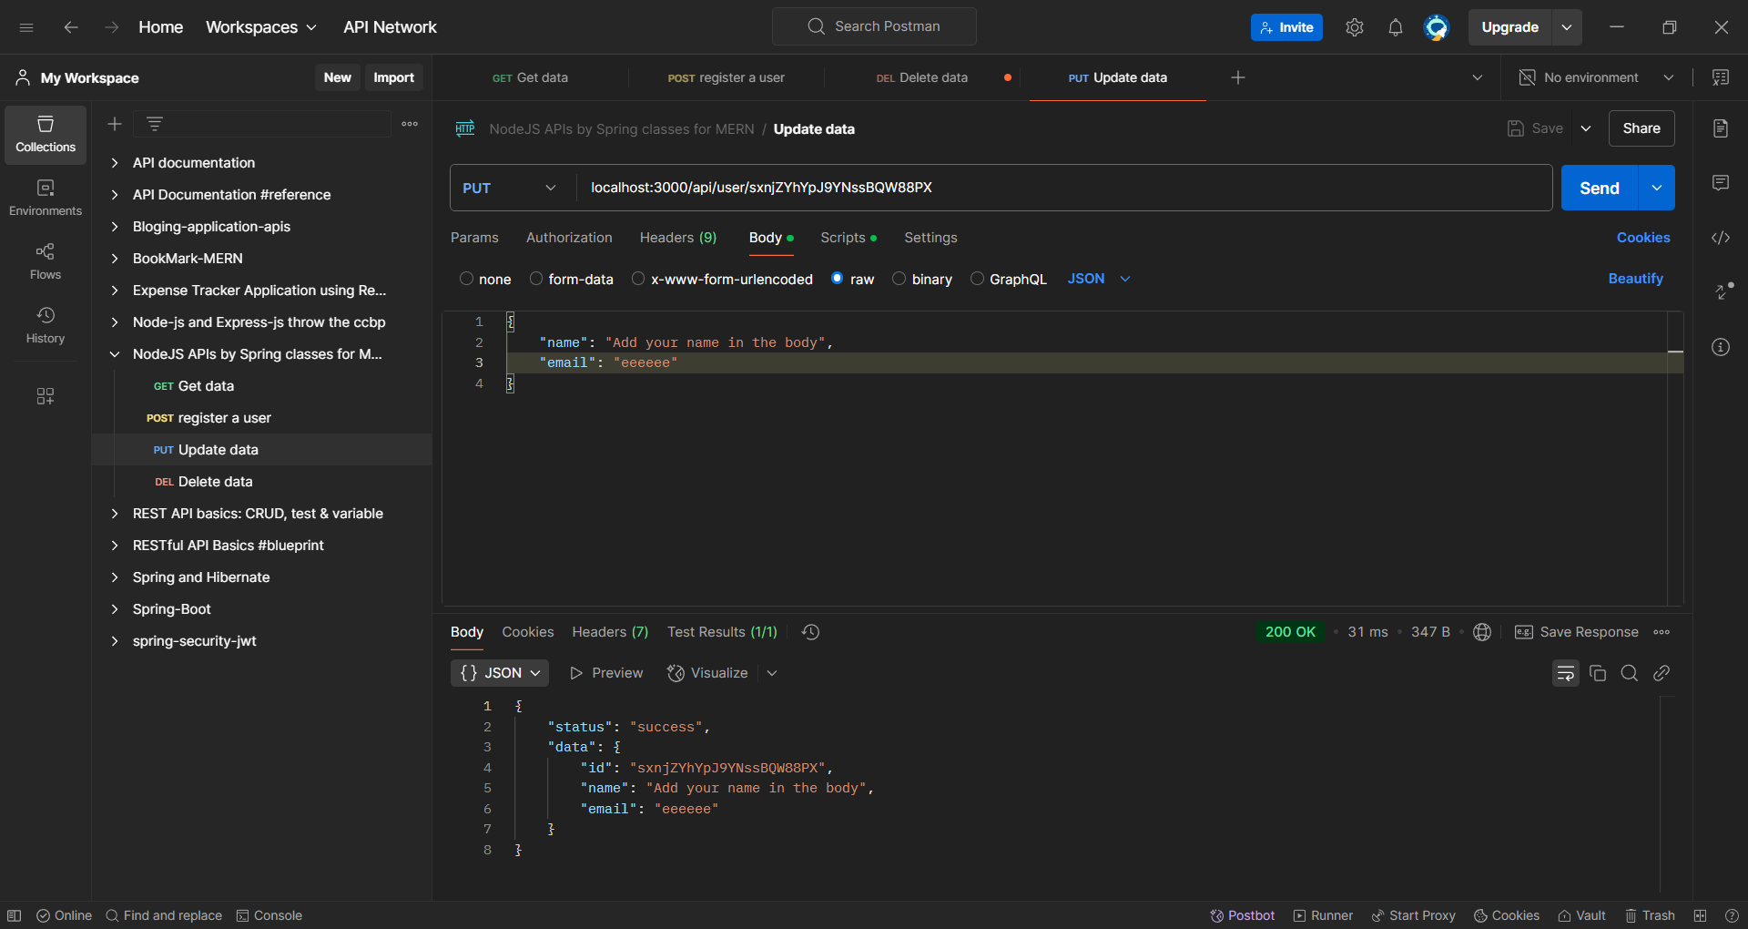

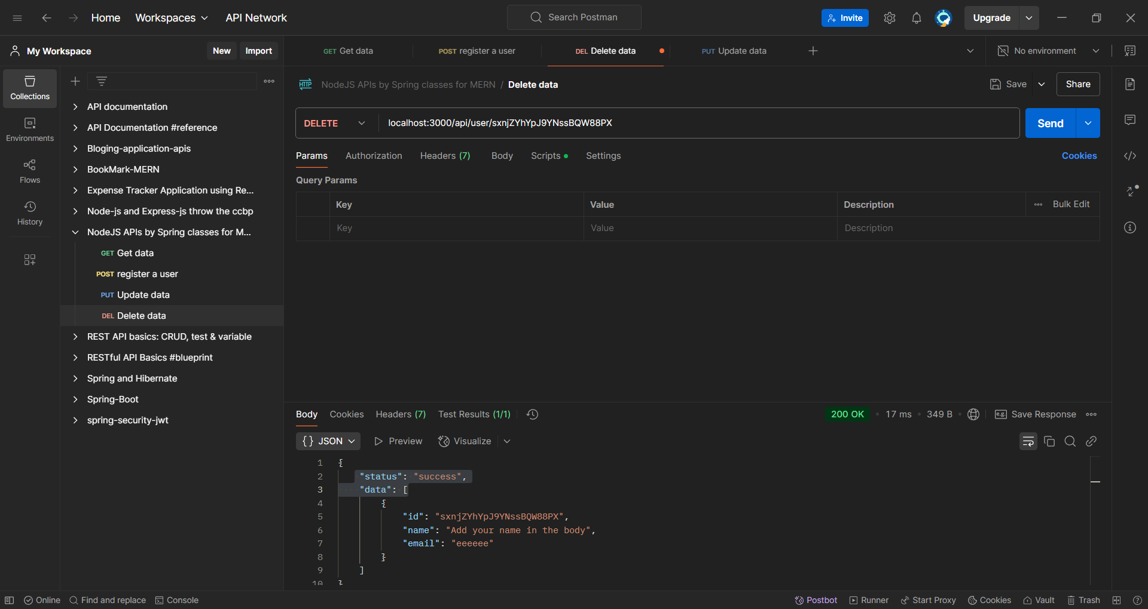

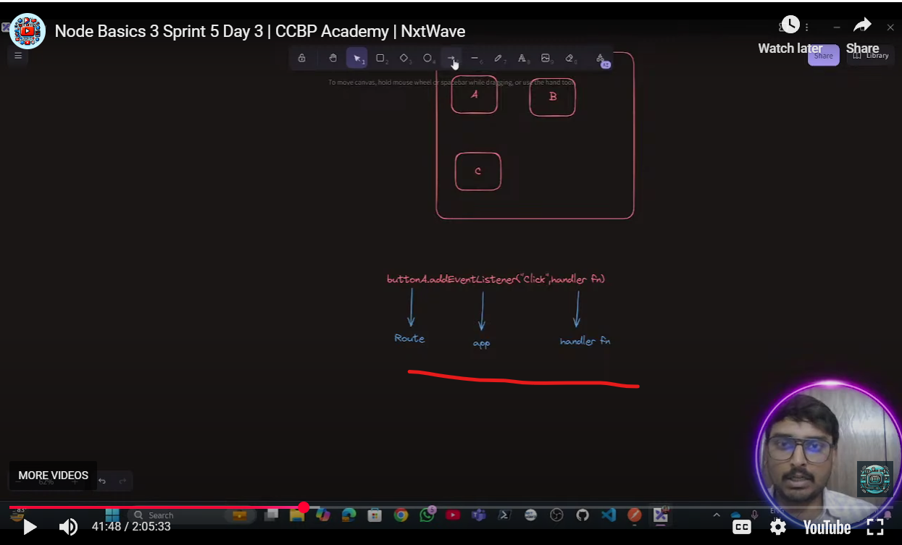

Here button role work route in backend:

addEventListener role work app in backend

and that handler function of front role work call-back function which is define in route

app.get(“/api/user”, call-backfunction);

get(“/api/user”)= it is as button(route);

call-backfunction = handler-function

app = addEventListenr

**## ------ working with database ---------------**

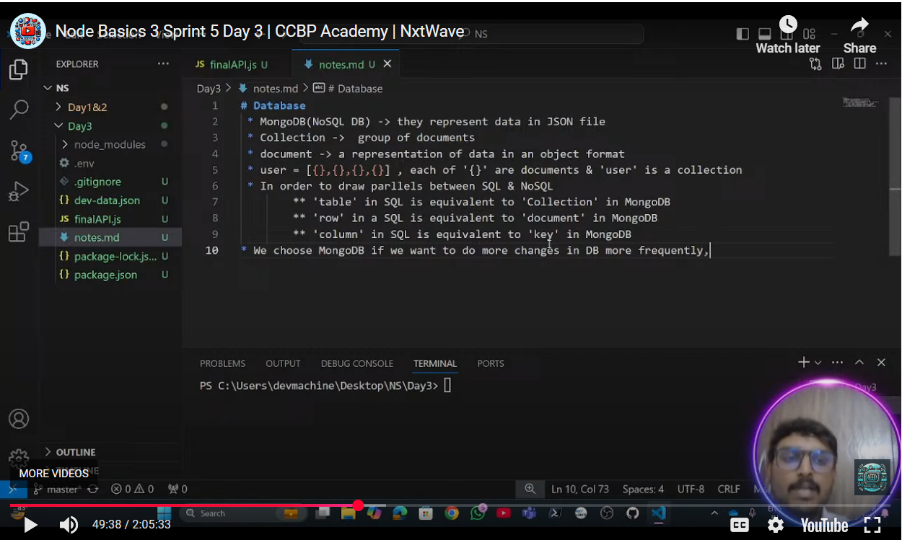

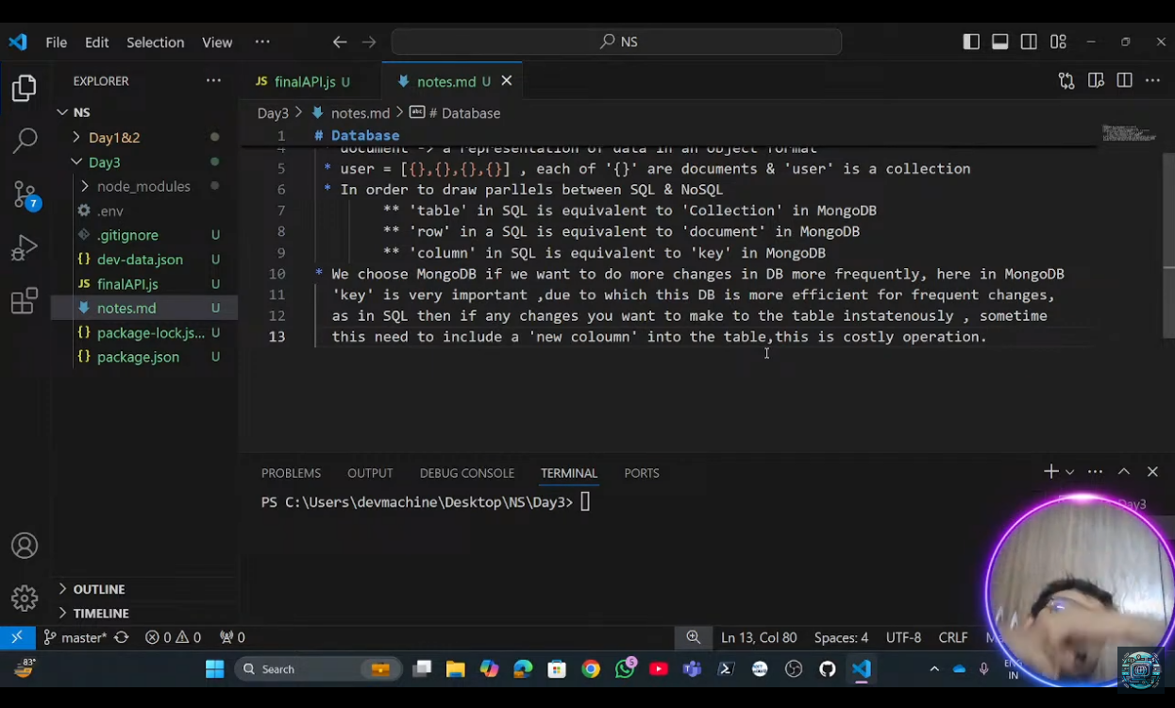

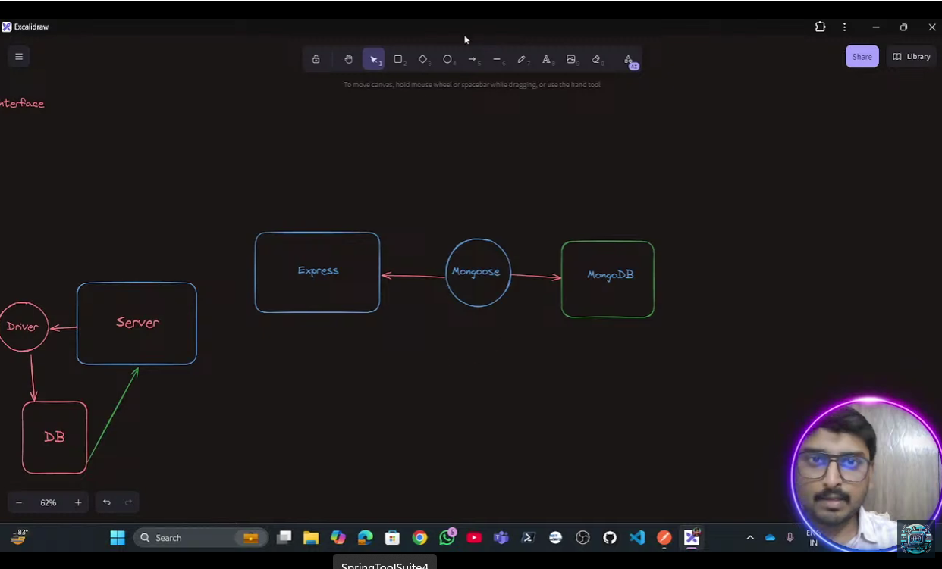

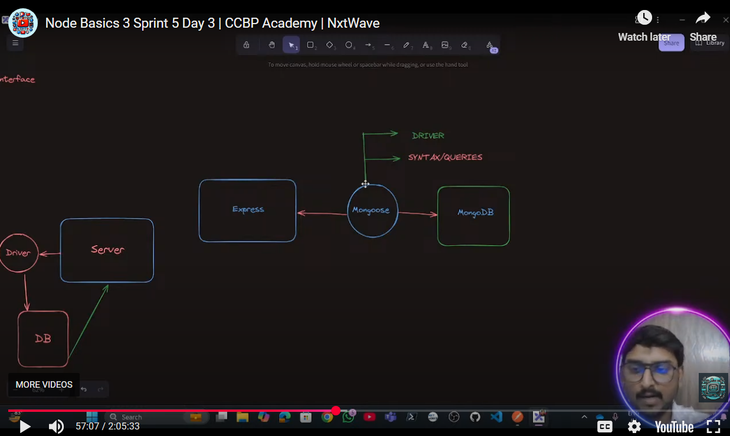

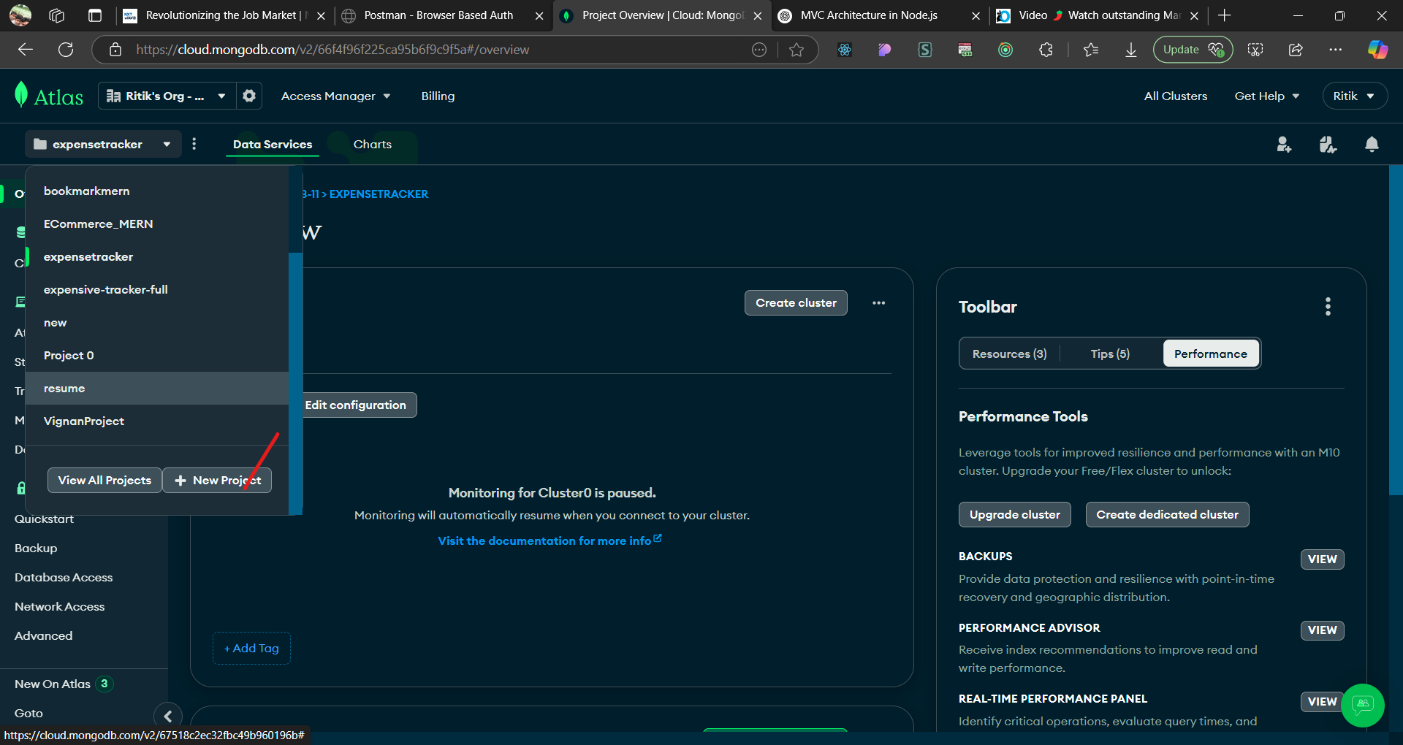

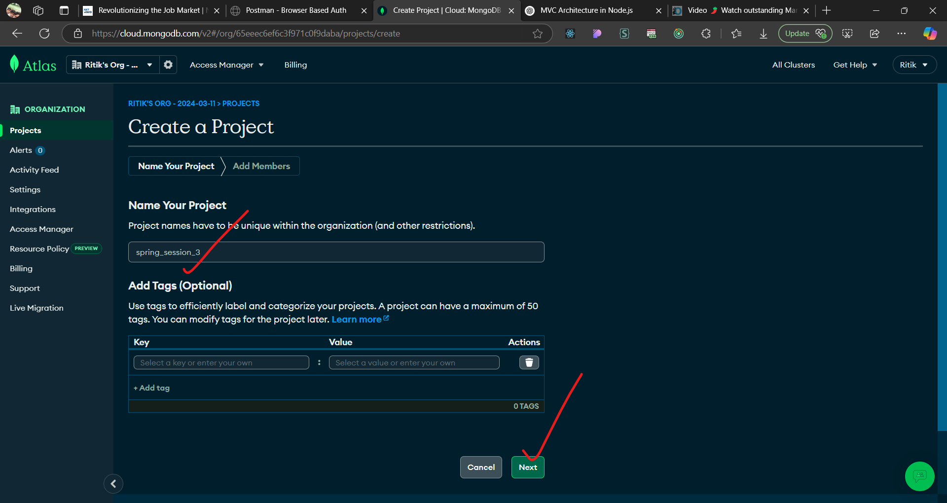

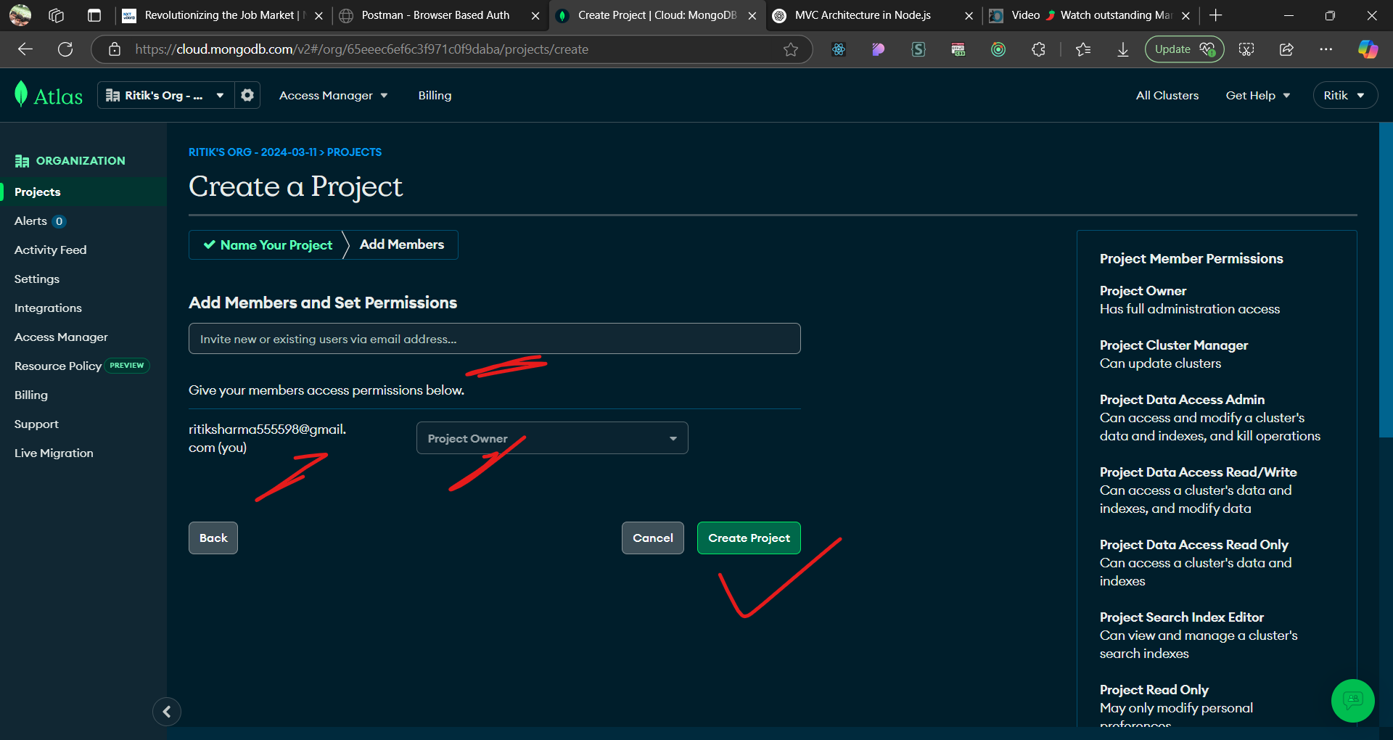

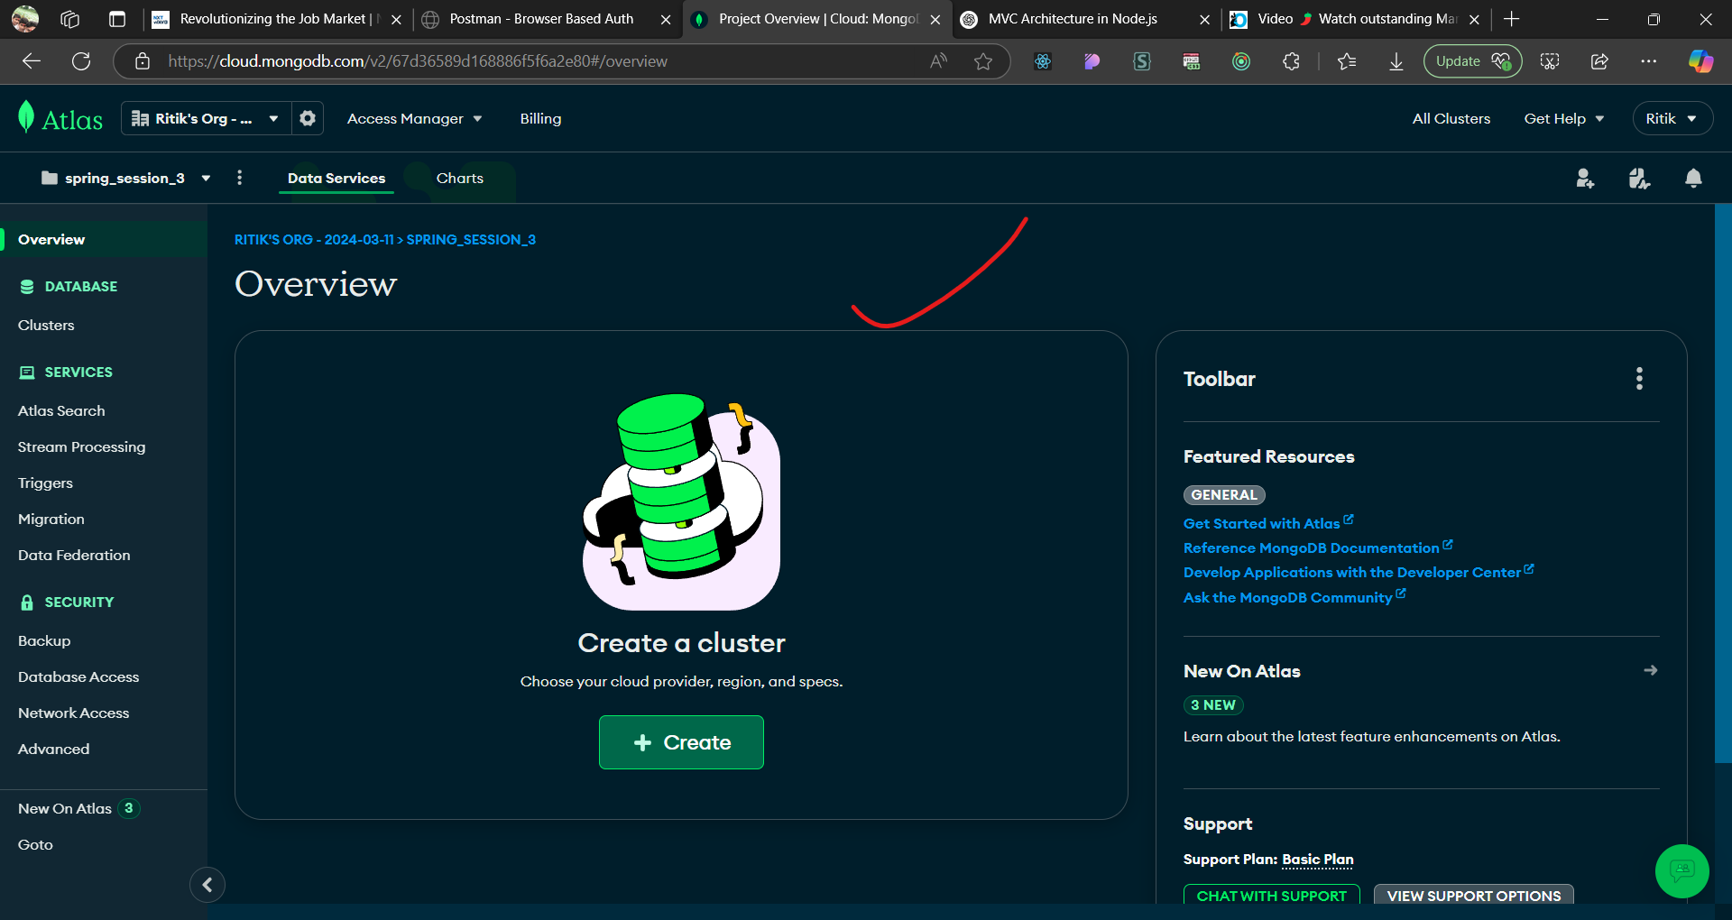

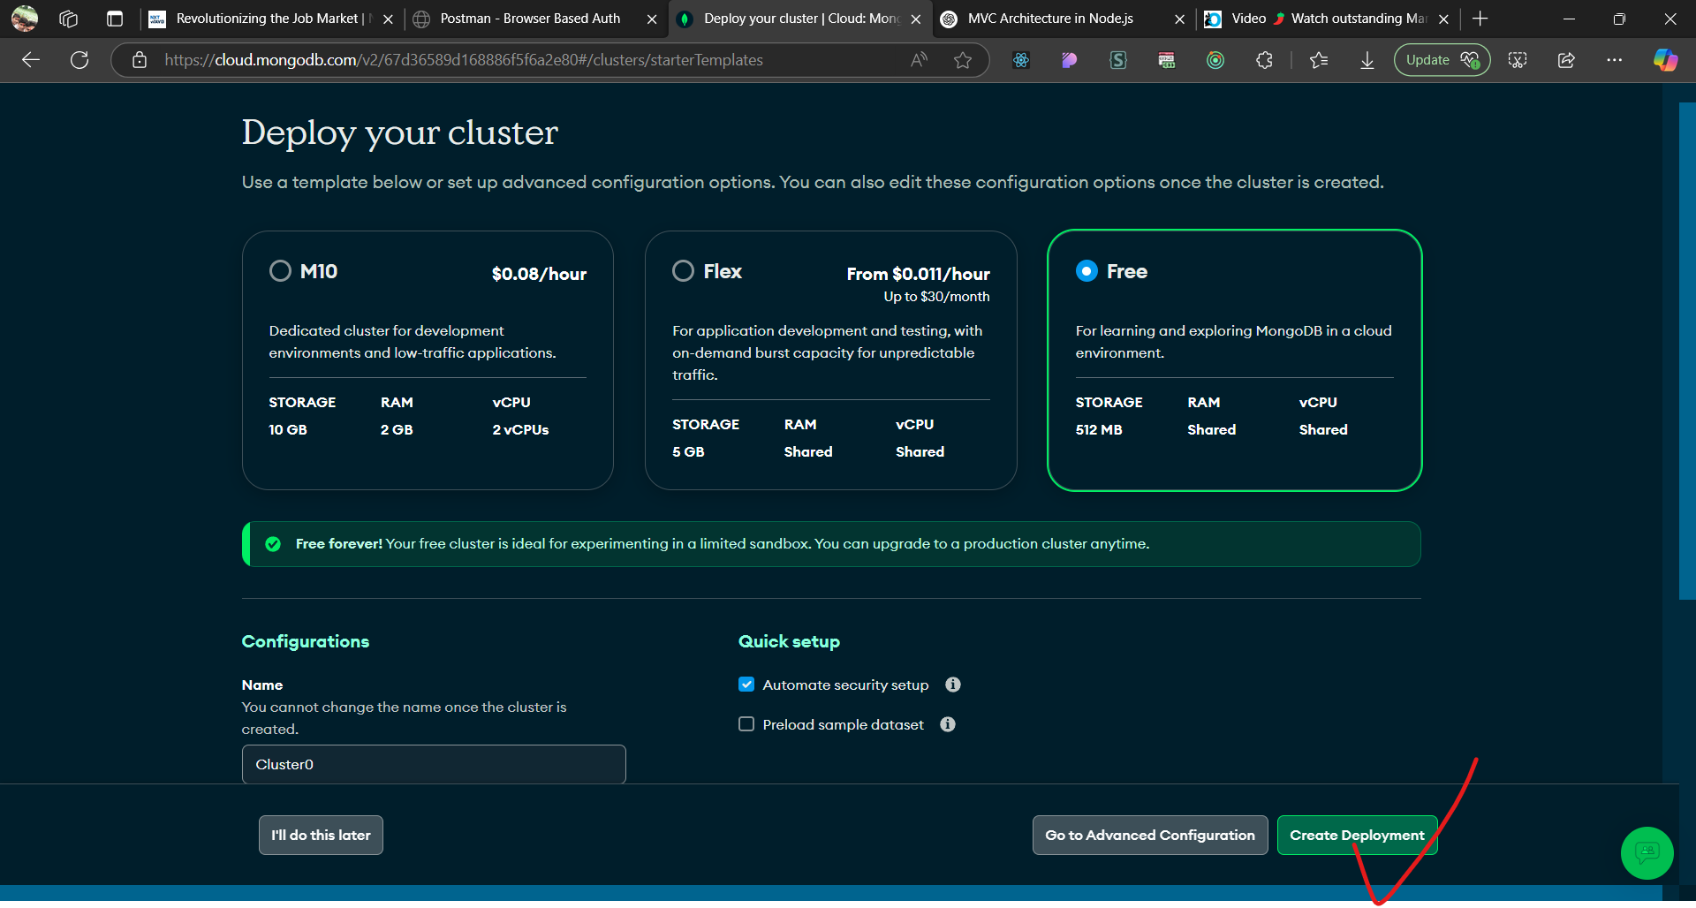

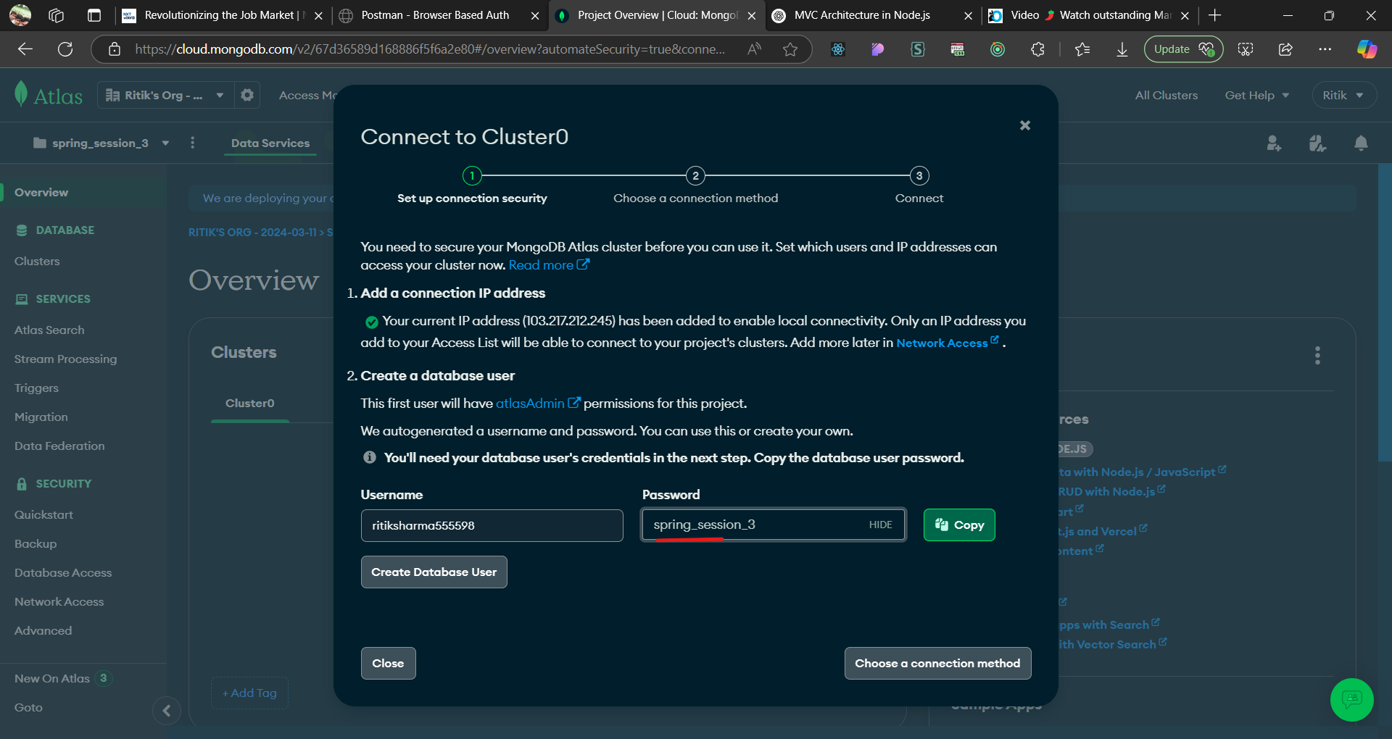

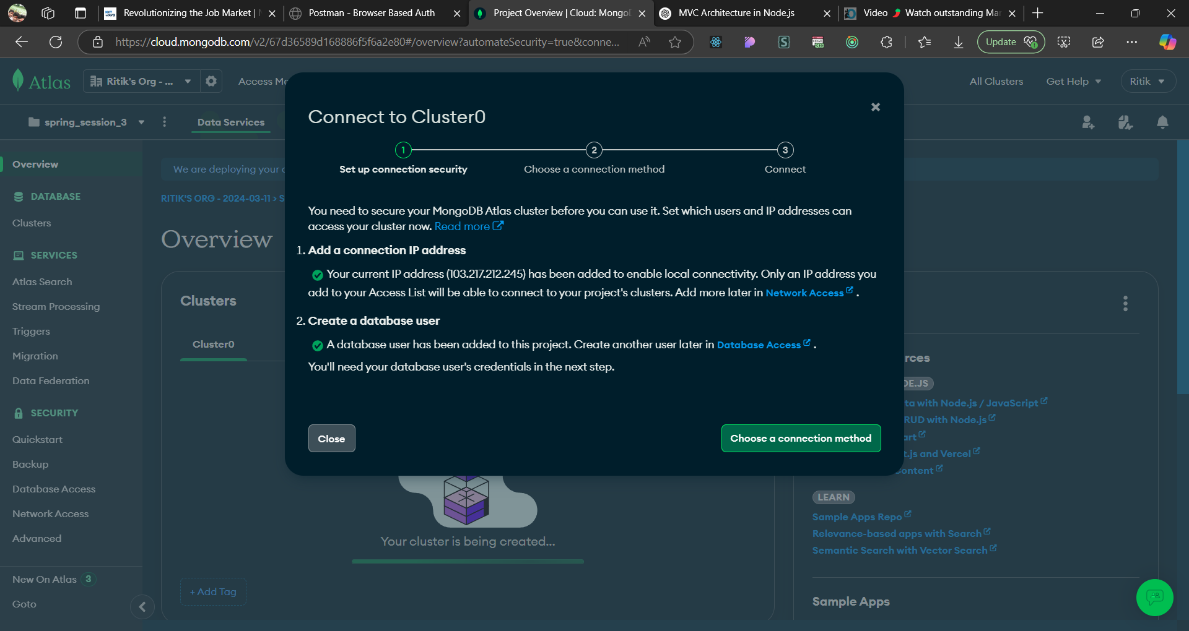

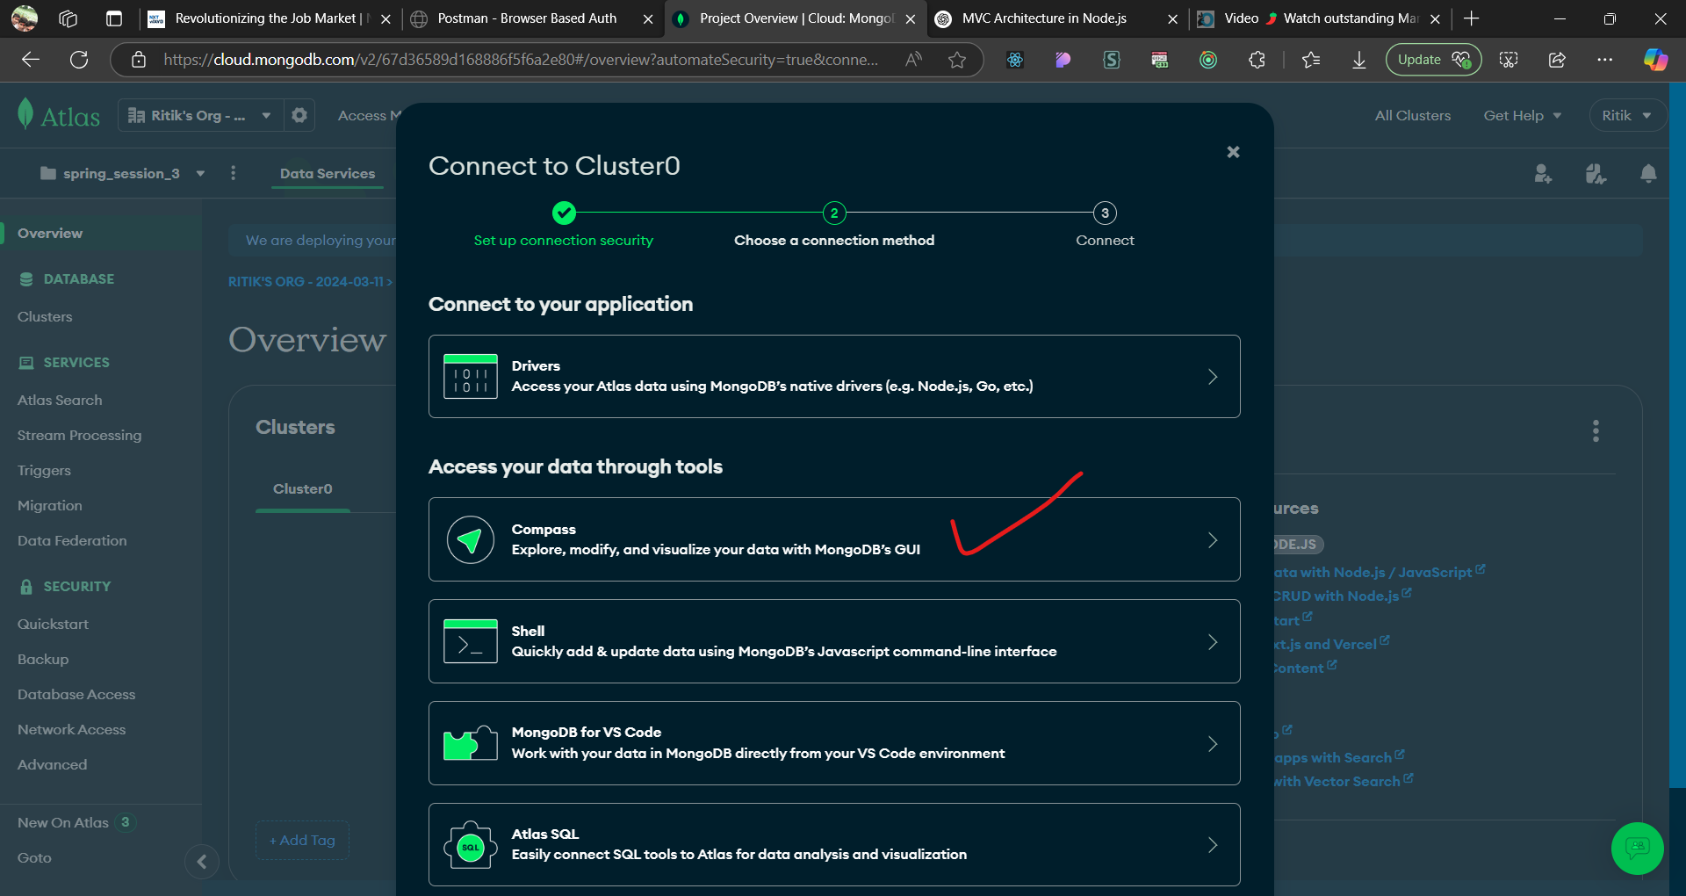

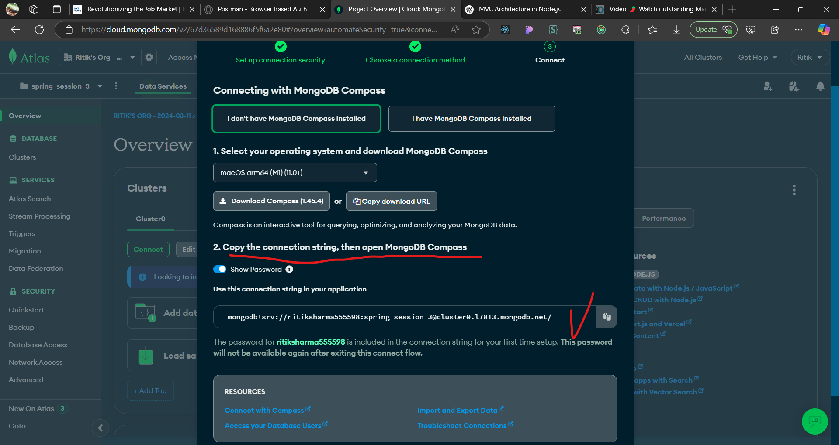

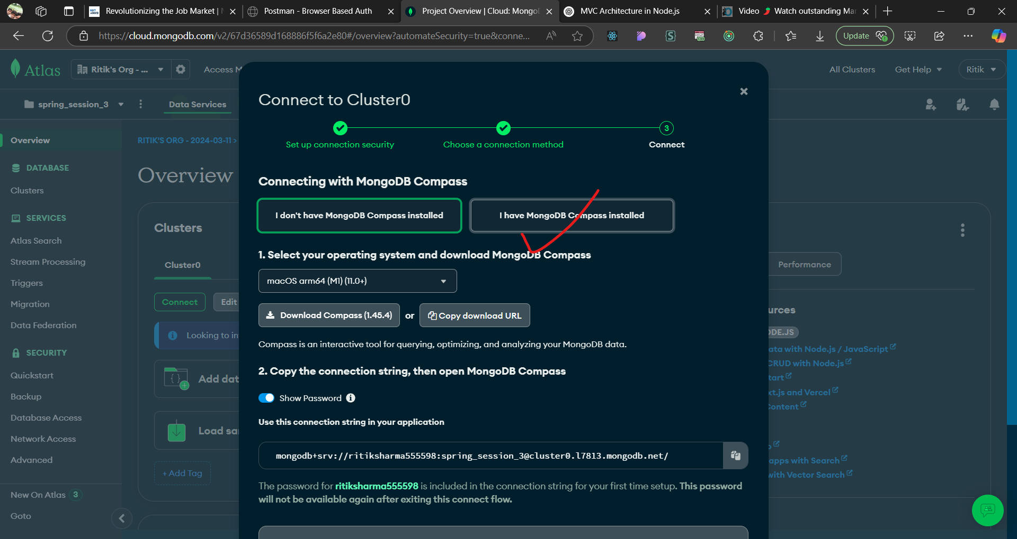

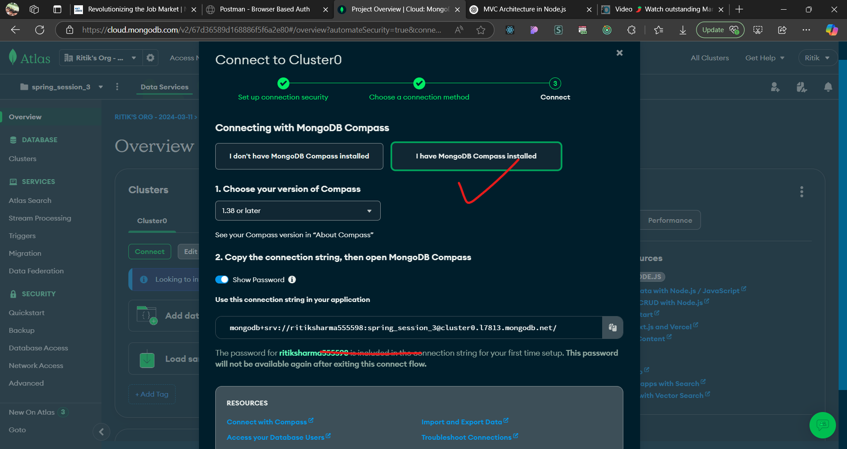

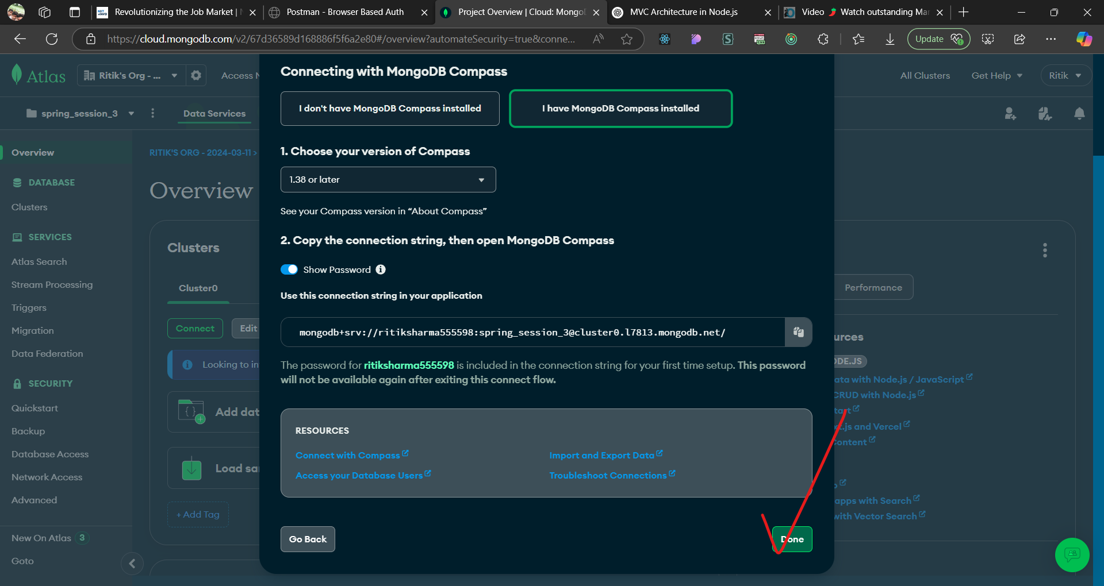

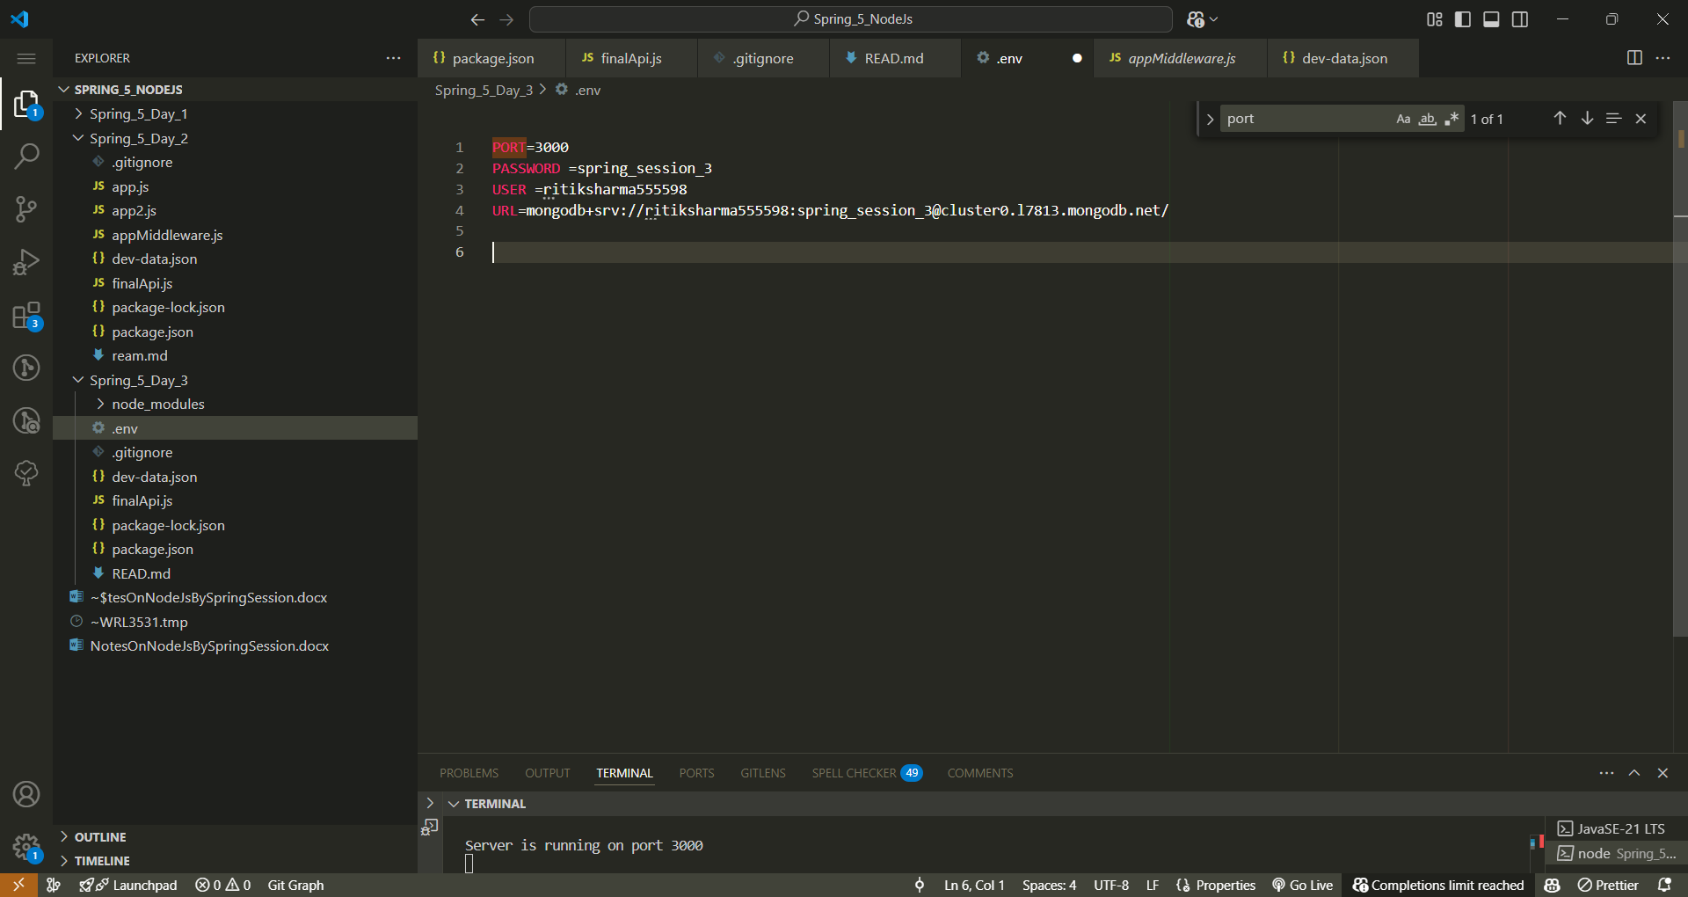

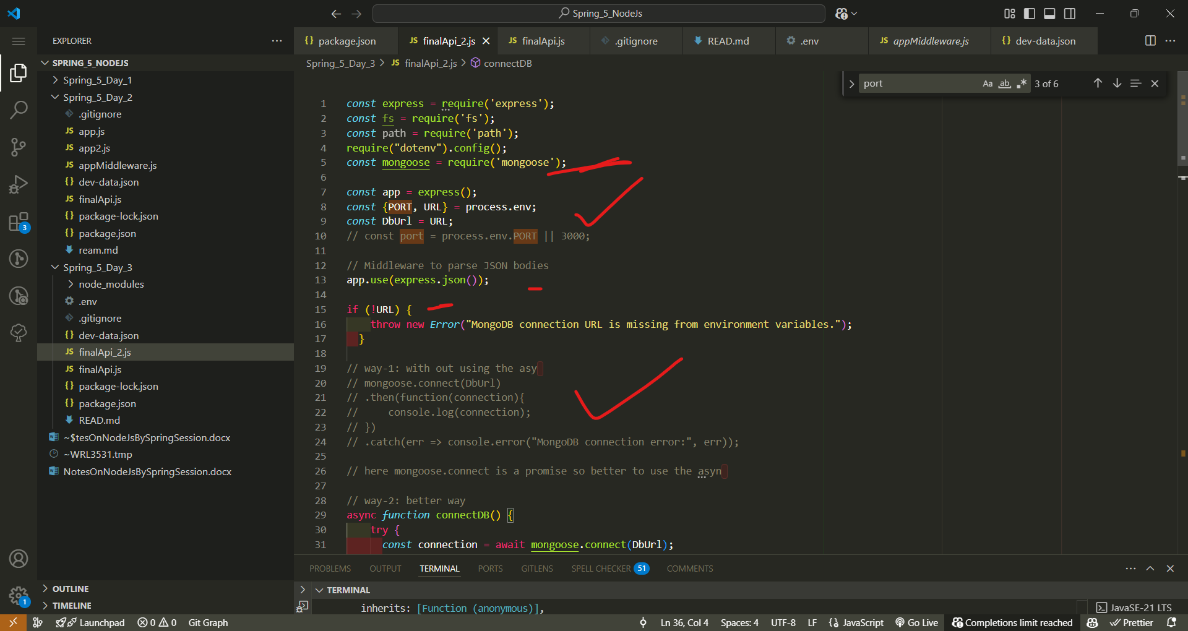

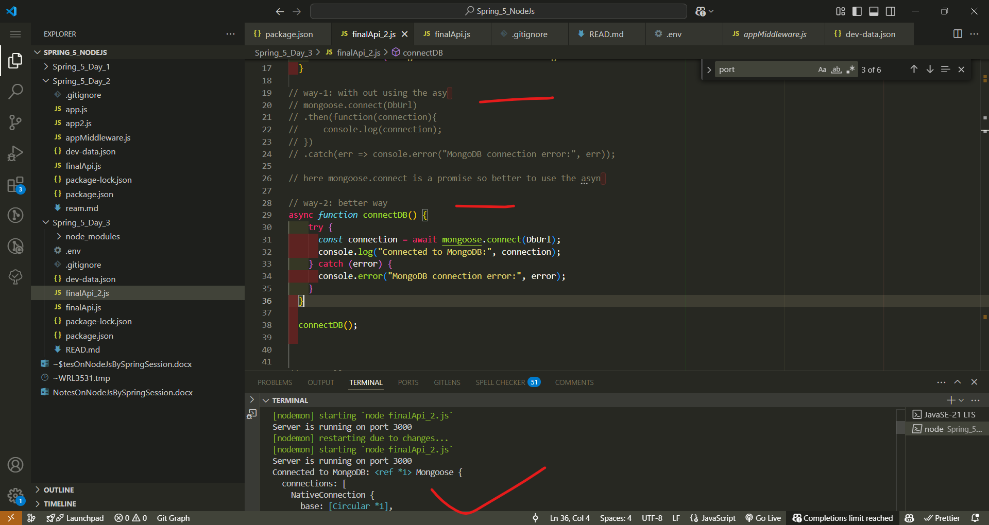

**What is a Promise in JavaScript? 🚀**

A **Promise** in JavaScript is an object that represents the eventual completion (or failure) of an asynchronous operation. It allows you to handle asynchronous tasks more efficiently, avoiding callback hell.

**🔹 Understanding Promises**

A Promise has **three states**:

1. **Pending** – The initial state; the promise is still in progress.
2. **Fulfilled** – The operation completed successfully.
3. **Rejected** – The operation failed.

• mongoose.connect(DbUrl) **returns a Promise**.

• .then(function(connection) { ... }) **executes when MongoDB connects successfully**.

• .catch(err => console.error(...)) **handles connection errors**

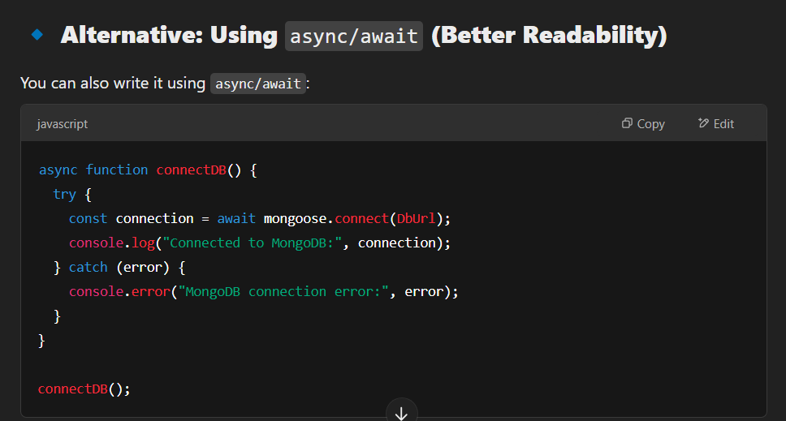

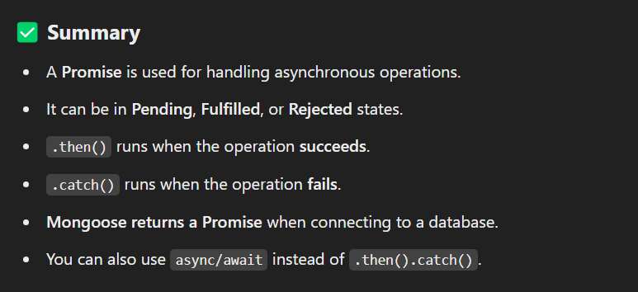

Here it is promise because express has to communicate with mongoDb using driver called as mongoose so it may take few time for that we are using the async..

**What are entity, schema, and model in node-js**

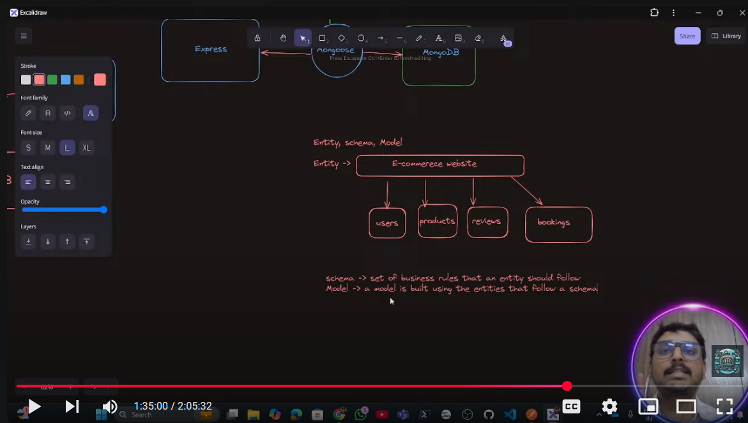

**Entities, Schema, and Models in Node.js (MongoDB + Mongoose)**

When working with **MongoDB** in **Node.js**, especially using **Mongoose**, you often deal with **Entities, Schemas, and Models**. Let’s break them down:

**1️⃣ Entity (What is it?)**

An **entity** represents a real-world object in your application, such as a **User**, **Product**, or **Order**. It defines the concept of data being stored in the database.

📌 **Example:**

* A User entity might have **name, email, and password**.
* A Product entity might have **name, price, and category**.

💡 **Analogy:**  
👉 Think of an **entity** as a "blueprint" for a real-world object.

**2️⃣ Schema (How is it structured?)**

A **Schema** is a **structure** that defines the shape of your documents (objects) in MongoDB. It enforces rules on the entity, such as required fields, data types, and validation.

**Example: Defining a Mongoose Schema**

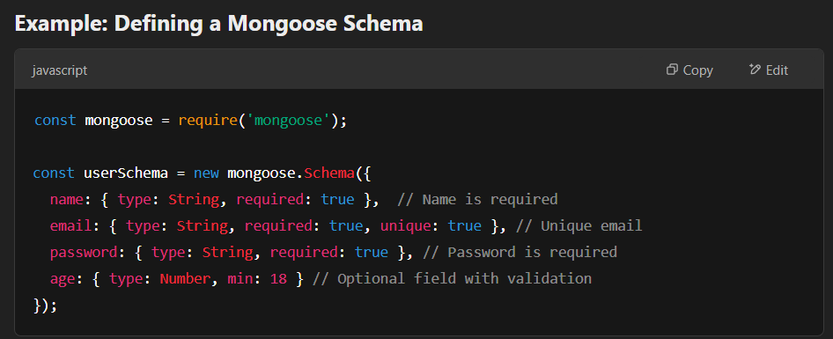

💡 **Analogy:**  
👉 A **Schema** is like a "blueprint" that specifies what properties an entity must have.

**3️⃣ Model (How is it used?)**

A **Model** is a wrapper around the schema. It provides an interface for interacting with the database, such as **creating, reading, updating, and deleting (CRUD)** documents.

**Example: Creating a Mongoose Model**

const User = mongoose.model('User', userSchema);

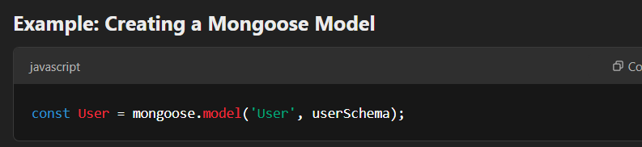

Now, we can use the User model to interact with the database.

**Example: Using the Model**

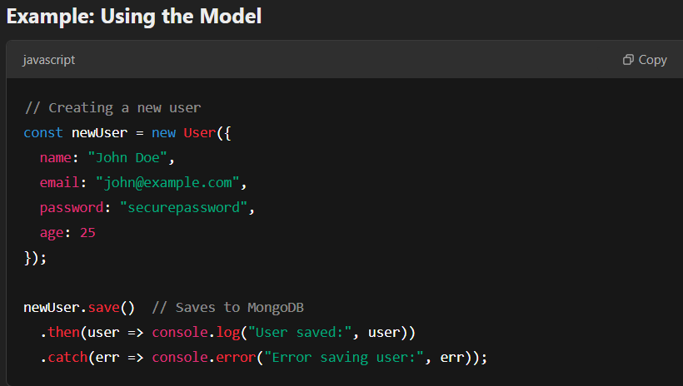

💡 **Analogy:**  
👉 A **Model** is like a "factory" that creates and manages data.

**🔹 Summary**

| **Term** | **Meaning** |
| --- | --- |
| **Entity** | A real-world object (User, Product, Order) |
| **Schema** | Defines the structure of the entity (fields, validation) |
| **Model** | An interface to interact with the database |

**🔹 Final Example: Complete Implementation**

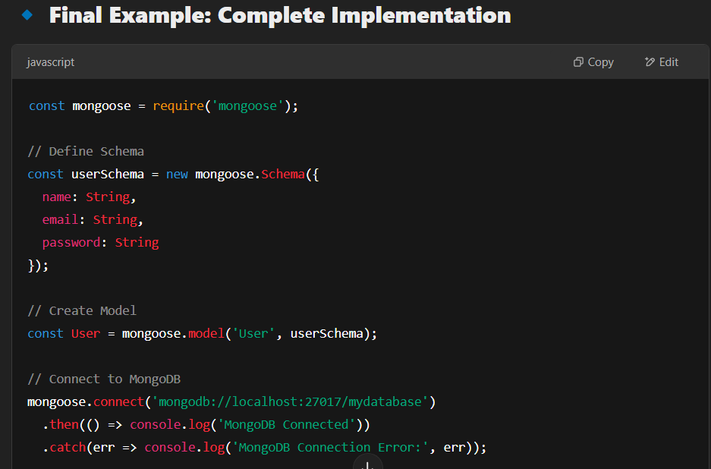

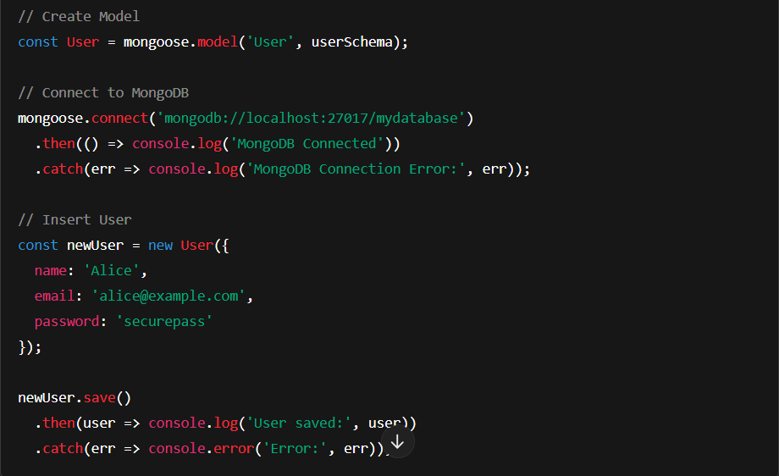

**✅ Key Takeaways**

1. **Entity** → Represents a real-world object (e.g., User, Product).
2. **Schema** → Defines the structure (fields, types, rules).
3. **Model** → Provides an interface to interact with the database.

Let me know if you need further explanation! 🚀

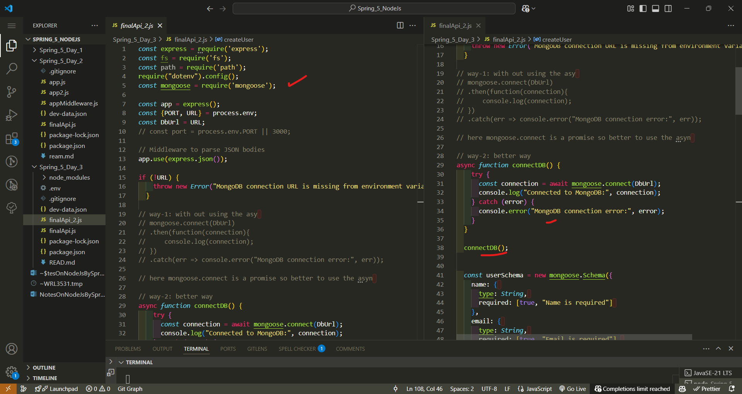

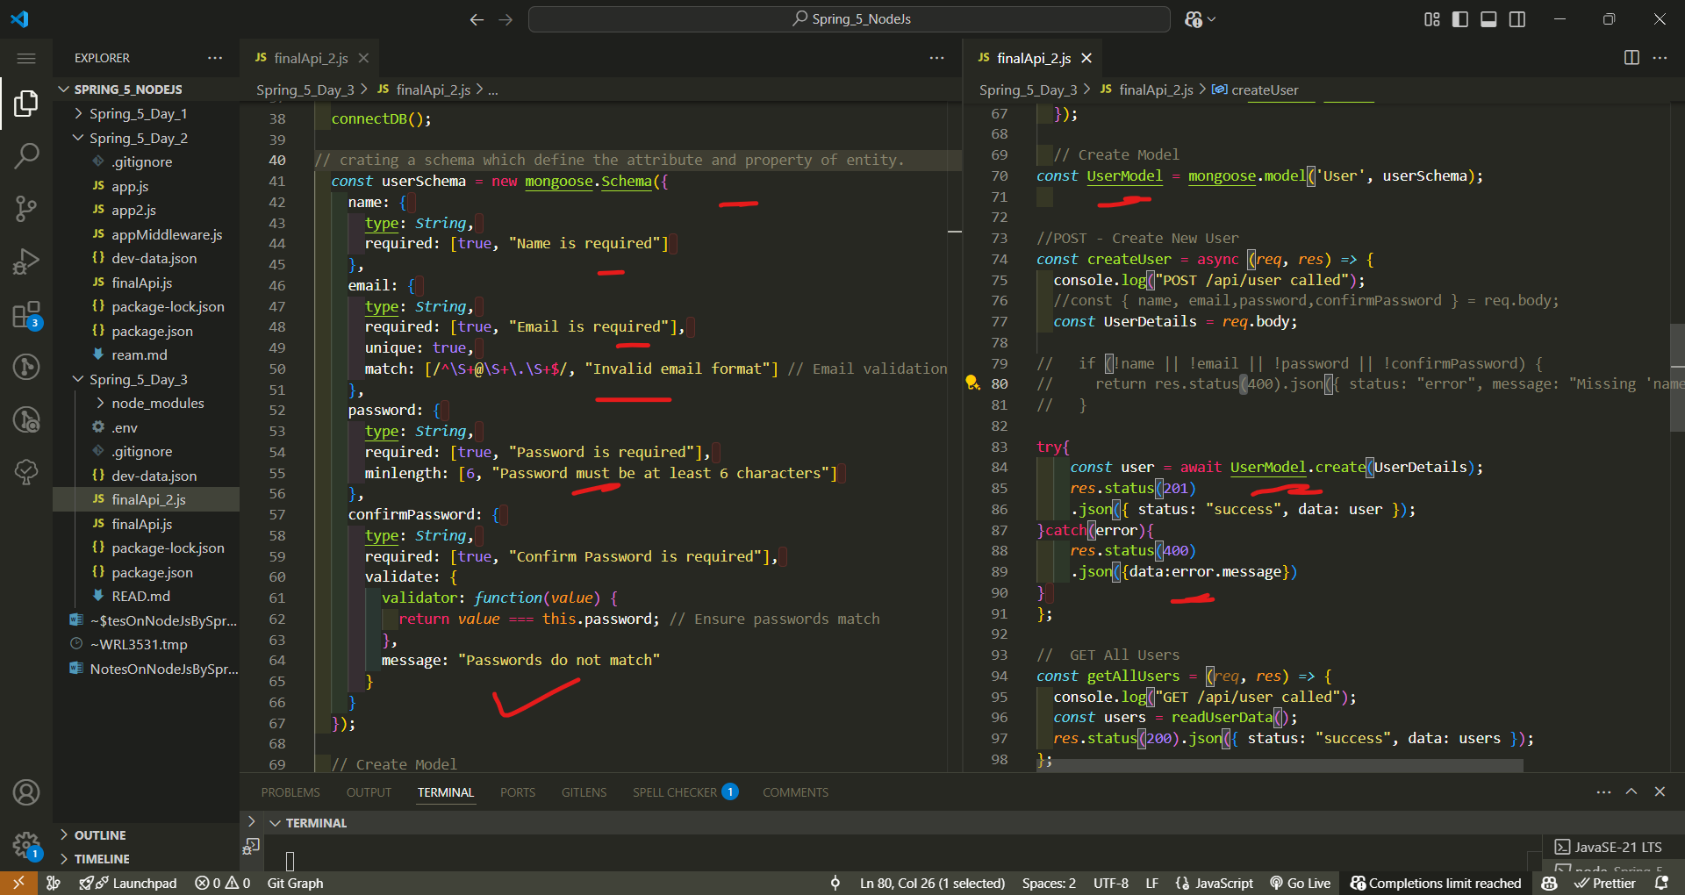

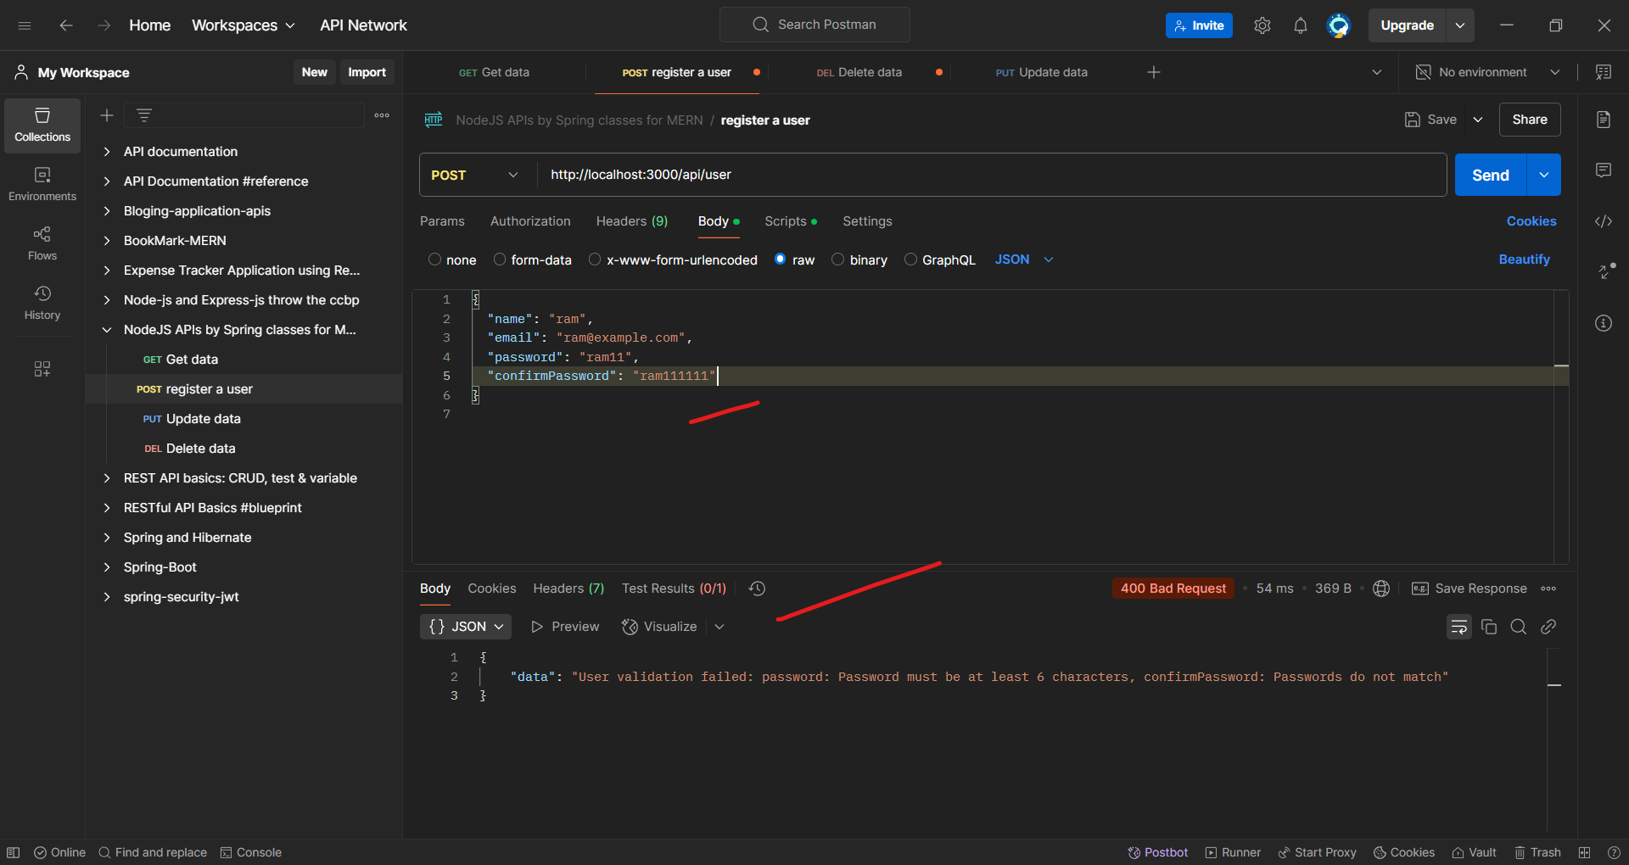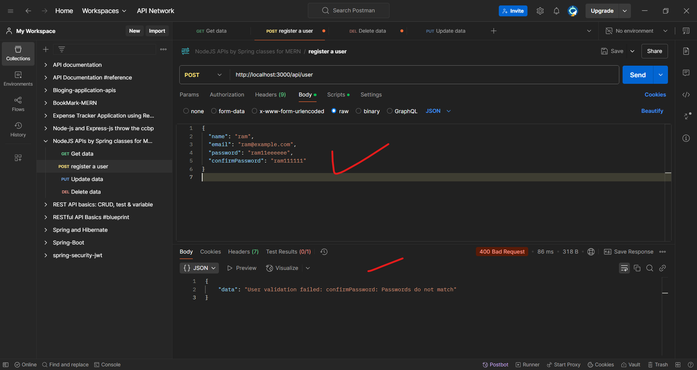

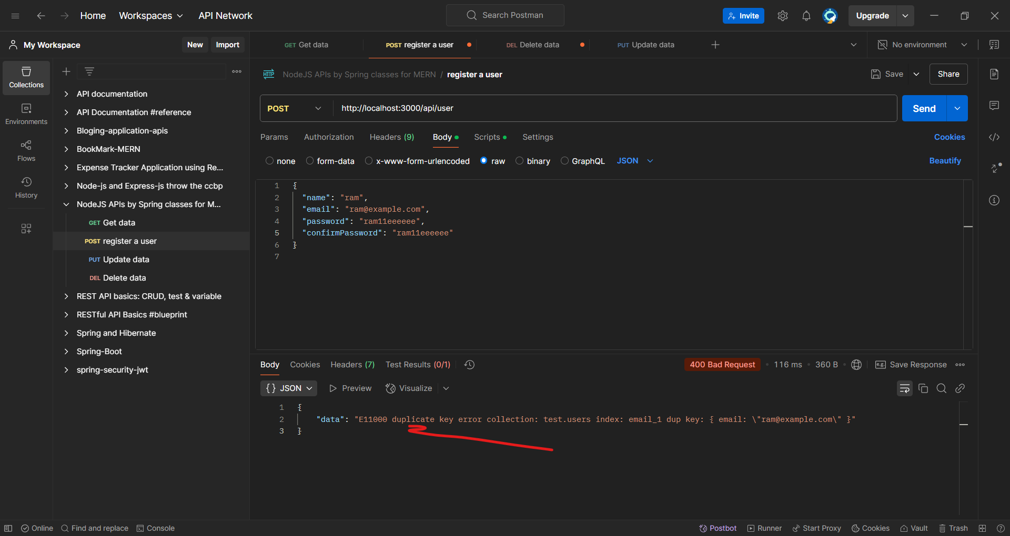

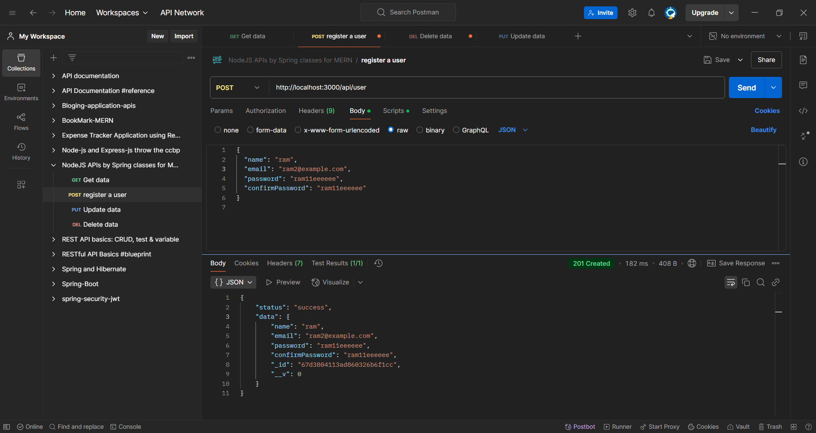

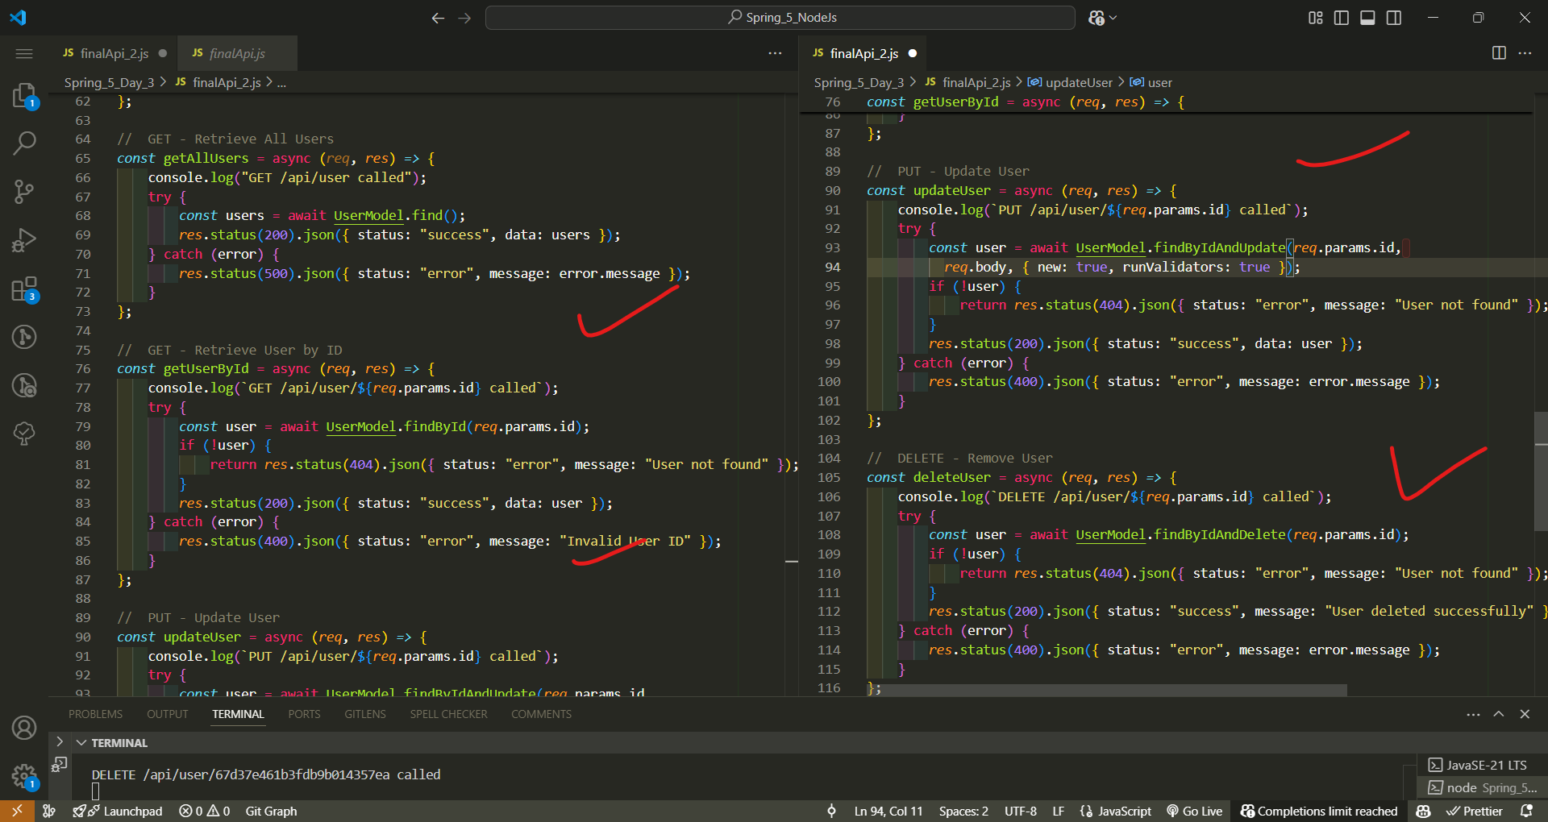

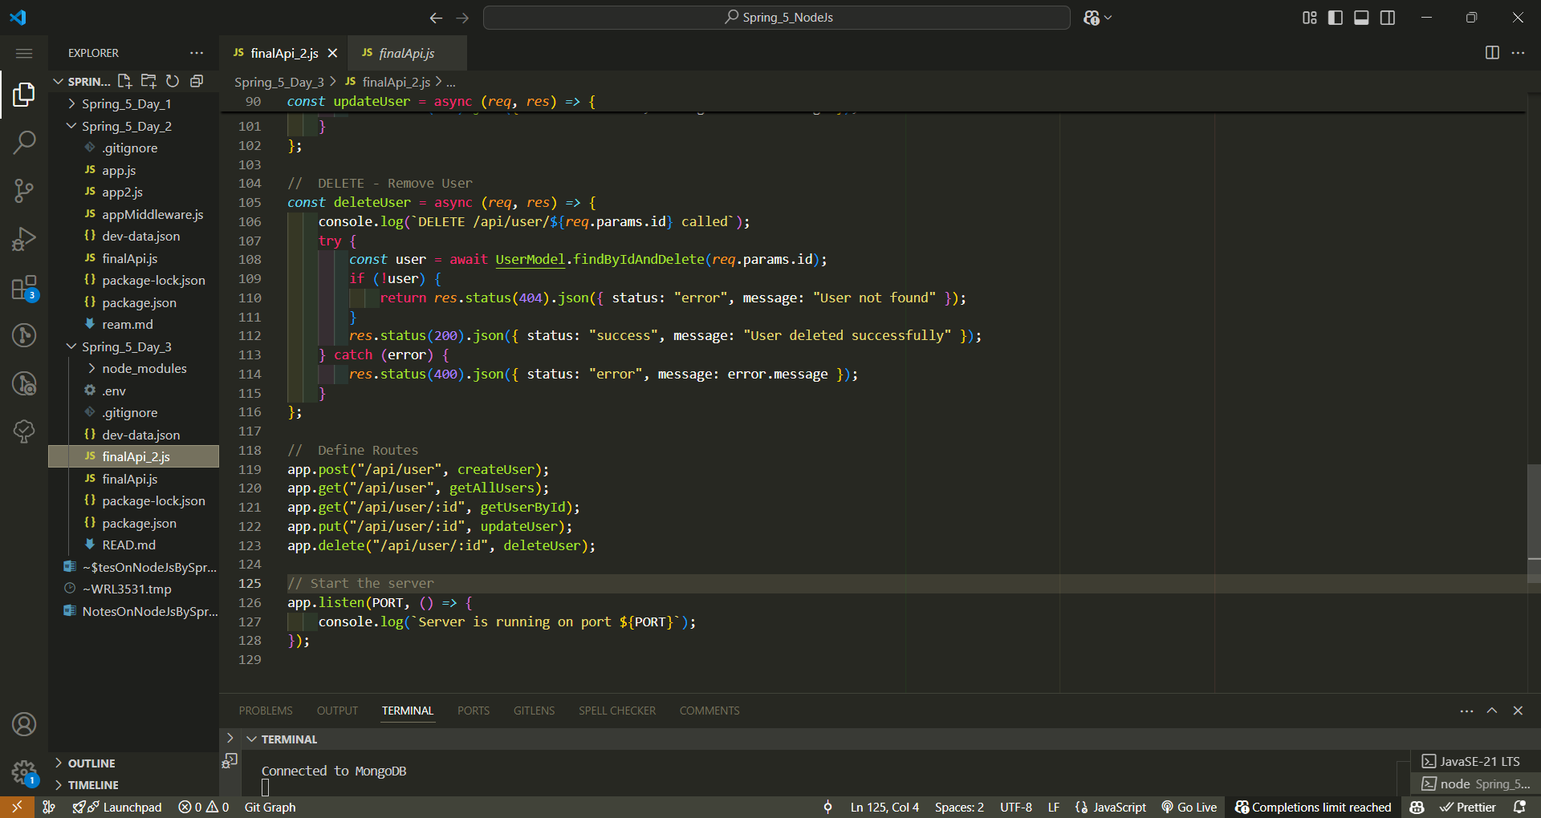

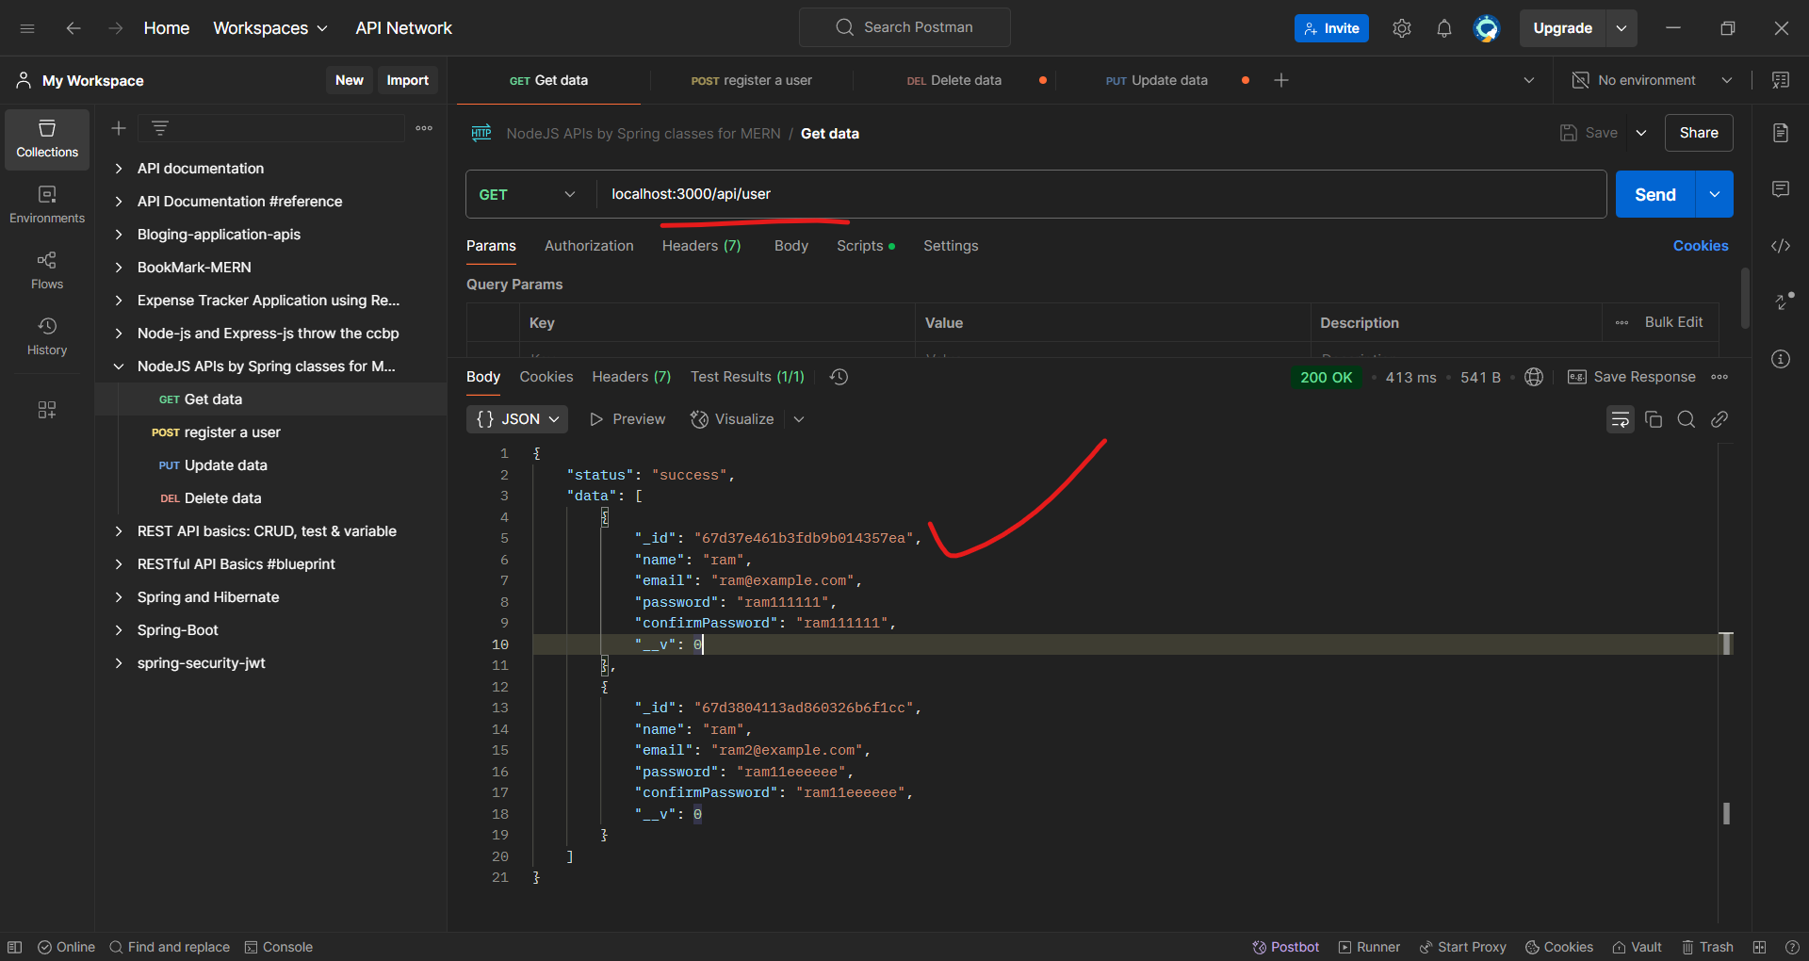

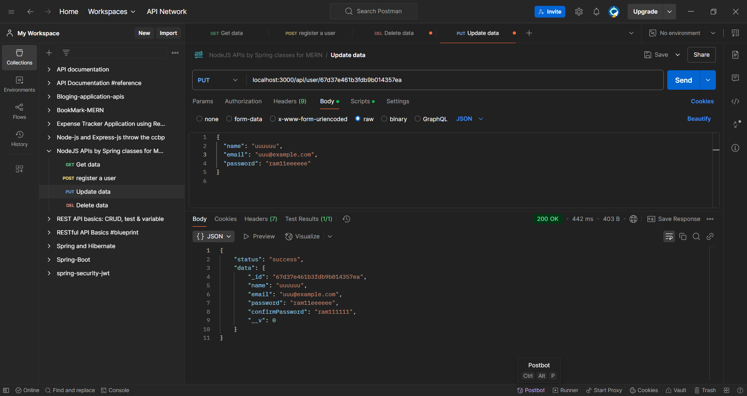

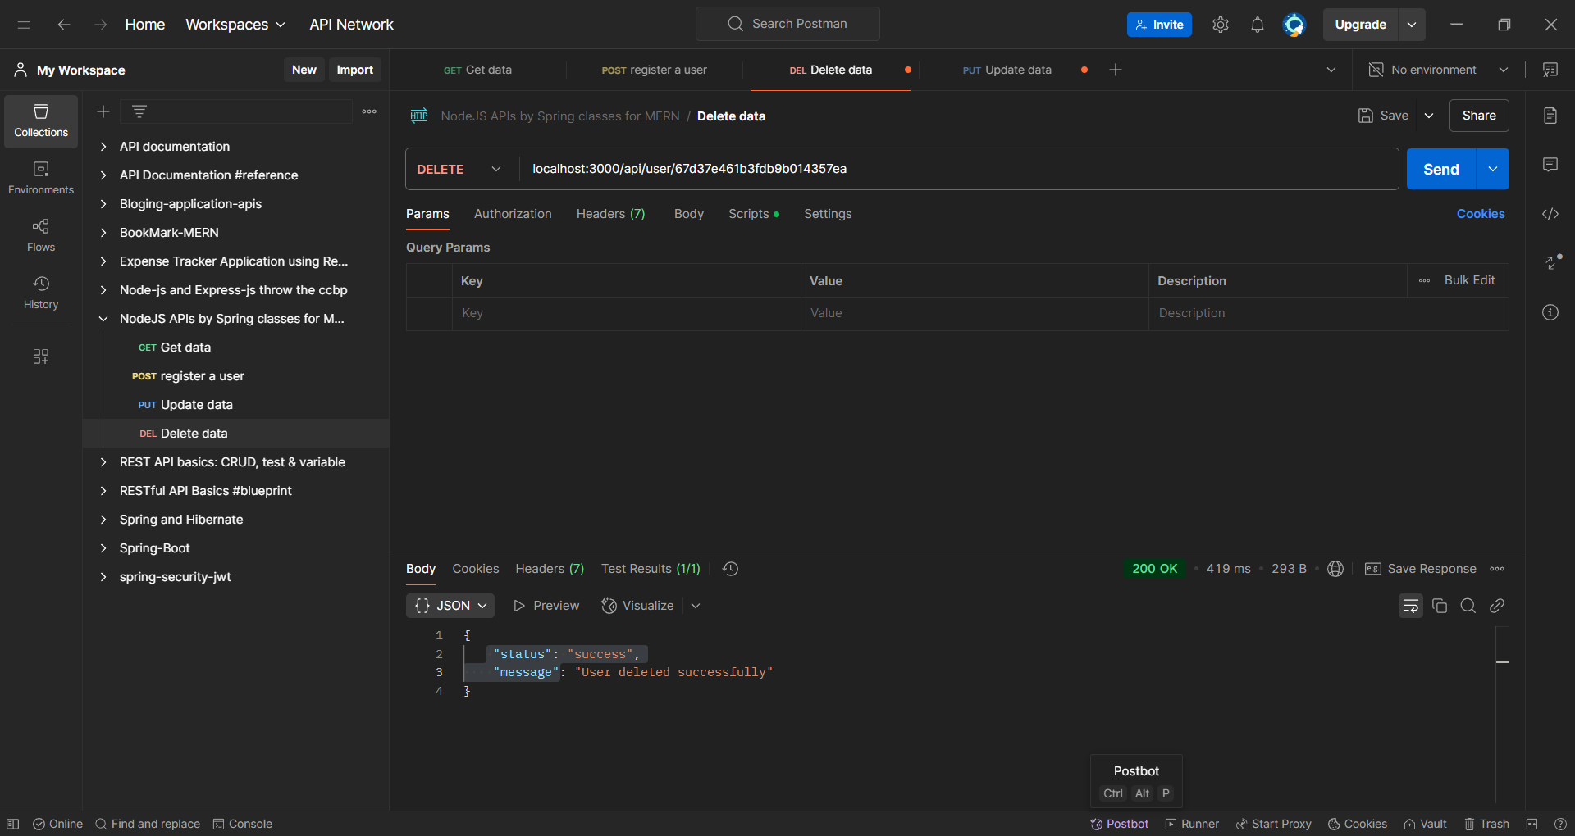

-----------------Spring-5-day-4---------------------------------

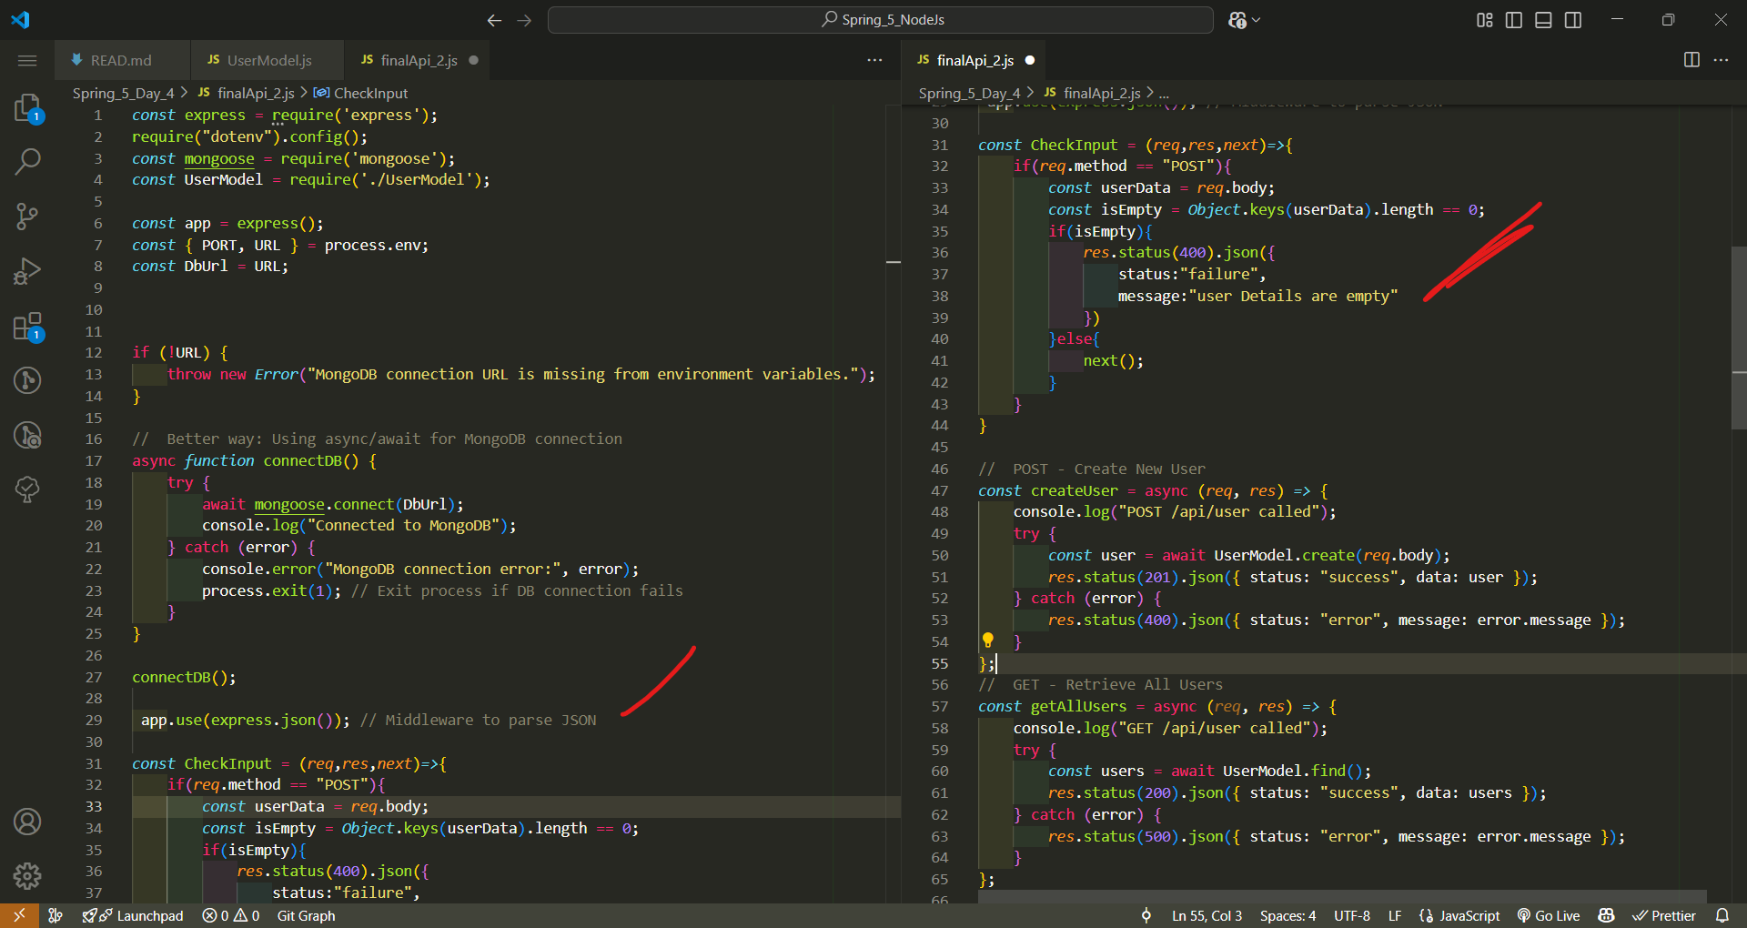

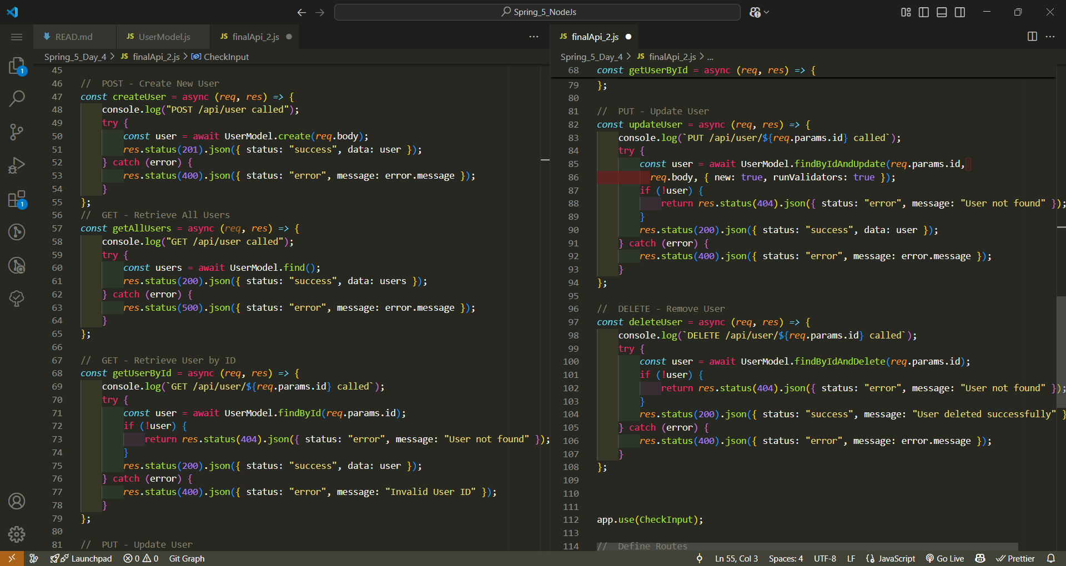

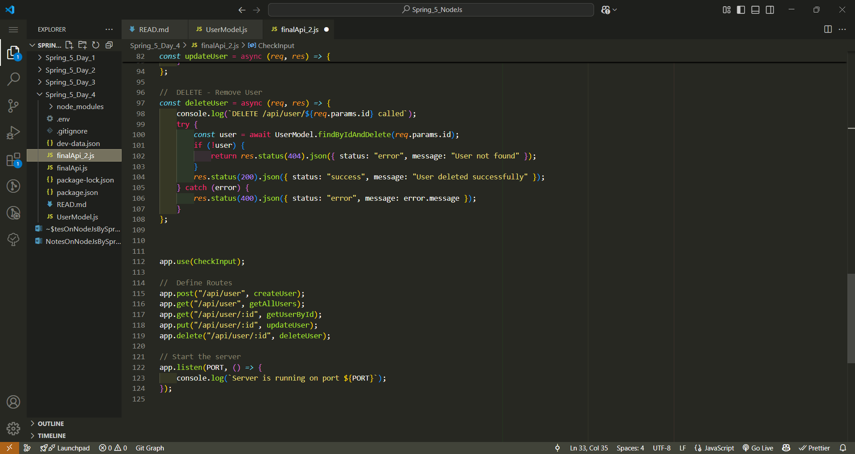

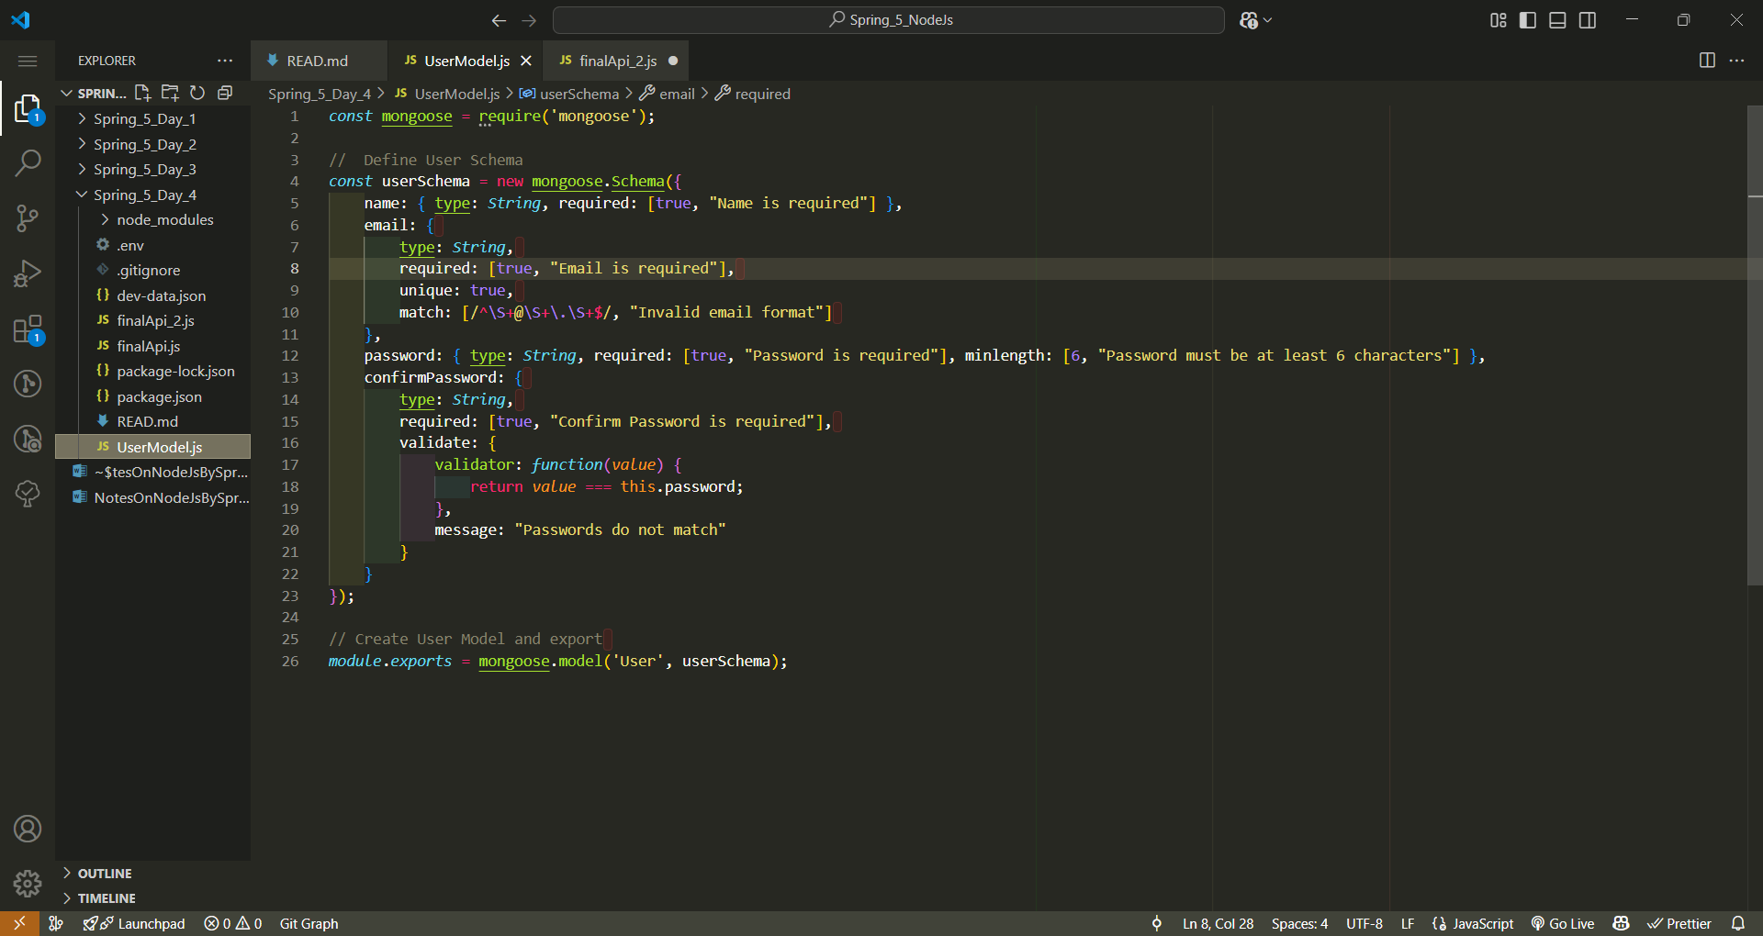

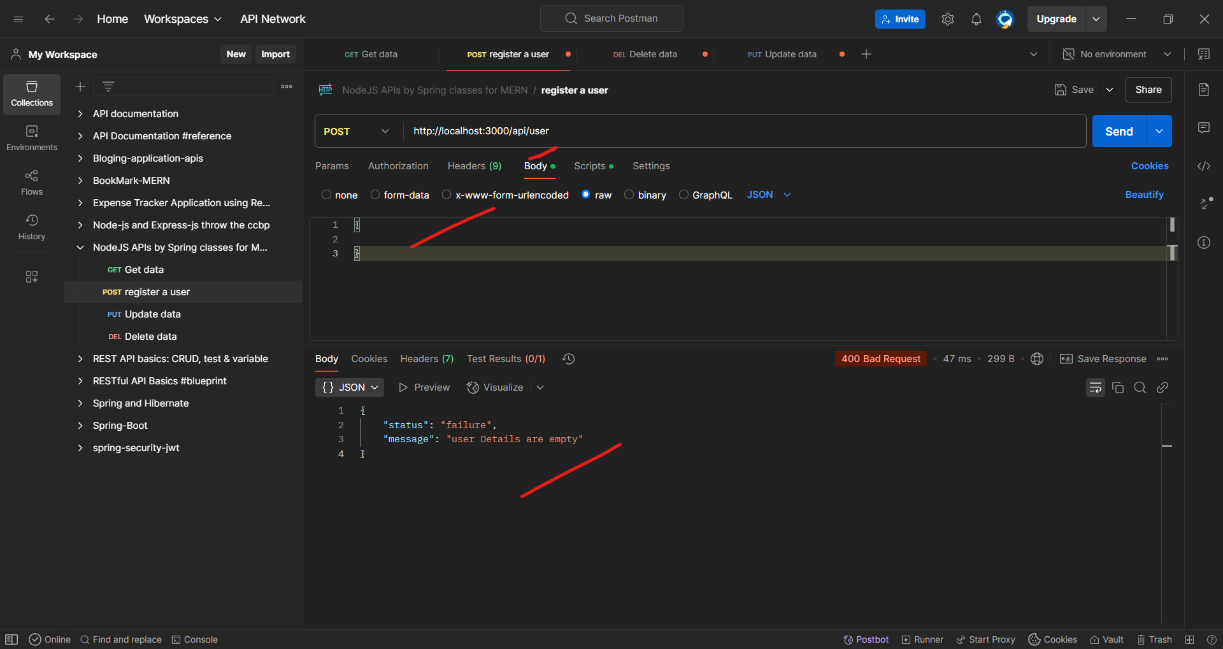

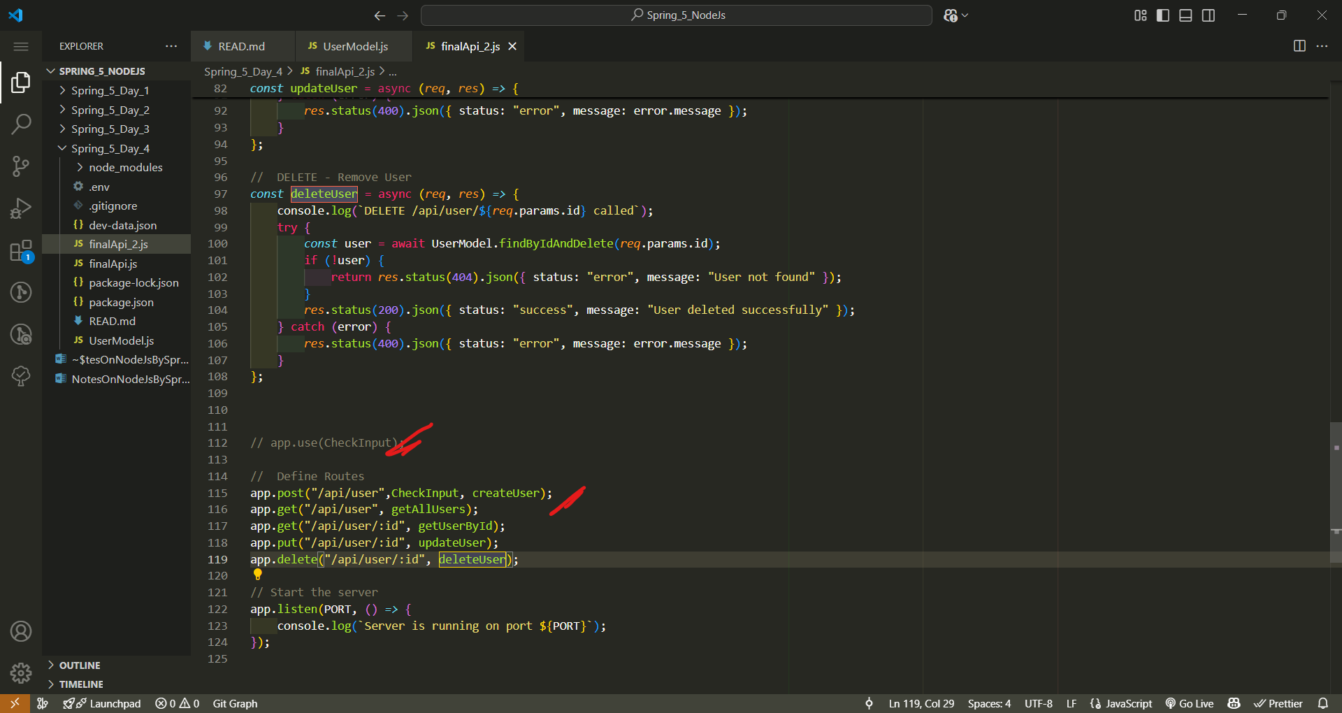

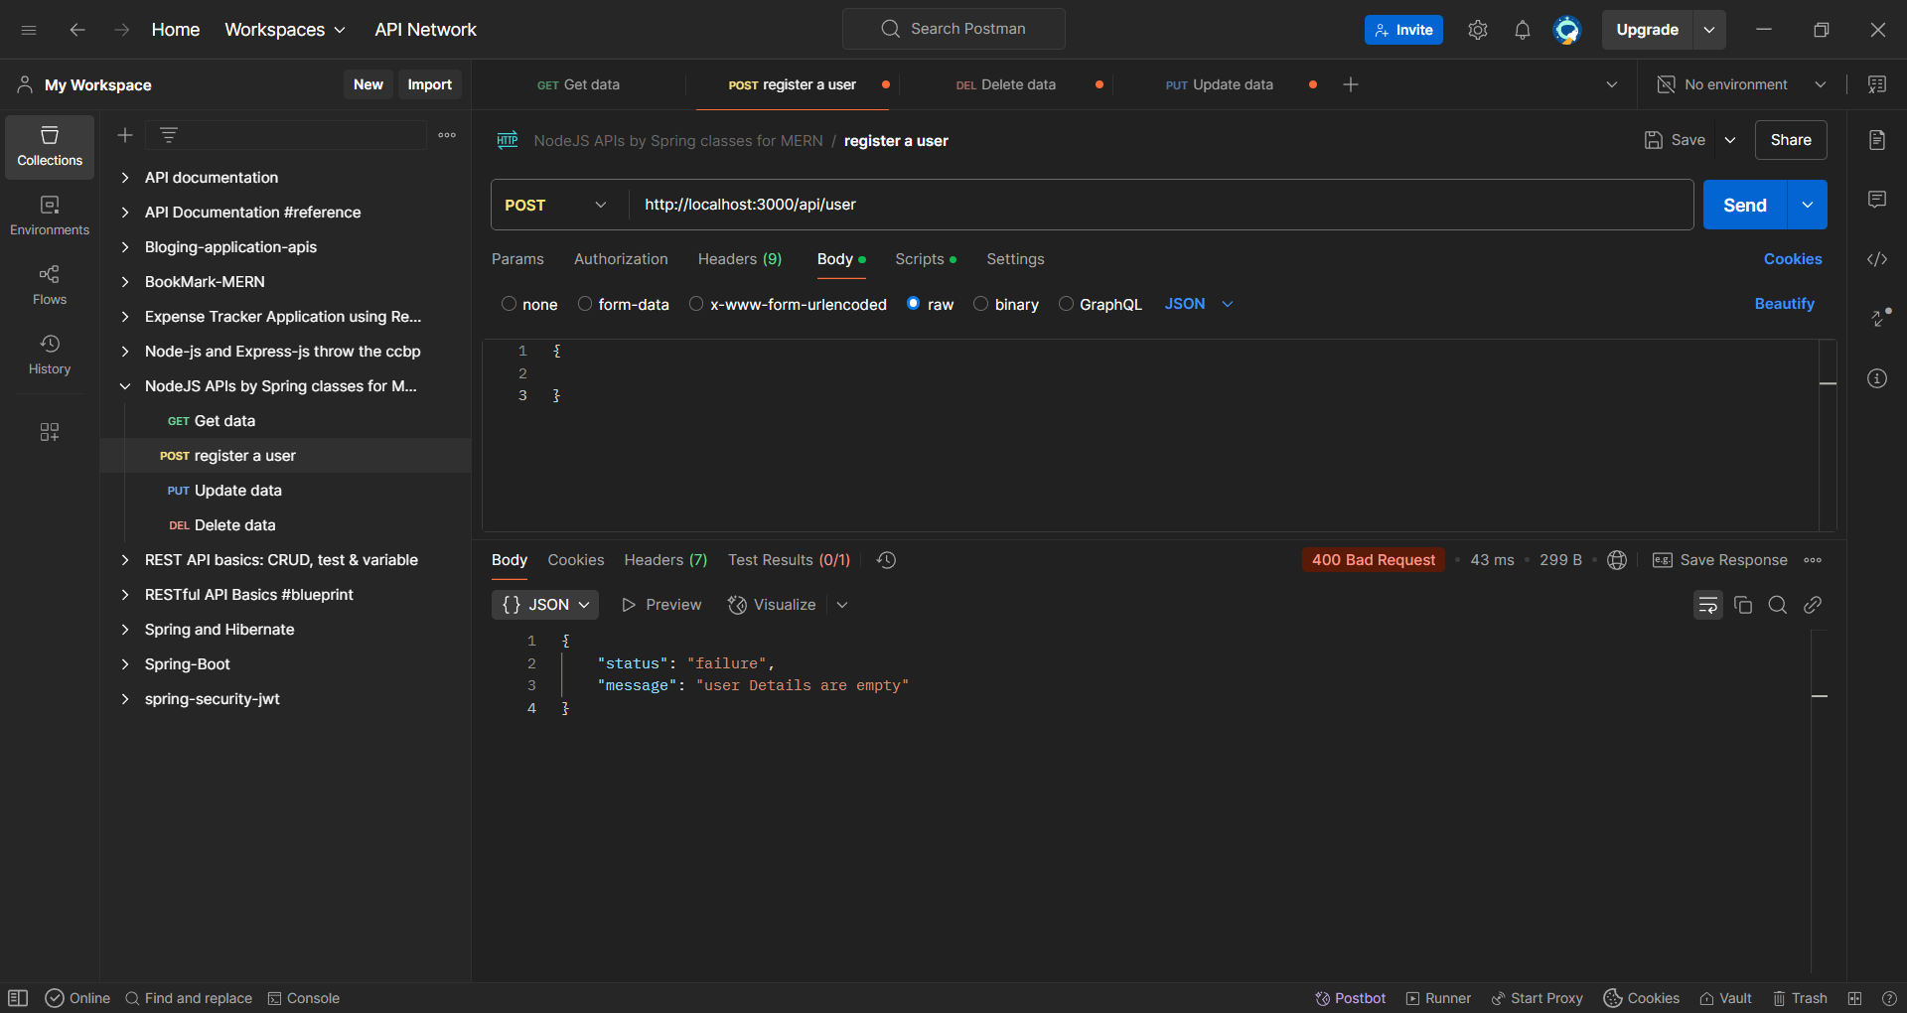

Key Principles of RESTful APIs

**Key Principles of RESTful APIs**

REST (Representational State Transfer) is an **architectural style** for designing networked applications. RESTful APIs follow a set of principles that make them **scalable, flexible, and easy to use**.

**1️⃣ Statelessness**

Each API request should contain **all the information** needed to process it.  
✅ No session or user state is stored on the server.  
✅ The server treats every request independently.

🔹 **Example:**  
A client sends a request with authentication details every time:

GET /api/user/123

Authorization: Bearer <token>

**2️⃣ Client-Server Separation**

The client and server should be **separate** and communicate only via API calls.  
✅ The front end (client) does not depend on the server's internal logic.  
✅ The back end (server) exposes only necessary data.

🔹 **Example:**  
A mobile app, web app, and third-party service can all use the same API.

**3️⃣ Uniform Interface**

The API should have a **consistent structure** and follow HTTP standards.  
✅ Use **standard HTTP methods** like GET, POST, PUT, and DELETE.  
✅ Use **resource-based URLs** instead of actions.

🔹 **Example:**  
Instead of:

GET /getUser?id=123

Use:

GET /api/user/123

**4️⃣ Resource-Based URLs (Naming Convention)**

✅ Use **nouns** in URLs, not verbs.  
✅ Use **plural names** for collections.

🔹 **Good API Design:**

GET /api/users -> Get all users

GET /api/users/123 -> Get user with ID 123

POST /api/users -> Create a new user

PUT /api/users/123 -> Update user with ID 123

DELETE /api/users/123 -> Delete user with ID 123

🔴 **Bad API Design:**

GET /api/getUserById/123

POST /api/createNewUser

DELETE /api/removeUser/123

**5️⃣ Use Proper HTTP Methods**

✅ **GET** → Retrieve data.  
✅ **POST** → Create new data.  
✅ **PUT** → Update existing data.  
✅ **PATCH** → Partially update data.  
✅ **DELETE** → Remove data.

🔹 **Example:**

GET /api/products # Fetch all products

POST /api/products # Add a new product

PUT /api/products/1 # Update product with ID 1

DELETE /api/products/1 # Delete product with ID 1

**6️⃣ Use Proper HTTP Status Codes**

Use correct **status codes** for responses to indicate success or failure.

| **Status Code** | **Meaning** |
| --- | --- |
| **200 OK** | Success |
| **201 Created** | Resource created |
| **204 No Content** | Request processed, no data returned |
| **400 Bad Request** | Invalid request |
| **401 Unauthorized** | Authentication required |
| **403 Forbidden** | Access denied |
| **404 Not Found** | Resource not found |
| **500 Internal Server Error** | Server failed to process request |

🔹 **Example Response:**

{

"status": "success",

"data": {

"id": 123,

"name": "John Doe"

}

}

**7️⃣ Use Pagination for Large Data**

For large datasets, always **paginate results** instead of returning everything.

🔹 **Example:**

GET /api/products?page=1&limit=10

Response:

{

"total": 100,

"page": 1,

"limit": 10,

"data": [ { "id": 1, "name": "Product A" }, ... ]

}

**8️⃣ Use Versioning**

APIs change over time. Use **versioning** to prevent breaking older clients.

🔹 **Example Versioning Strategies:** 1️⃣ **URL Versioning:**

GET /api/v1/users

GET /api/v2/users

2️⃣ **Header Versioning:**

GET /api/users

Headers: Accept-Version: v1

**9️⃣ Secure Your API**

✅ Use **Authentication & Authorization** (e.g., JWT, OAuth).  
✅ Use **HTTPS** to encrypt data.  
✅ Prevent **SQL Injection & XSS attacks**.  
✅ Implement **rate limiting** to prevent abuse.

**🔟 Return Consistent JSON Responses**

✅ Always return responses in a structured **JSON format**.  
✅ Include a **status message** and **data**.

🔹 **Example Response:**

{

"status": "success",

"data": {

"id": 123,

"name": "Alice",

"email": "alice@example.com"

}

}

**Conclusion**

By following these **RESTful API principles**, your API will be **scalable, maintainable, and easy to use**! 🚀

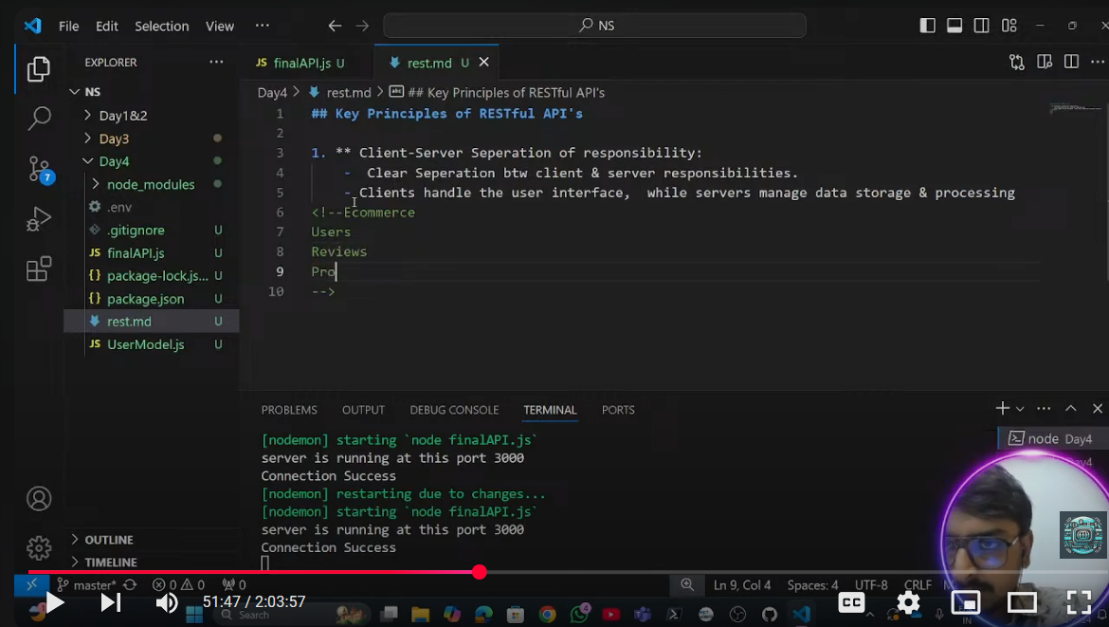

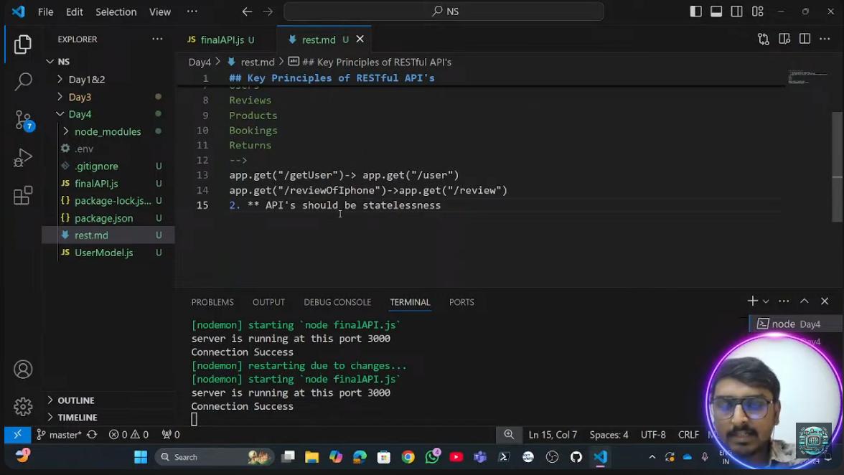

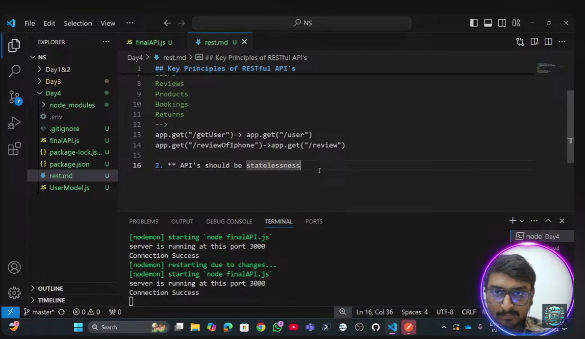

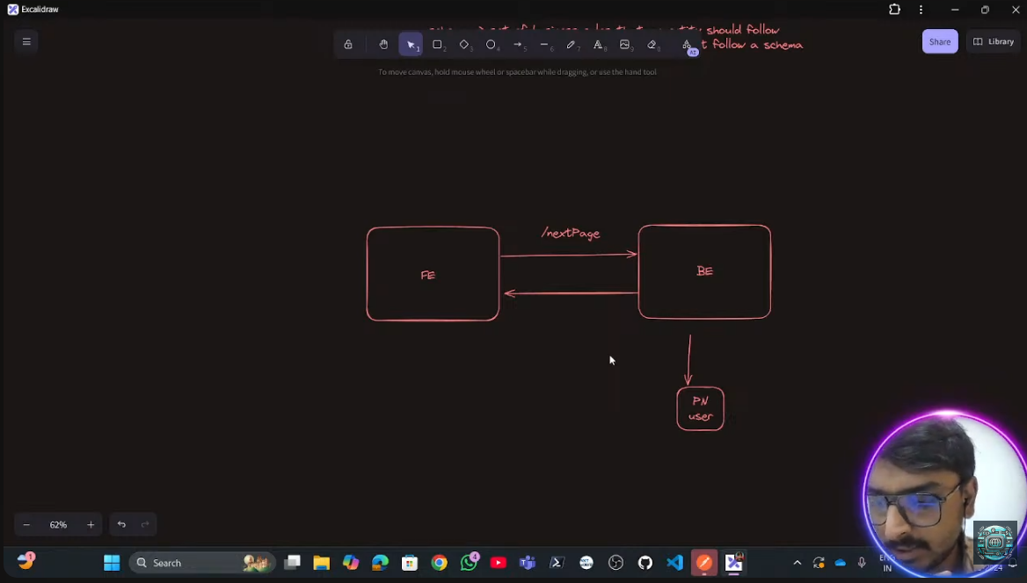

Working with new entity called product

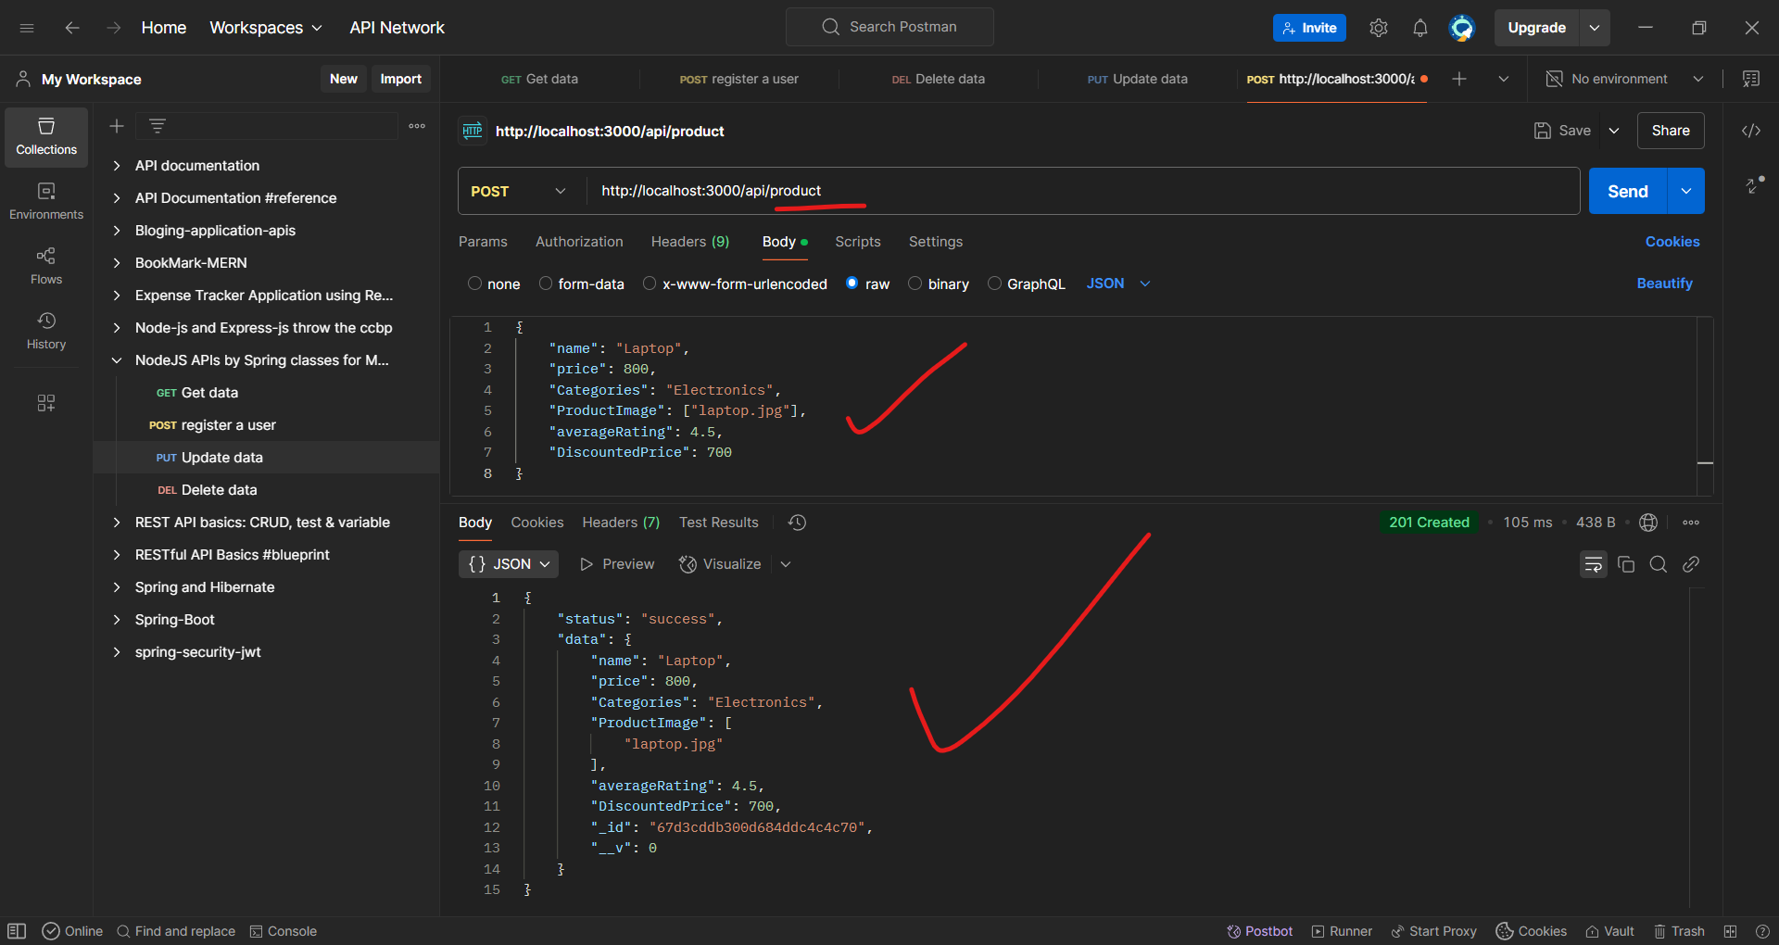

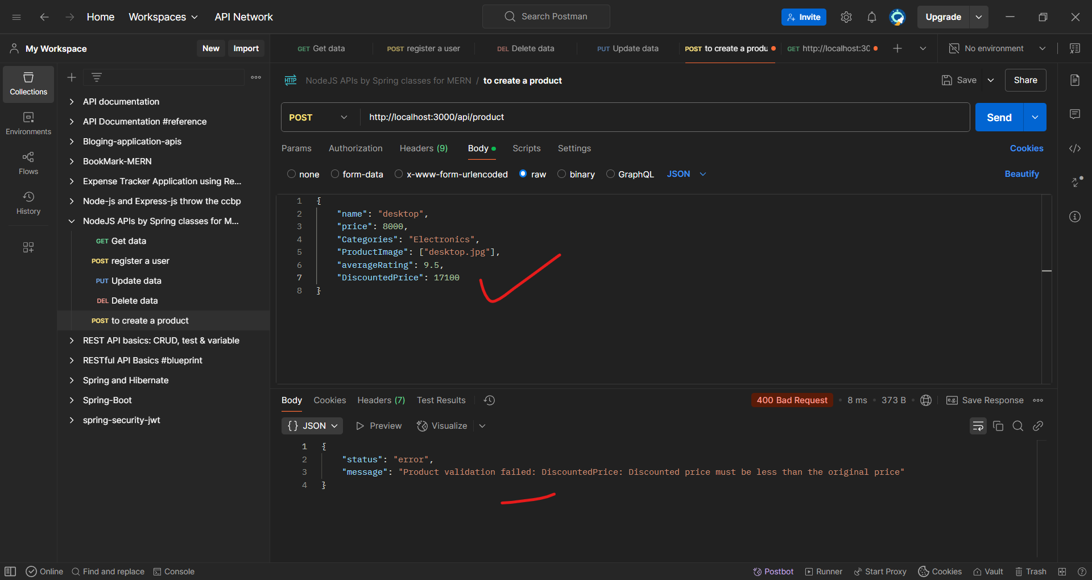

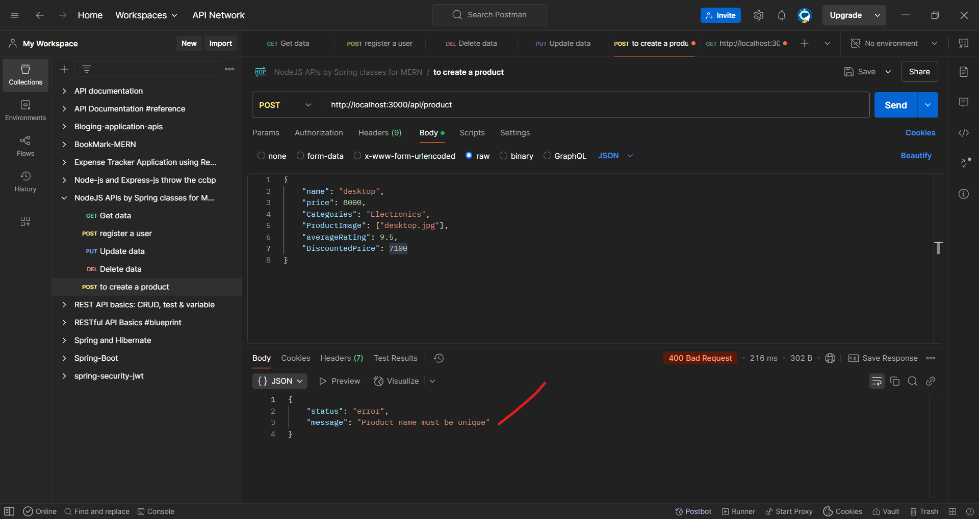

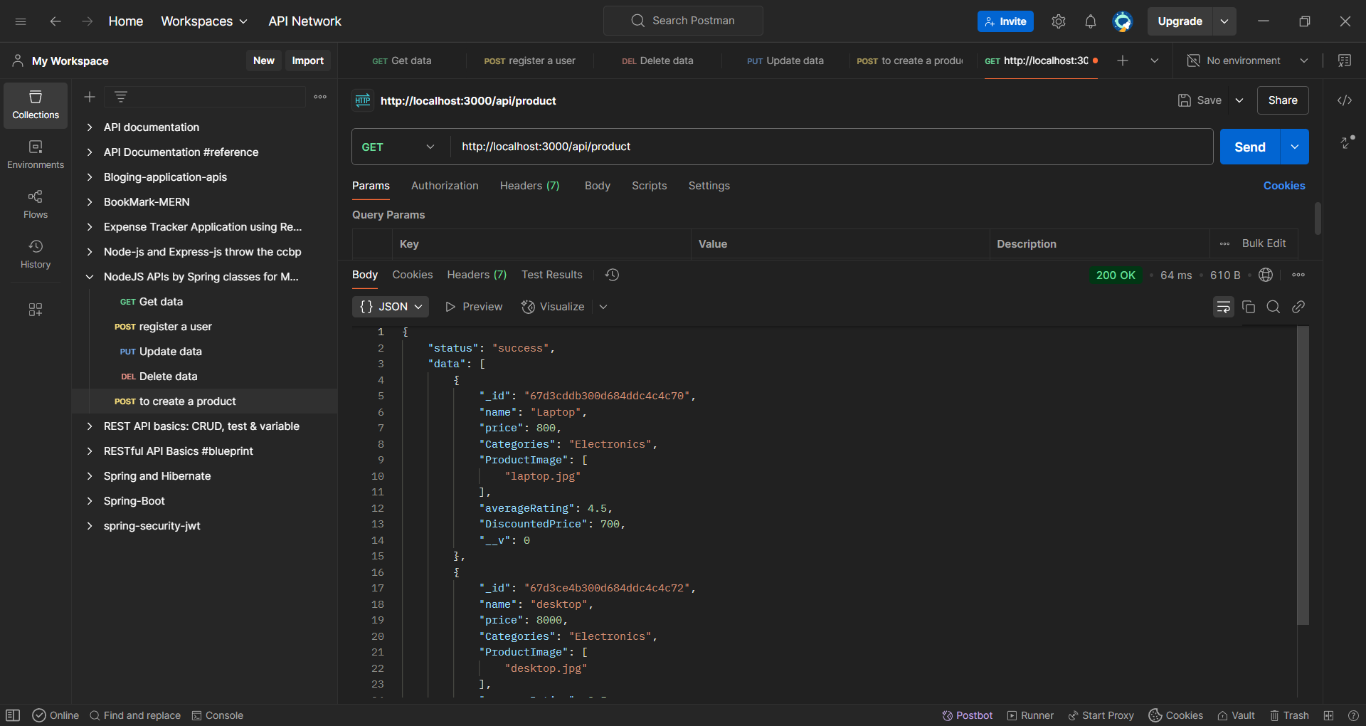

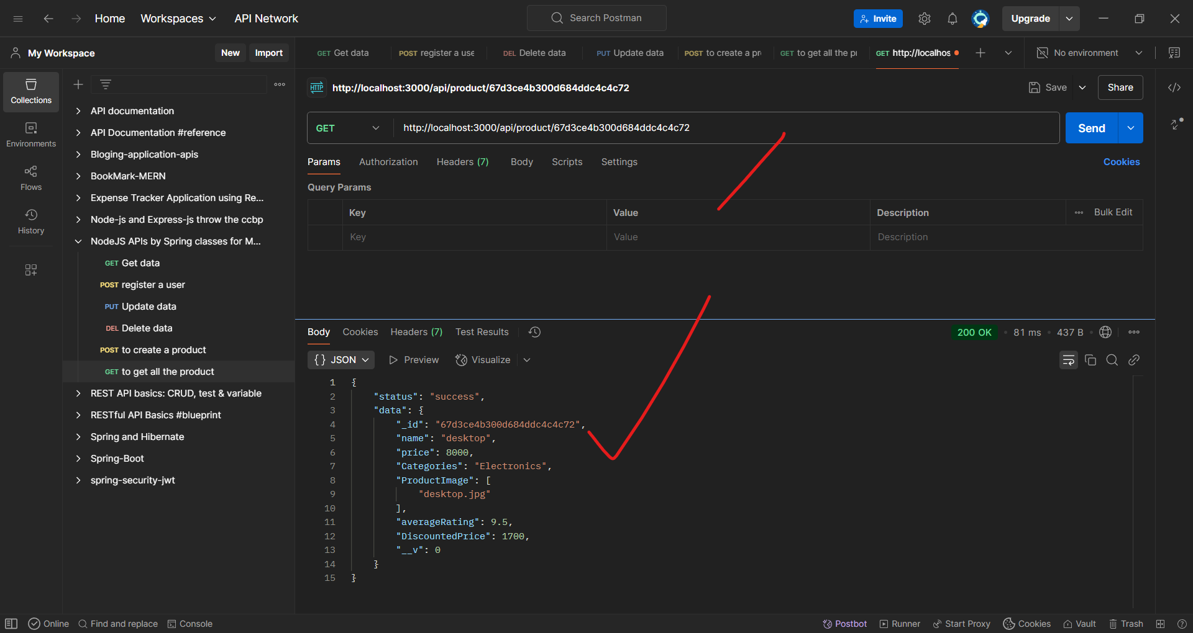

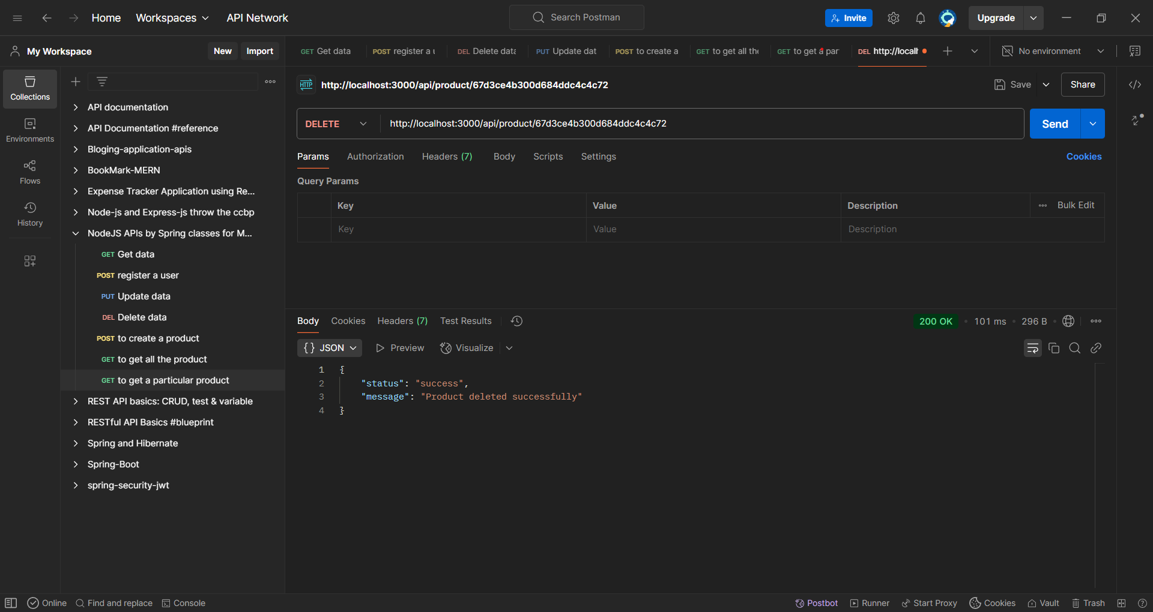

**Factory Pattern in Node.js**

The **Factory Pattern** in Node.js is a **creational design pattern** that provides an **interface for creating objects** while allowing subclasses or methods to decide **which class to instantiate**.

**Why Use the Factory Pattern in Node.js?**

✔ **Encapsulation** – Hides object creation logic.  
✔ **Decoupling** – Reduces dependency on direct class instantiation.  
✔ **Flexibility** – Easily add new types without modifying existing code.  
✔ **Reusability** – Centralized object creation.

**1️⃣ Simple Factory Pattern in Node.js**

Let’s create a **factory for different types of database connections** (MongoDB, MySQL, PostgreSQL).

**📝 Example: Database Connection Factory**

// DatabaseFactory.js

class MongoDB {

connect() {

console.log("Connected to MongoDB");

}

}

class MySQL {

connect() {

console.log("Connected to MySQL");

}

}

class PostgreSQL {

connect() {

console.log("Connected to PostgreSQL");

}

}

class DatabaseFactory {

static createDatabase(type) {

switch (type) {

case "mongo":

return new MongoDB();

case "mysql":

return new MySQL();

case "postgres":

return new PostgreSQL();

default:

throw new Error("Invalid database type");

}

}

}

// Usage Example

const db1 = DatabaseFactory.createDatabase("mongo");

db1.connect(); // Output: Connected to MongoDB

const db2 = DatabaseFactory.createDatabase("mysql");

db2.connect(); // Output: Connected to MySQL

**🔹 Benefits:**

✅ Flexible → Supports multiple database types.  
✅ Scalable → Easily add new databases without modifying client code.  
✅ Encapsulated → Hides object creation logic from the main application.

**2️⃣ Factory Pattern with Mongoose (Node.js + MongoDB)**

**📝 Example: User Factory for Different Roles**

In a real-world Node.js application using **MongoDB (Mongoose)**, we can use the **Factory Pattern** to create different user types dynamically.

// models/UserFactory.js

const mongoose = require("mongoose");

const userSchema = new mongoose.Schema({

name: String,

role: String

});

const Admin = mongoose.model("Admin", userSchema);

const Customer = mongoose.model("Customer", userSchema);

class UserFactory {

static createUser(type, name) {

if (type === "admin") {

return new Admin({ name, role: "Admin" });

} else if (type === "customer") {

return new Customer({ name, role: "Customer" });

} else {

throw new Error("Invalid user type");

}

}

}

// Usage in Express API

const express = require("express");

const app = express();

app.use(express.json());

app.post("/api/user", async (req, res) => {

try {

const { type, name } = req.body;

const user = UserFactory.createUser(type, name);

await user.save();

res.status(201).json({ message: "User created successfully", user });

} catch (error) {

res.status(400).json({ error: error.message });

}

});

app.listen(5000, () => console.log("Server running on port 5000"));

**🔹 Benefits:**

✅ Encapsulates the user creation logic.  
✅ Easily add new roles (e.g., Editor, Moderator).  
✅ Works well with **REST APIs** in Node.js.

**3️⃣ Factory Pattern with Dependency Injection**

**📝 Example: Logging Factory**

Instead of manually selecting a logging method (ConsoleLogger, FileLogger), a **factory** can return the correct logger dynamically.

// logger/LoggerFactory.js

class ConsoleLogger {

log(message) {

console.log("Console Logger:", message);

}

}

class FileLogger {

log(message) {

// Simulating file logging

console.log("File Logger (writing to file):", message);

}

}

class LoggerFactory {

static getLogger(type) {

if (type === "console") return new ConsoleLogger();

if (type === "file") return new FileLogger();

throw new Error("Invalid logger type");

}

}

// Usage Example

const logger = LoggerFactory.getLogger("console");

logger.log("This is a log message");

const fileLogger = LoggerFactory.getLogger("file");

fileLogger.log("This is a log message in file");

**🔹 Benefits:**

✅ Allows switching between **different logging mechanisms dynamically**.  
✅ **Easily configurable** in production/staging environments.

**🚀 When to Use the Factory Pattern in Node.js?**

✔ When object creation **depends on conditions** (e.g., User roles, Database connections).  
✔ When multiple classes **share a common interface**.  
✔ When you **want to hide the instantiation logic**.  
✔ When building **scalable, modular applications**.

**🔥 Conclusion**

The **Factory Pattern in Node.js** is useful for dynamically creating objects based on conditions. Whether you're handling **database connections, user roles, logging, or services**, the factory pattern makes the code **more flexible and maintainable**.

Would you like a factory example for a **specific use case** in your project? 😊

**Factory Function in Node.js**

A **Factory Function** in Node.js is a **function that returns an object** instead of using a constructor (class). It allows creating multiple instances of an object **without using the new keyword**.

**🔹 Why Use Factory Functions?**

✔ **Encapsulation** – Keeps object creation logic private.  
✔ **Reusability** – Easily create multiple instances with different configurations.  
✔ **Flexibility** – Can return objects dynamically based on conditions.  
✔ **Memory Efficient** – Avoids unnecessary memory consumption.

**1️⃣ Basic Factory Function Example**

Instead of using a class, we use a **function to create objects**.

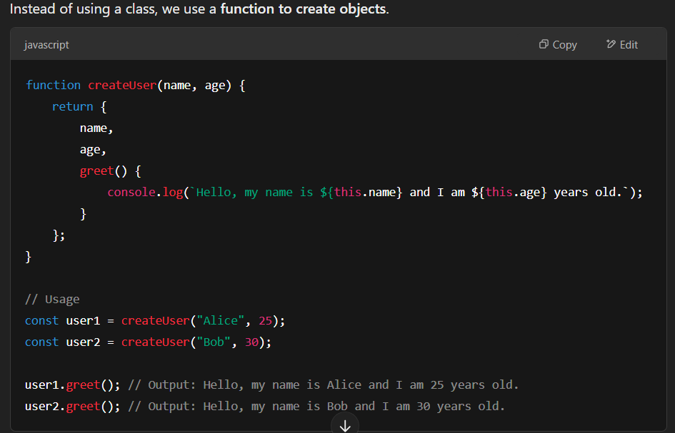

**🔹 Benefits:**

✅ **Simpler than classes** (no new keyword required).  
✅ **Encapsulated behavior** (methods inside the returned object).  
✅ **Easier to use in functional programming**.

**5️⃣ Factory Function vs. Constructor vs. Class**

| **Feature** | **Factory Function** | **Constructor Function** | **Class** |
| --- | --- | --- | --- |
| **Syntax** | **Uses a function** | **Uses new keyword** | **Uses class keyword** |
| **Object Creation** | **Direct return** | **Uses this keyword** | **Uses this keyword** |
| **Private Variables** | **✅ (via closures)** | **❌ (not easily)** | **✅ (via # private fields)** |
| **Simplicity** | **✅ Easy** | **Moderate** | **More structure** |
| **Use Case** | **Flexible object creation** | **Creating multiple instances** | **More structured OOP** |

**🚀 When to Use Factory Functions in Node.js?**

**✔ When you need multiple instances of an object.  
✔ When encapsulation (private variables) is needed.  
✔ When avoiding this and new makes code simpler.  
✔ When working with functional programming principles.**

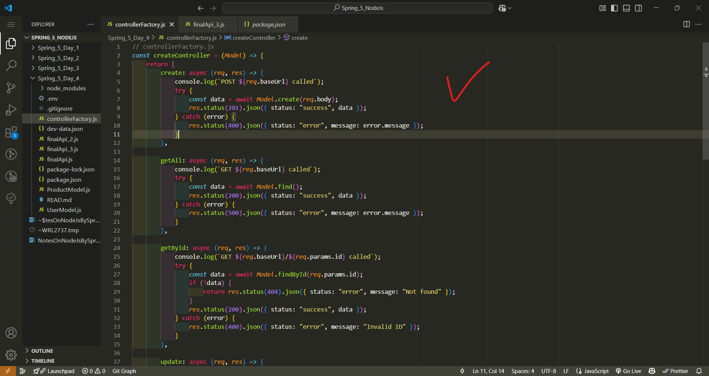

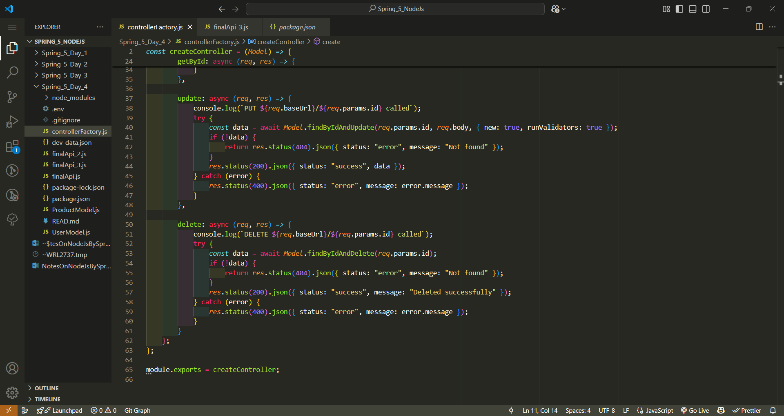

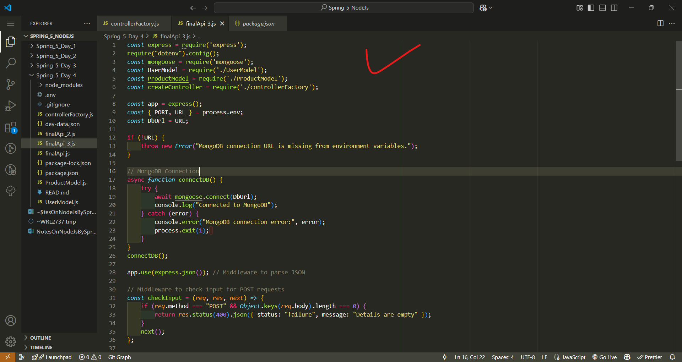

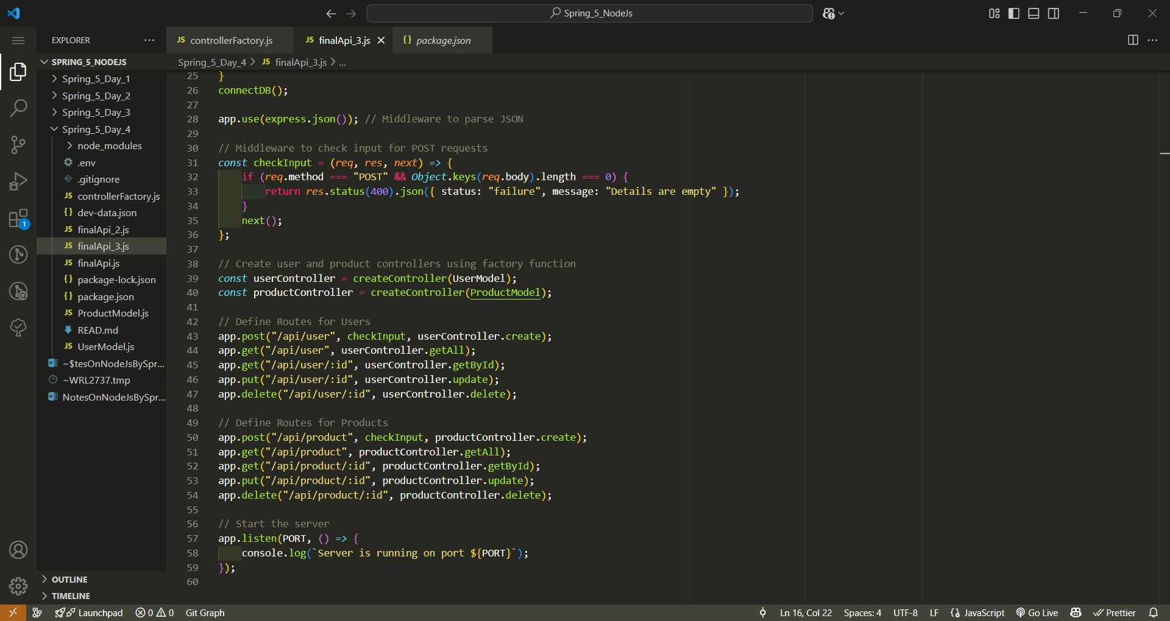

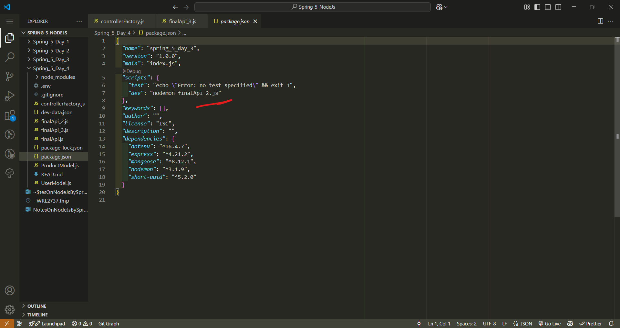

Change the file name to run from package.json

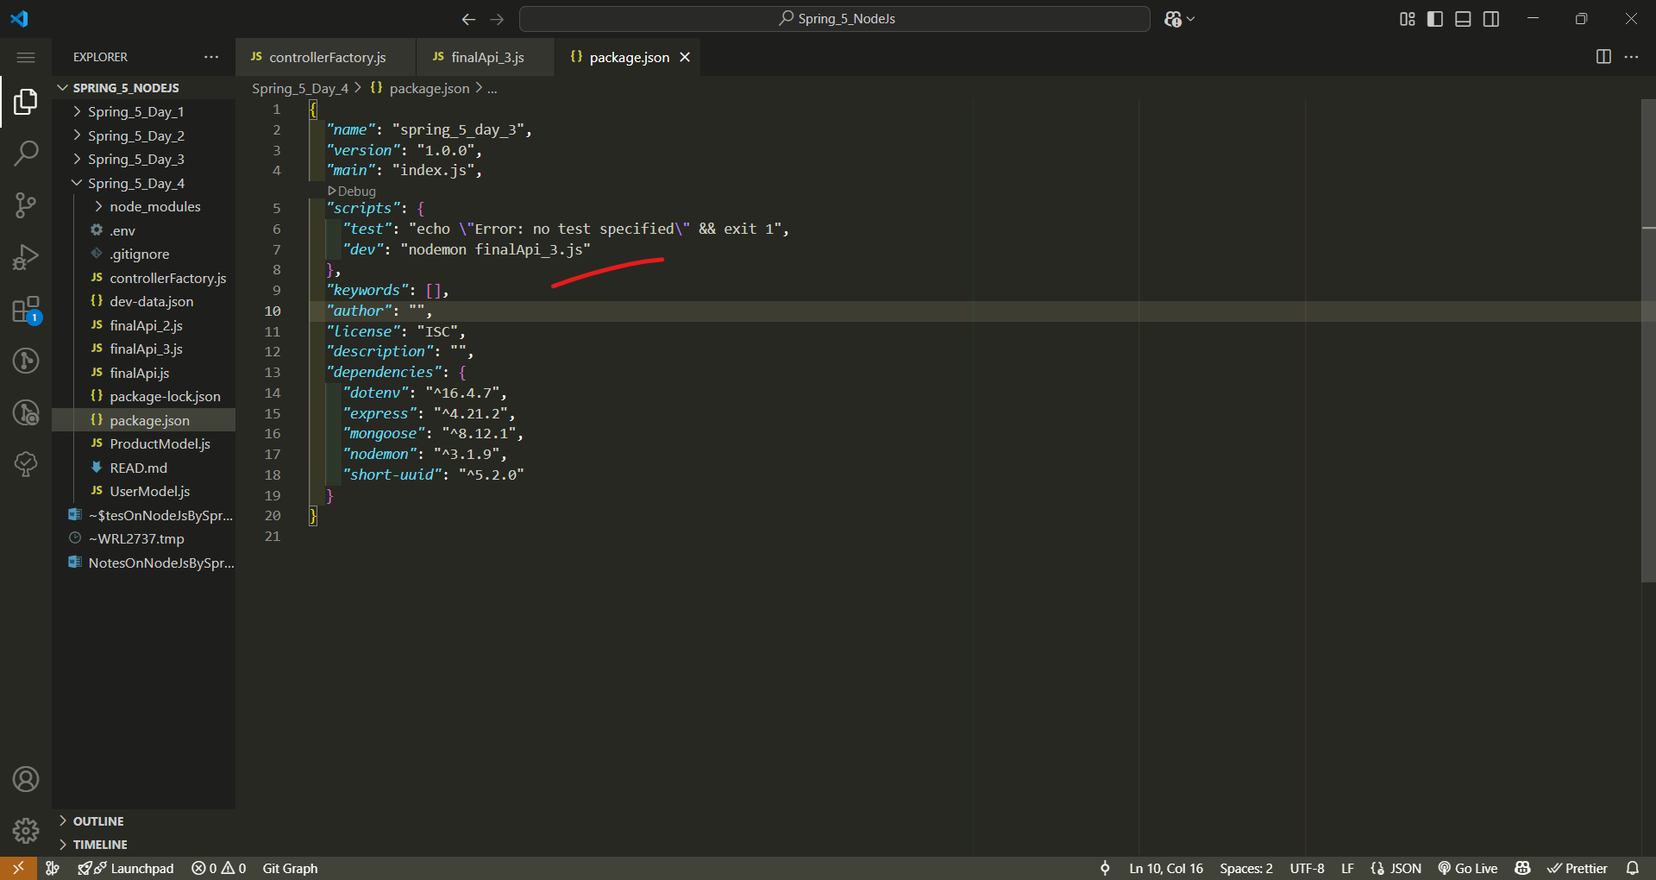

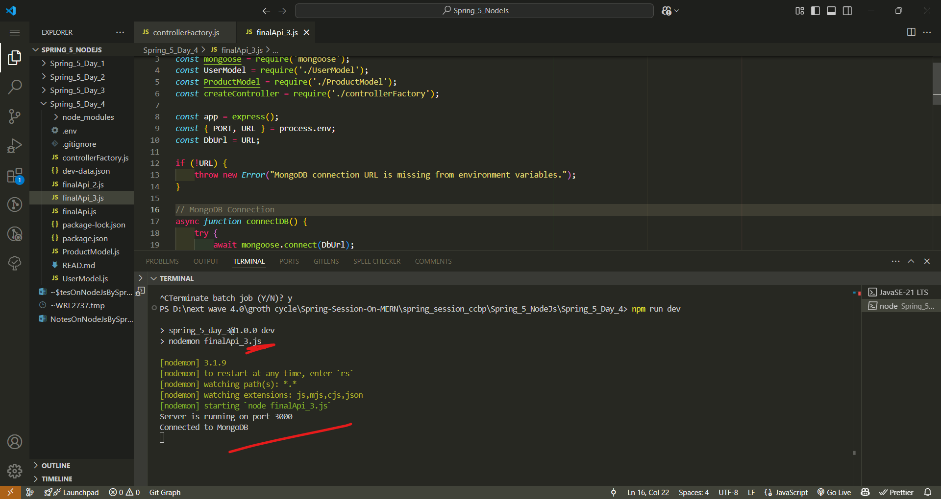

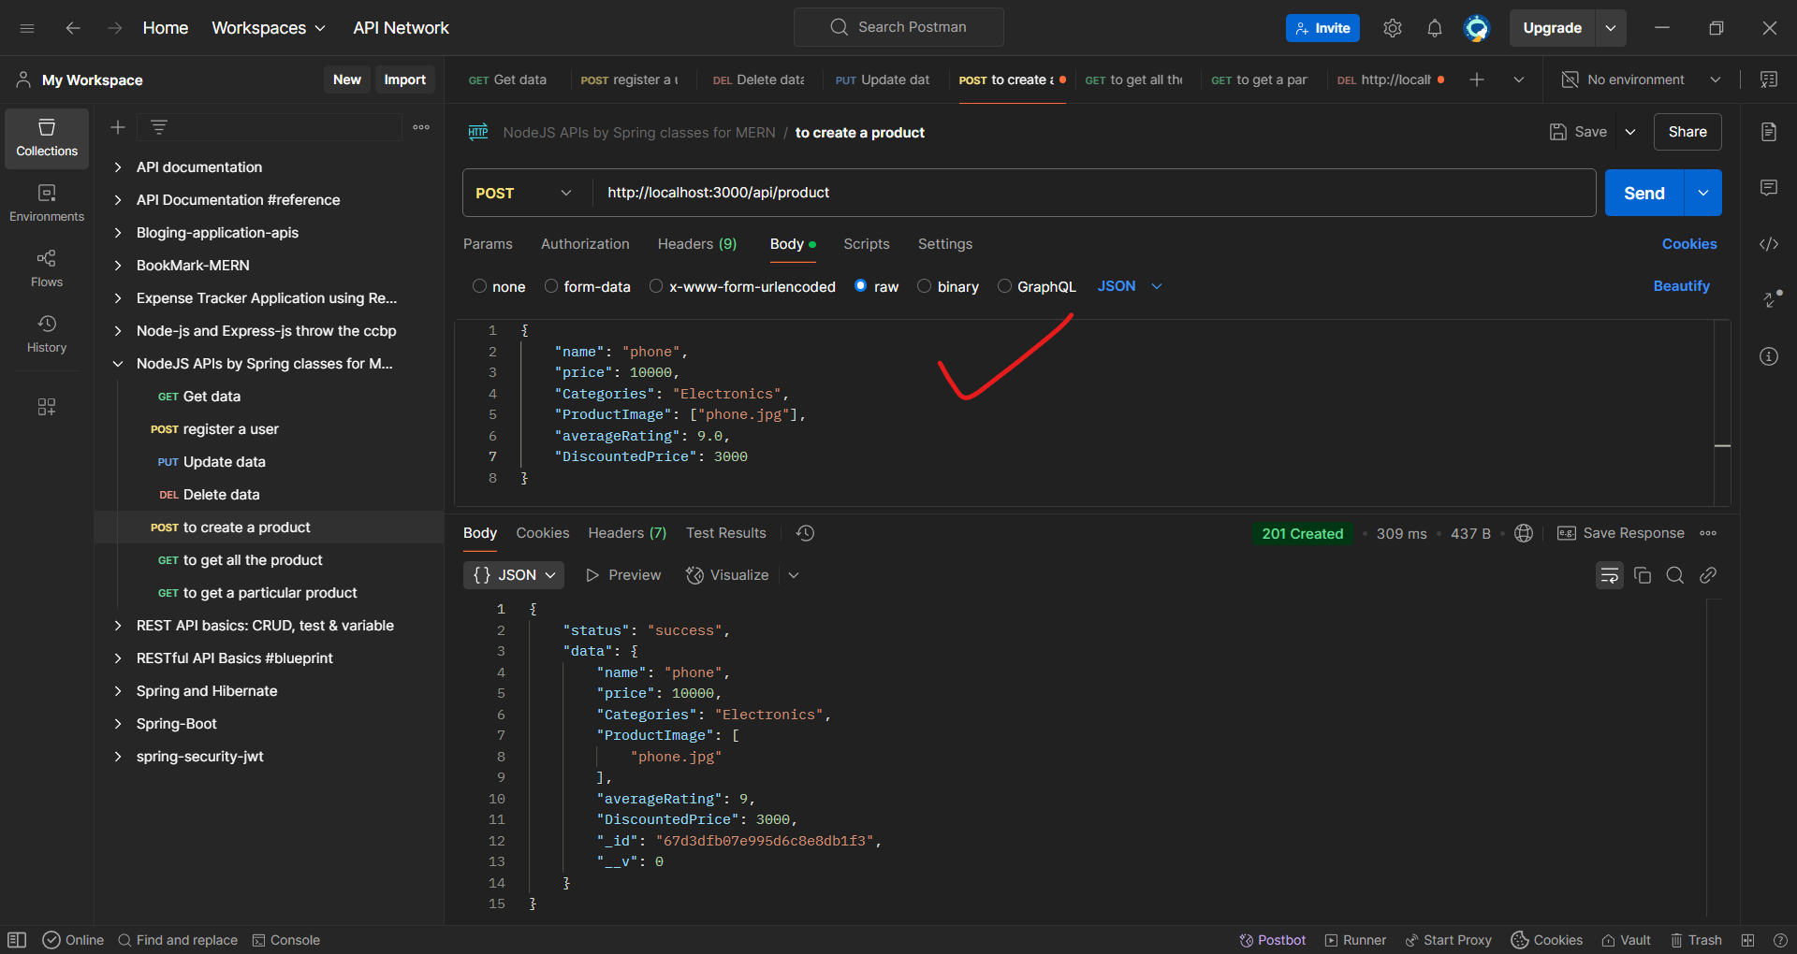

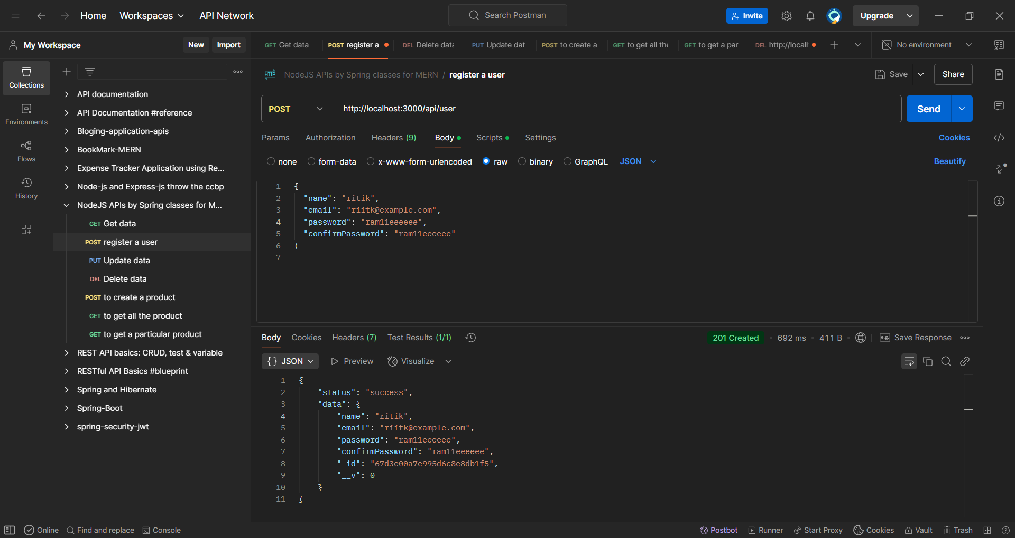

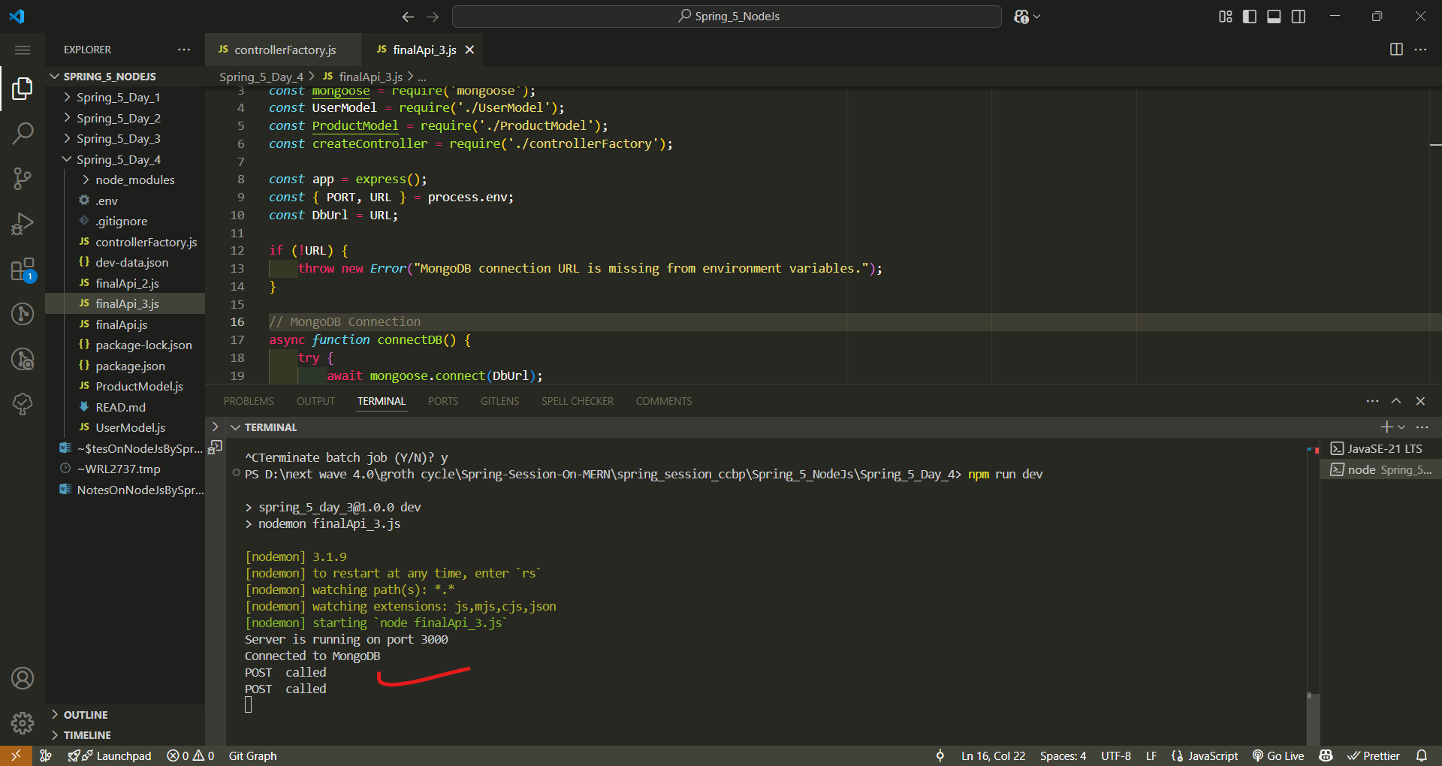

Learn the Clouser concept in Js

The controllerFactory.js file can logically fit into **either** the controller folder or the utility folder, depending on its purpose and your project structure. Here's how you can decide:

**1. If controllerFactory.js Generates Controllers Dynamically**

* If your controllerFactory.js creates controller functions dynamically and is closely tied to the business logic of your API (e.g., handling CRUD operations for multiple models in a structured way), it **belongs in the controller folder**.
* Example folder structure:
* /controllers
* ├── controllerFactory.js <-- (Handles generic controller logic)
* ├── userController.js
* ├── productController.js

**2. If controllerFactory.js is a Generic Utility**

* If it is a **generic helper function** that provides reusable logic for various controllers but isn't strictly part of the business logic, then it fits better in the utility (or utils) folder.
* Example folder structure:
* /controllers
* ├── userController.js
* ├── productController.js
* /utils
* ├── controllerFactory.js <-- (Generic function used by multiple controllers)

**Best Practice Approach**

* If the file is **closely related to controller logic**, put it inside controllers.
* If the file is **a reusable utility function** that could be used elsewhere, place it in utils.

Would you like help structuring your controllerFactory.js file? 🚀

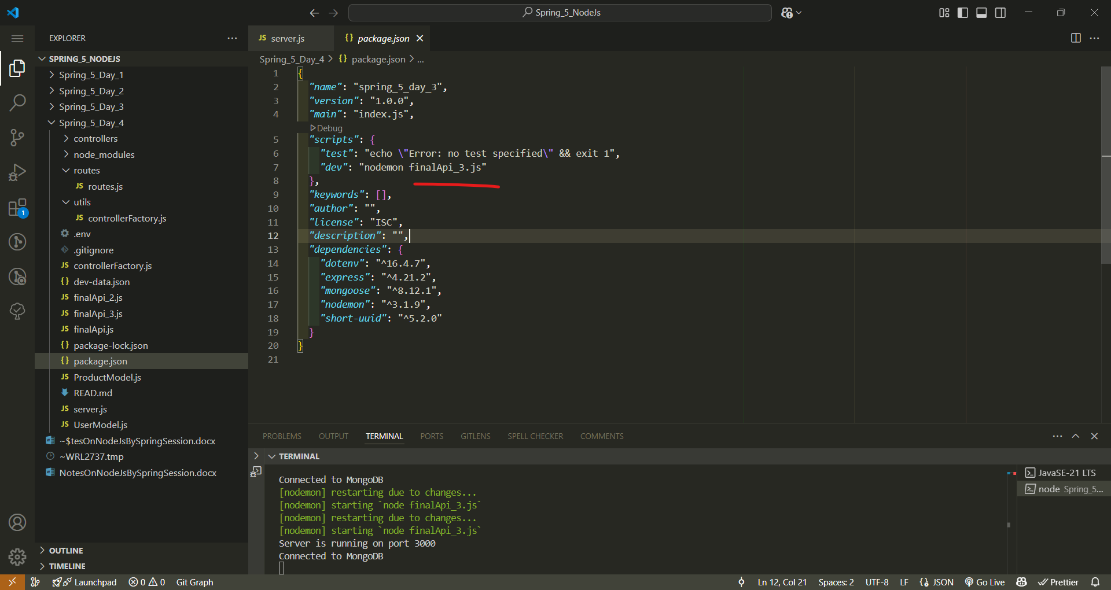

Change it as server.js

npm install cors express mongoose dotenv morgan

Q: what is use of morgan

**What is morgan in Node.js?**

morgan is a **logging middleware** for **Express.js** that helps track HTTP requests and responses in your Node.js application. It provides detailed logs about incoming requests, including method, status code, response time, and more.

**📌 Why Use morgan?**

1. **Debugging**: Helps track request details for troubleshooting issues.
2. **Monitoring**: Logs every API request, useful for analyzing API performance.
3. **Security**: Helps detect suspicious activities (e.g., frequent failed login attempts).
4. **Production Logs**: Stores logs for future analysis.

**🚀 How to Use morgan?**

**1️⃣ Install morgan**

Run this command in your project directory:

npm install morgan

**2️⃣ Import and Use It in server.js**

const express = require("express");

const morgan = require("morgan");

const app = express();

// Use morgan to log requests

app.use(morgan("dev")); // 'dev' is a pre-defined logging format

app.get("/", (req, res) => {

res.send("Hello, Morgan Logging!");

});

app.listen(3000, () => {

console.log("Server is running on port 3000");

});

**📌 Different Logging Formats in Morgan**

| **Format** | **Description** |
| --- | --- |
| **dev** | Logs method, URL, status, response time (color-coded in the console). |
| **combined** | Standard Apache log format (good for production logs). |
| **common** | Similar to combined, but without referrer and user-agent. |
| **short** | Minimal logging format. |
| **tiny** | Logs only method, URL, and status code. |

**Example Usage**

app.use(morgan("combined")); // More detailed logs, good for production

**📌 Example Log Output (dev format)**

GET /api/user 200 10ms

POST /api/login 401 5ms

DELETE /api/product/123 204 12ms

**✅ Conclusion**

* morgan helps log API requests in a structured way.
* Useful for debugging, performance monitoring, and security.
* Easy to integrate with Express.js apps.

**Introduction to MVC Architecture & Its Uses in Node.js**

**What is MVC Architecture?**

MVC (Model-View-Controller) is a **software design pattern** used for organizing code in web applications. It helps in separating concerns, making the application more scalable and maintainable.

The three main components of MVC are:

1. **Model**
   * Represents the **data** and **business logic** of the application.
   * Interacts with the database to perform CRUD (Create, Read, Update, Delete) operations.
   * Example: Database schema, data validation, and business rules.
2. **View**
   * Handles the **presentation layer** (UI/UX) of the application.
   * Displays data received from the **Model** and sends user input to the **Controller**.
   * Example: EJS, Handlebars, or frontend frameworks like React in a separate client-server setup.
3. **Controller**
   * Acts as an **intermediary** between the Model and the View.
   * Handles user requests, processes input, interacts with the Model, and returns responses to the View.
   * Example: Routing logic in Express.js.

**Why Use MVC in Node.js?**

Node.js is widely used for building web applications, and MVC provides an **organized structure** for managing code effectively. Some benefits include:

✅ **Separation of Concerns** – Each part of the application has a clear role.  
✅ **Scalability** – Easy to extend and modify the application.  
✅ **Code Reusability** – Components can be reused across different parts of the application.  
✅ **Maintainability** – Debugging and testing become more manageable.

**MVC in a Node.js + Express Application**

Below is an example of how MVC is implemented in a Node.js application using **Express.js** and **MongoDB (Mongoose ORM)**.

**Project Structure**

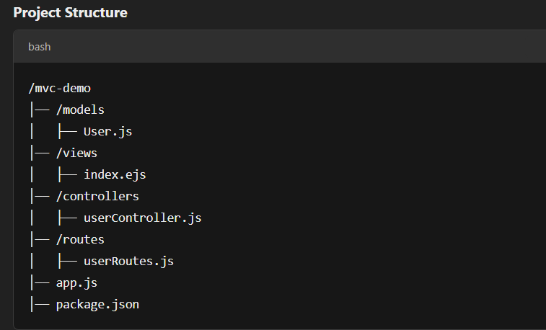

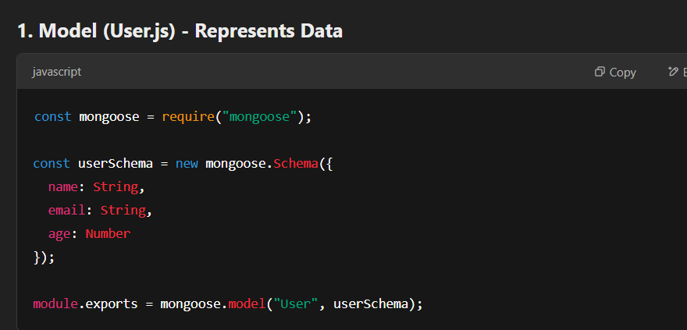

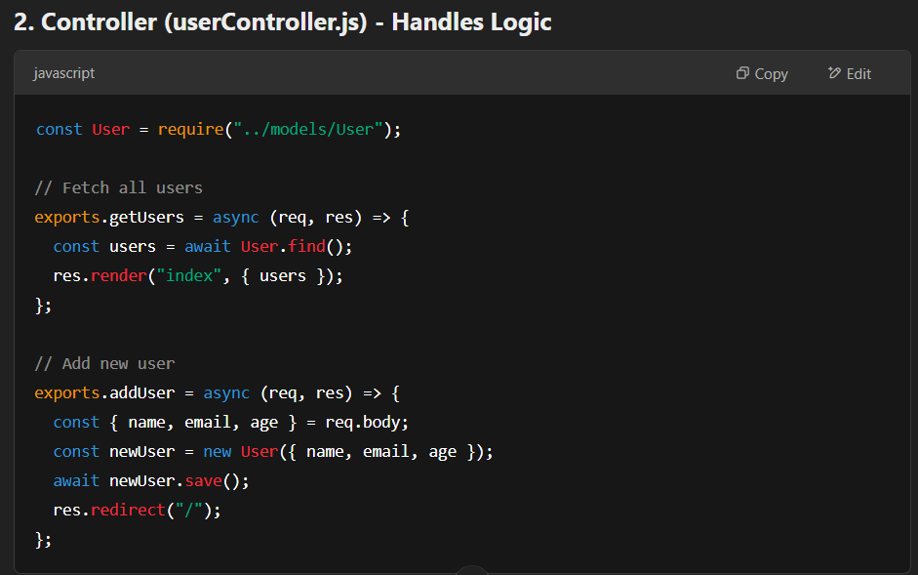

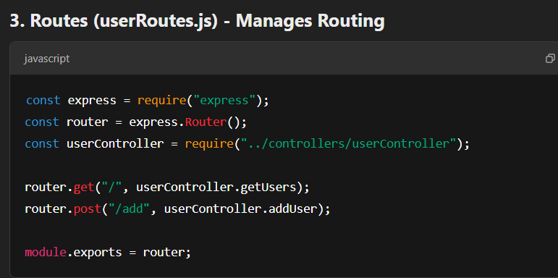

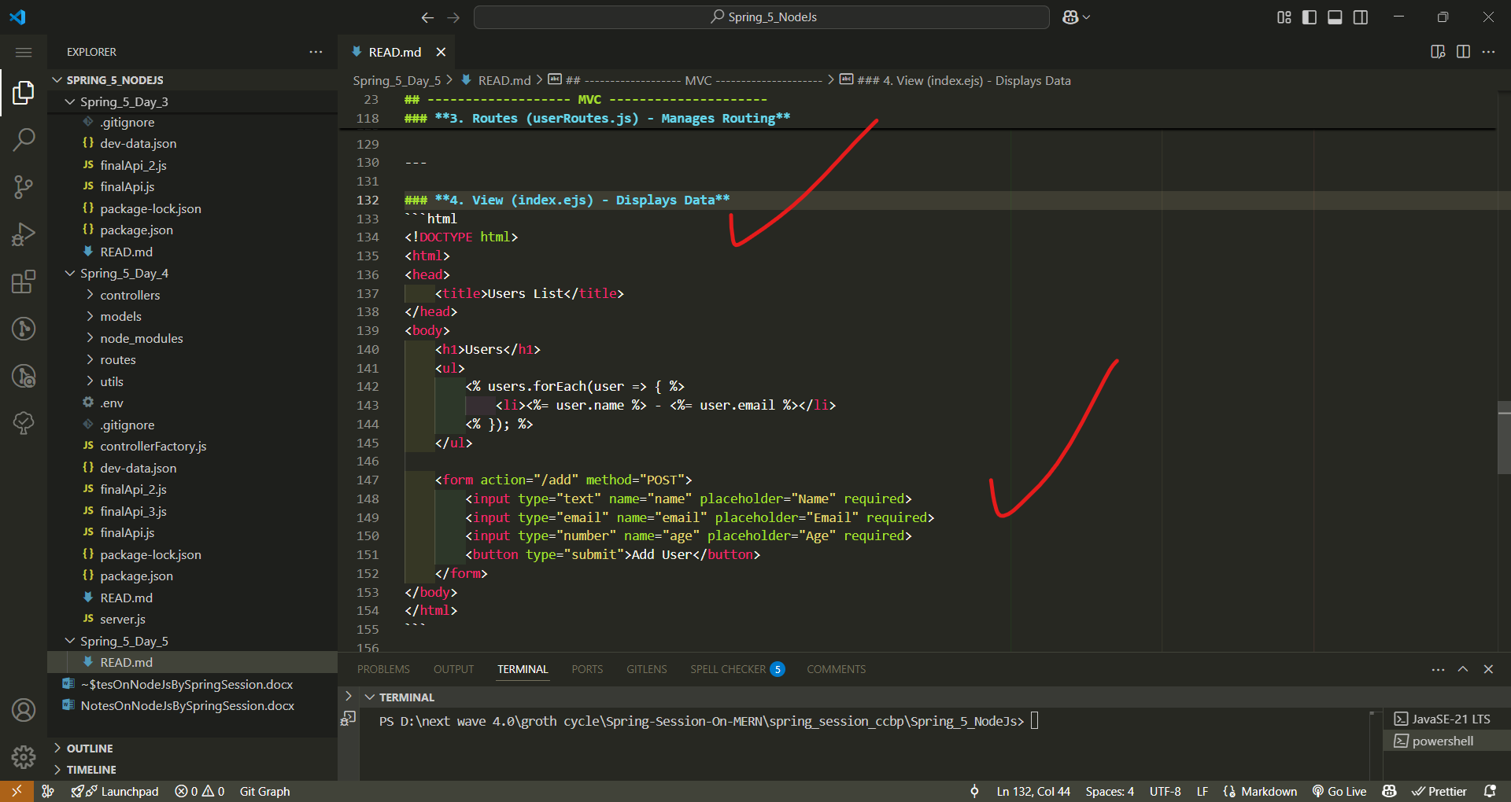

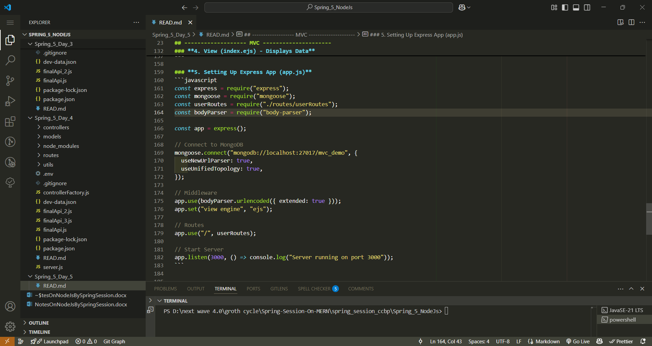

**How the MVC Flow Works**

1️⃣ A user visits / → The **Controller** calls the **Model** to fetch data.  
2️⃣ The **Model** retrieves users from the database and sends them to the **View**.  
3️⃣ The **View (EJS template)** displays the users in a list.  
4️⃣ When a user submits the form, the **Controller** adds the data to the **Model**.  
5️⃣ The **Model** stores the new user in MongoDB and redirects the user back to /.

**Conclusion**

Using the **MVC architecture** in Node.js applications helps in writing **structured, scalable, and maintainable** code. It ensures **separation of concerns**, making it easier to debug and extend functionality as needed.

Would you like me to extend this with additional features like authentication, pagination, or API-based MVC?

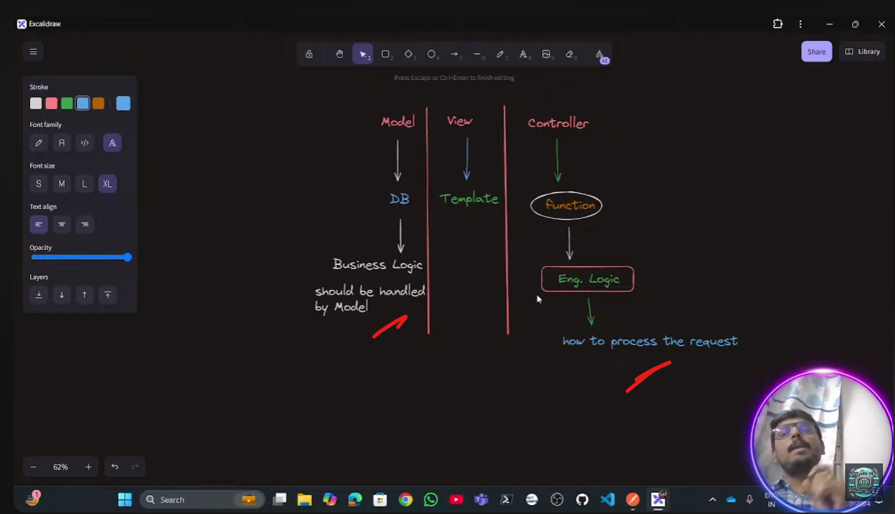

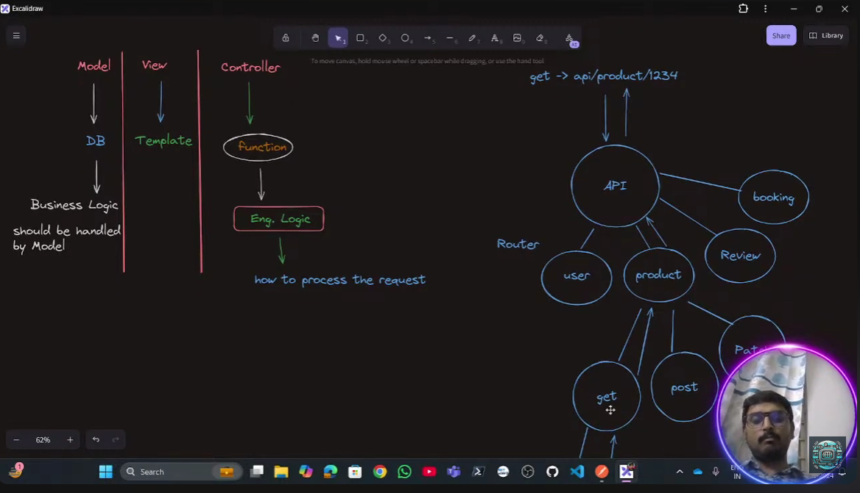

Working with query-parameters

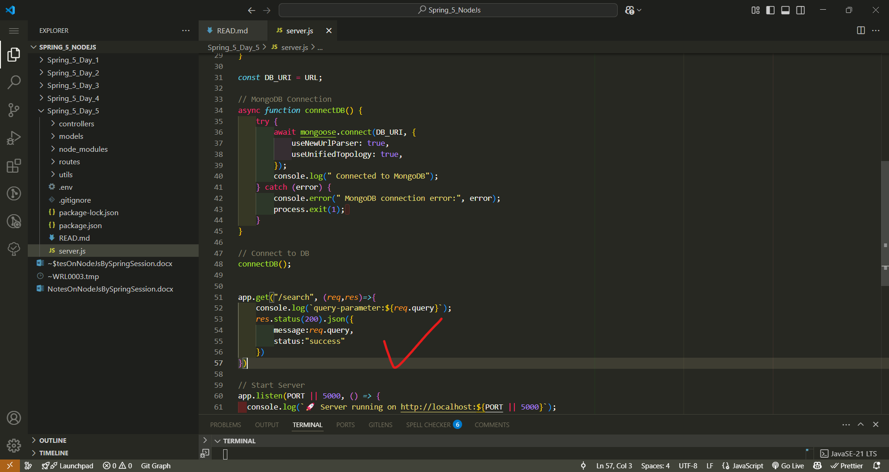

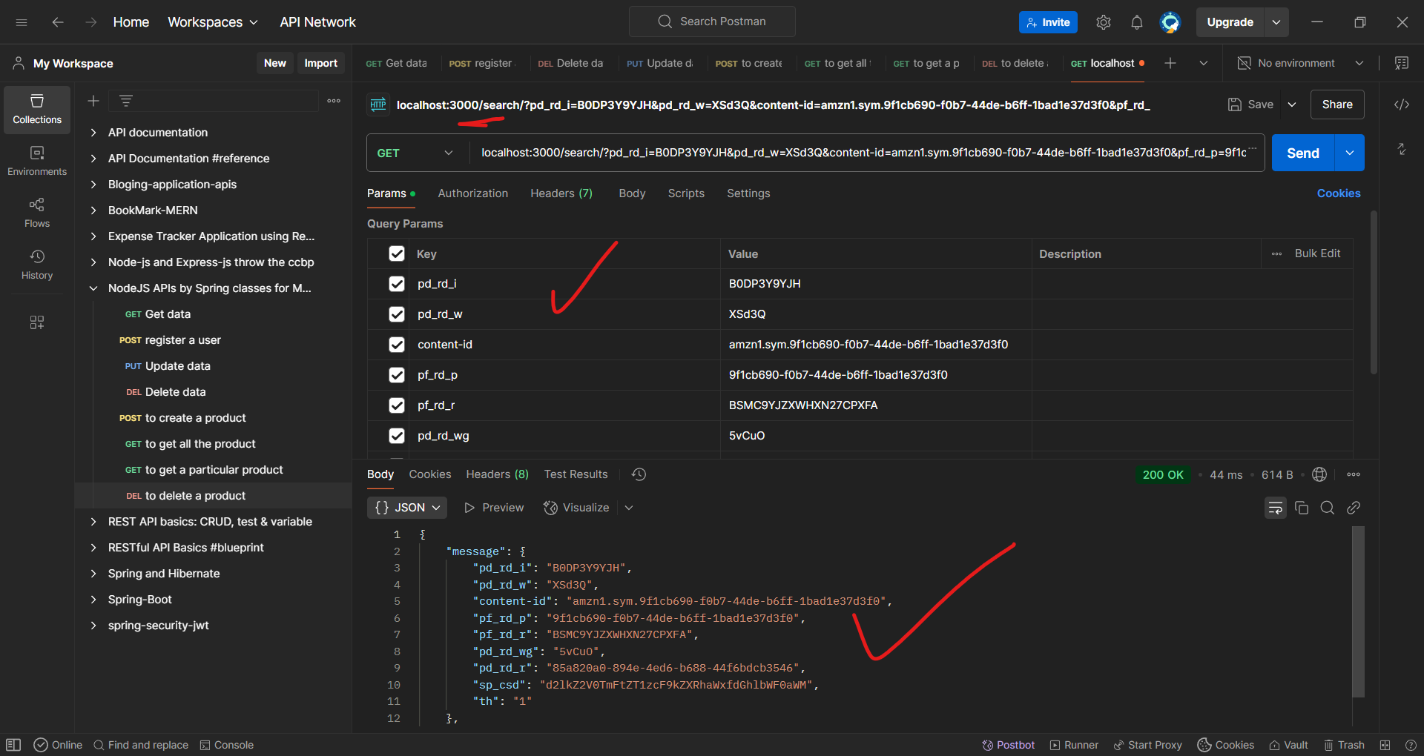

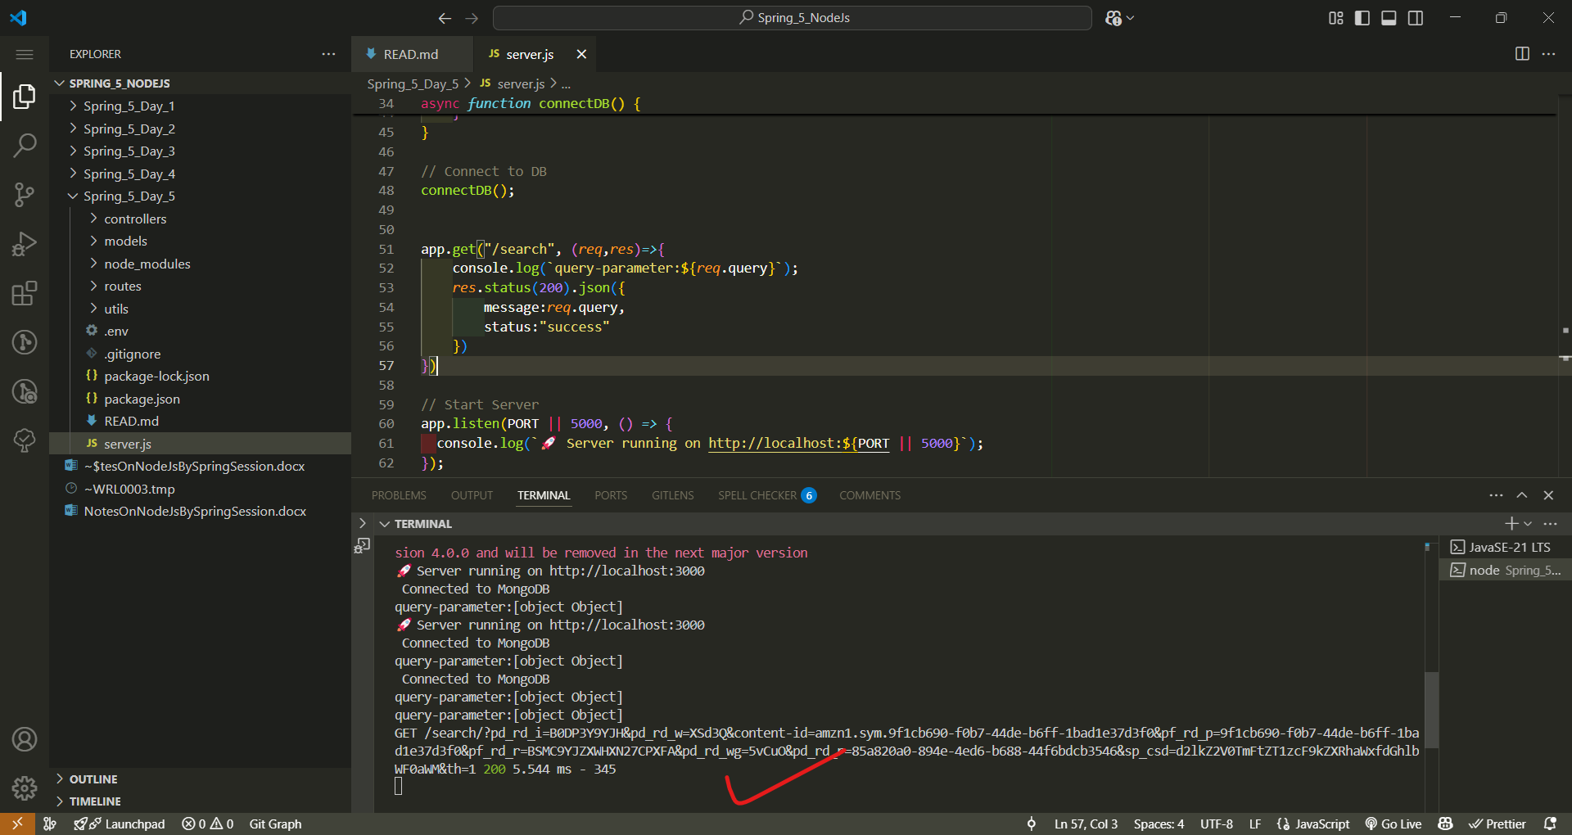

Spring_5_day_6

